Year 1/2
Week beginning: Monday 22nd June 2020 Summer term 2- Week 4 out of 7

Hello amazing Deer Class!
I hope you have had a lovely weekend!
Over the last few weeks I have become much better at using computers as I'm sure you have too!
This week you can click on my picture below to hear my introduction to our week's learning.
See if you can spot my filming mistake! I can only get better next week! 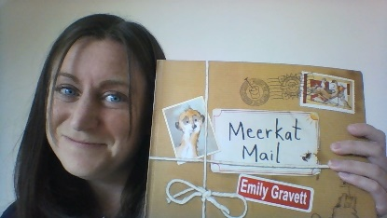
I have also attached this picture of a zoo keeper for you which I hope will make you smile as I did!
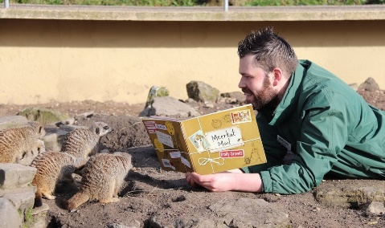
So, this week I have set you maths work (subtraction), writing (Sunny's diary), science (reptiles), Art (animal patterns), Geography (Where is Madagascar?) and computing (addition and subtraction games).
Mr Dooley has also given me some more sports activities for you!
We have some year 1 children back in school from Monday who will be working from this webpage, just as you are at home.
We will be following this timetable should you want to do something similar. Please continue to do whatever works for you though as there is no right or wrong answer!
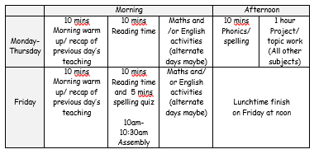Have fun completing some or all of these activities and I look forward to seeing your work if you would like to share it!
Have a lovely week. Still missing you all lots! Love from Miss Dutton x
Click here to enter online Purple Mash resources
Click here to enter Mathletics
Click here to enter TT Rockstars

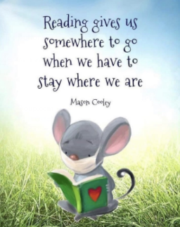
Use the link below to register on the Oxford Owls website. It is easy to set up the registration and it will give you access to a range of ebooks for ages 3-11.
Oxford Owl E Book Registration- link

This week I would like you to have a go at these Meerkat Mail comprehension questions.
Meerkat Mail comprehension questions
You can either read your book if you have one or watch the video below to help you to answer them.
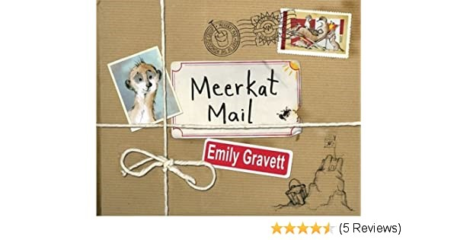 Meerkat Mail by Emily Gravett- https://www.youtube.com/watch?v=7lEigAZpusIvideo
The answers are in a file at the bottom of the page should you need them.

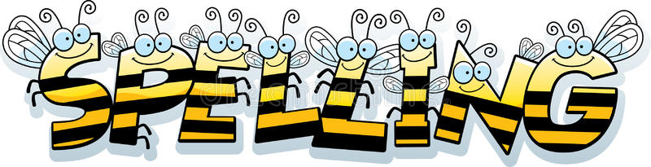
Reading and Spelling - It is really important that you can all read and write words with the sounds below. Keep practising them! Can you choose a sound and write 6 words for it. Try to learn to spell 5 common exception words each week too. 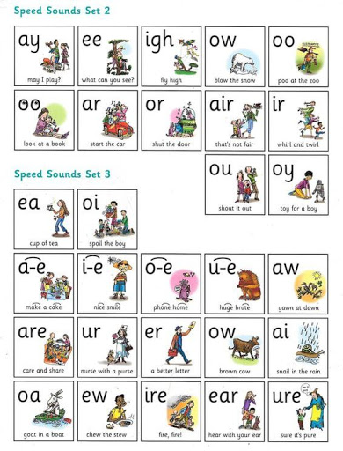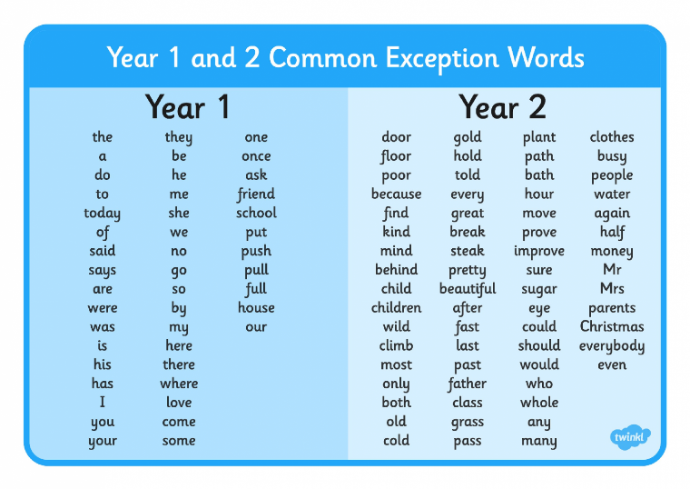

Year 1 children- Check you can spell these words from the list above?

no/ go/ so by/ my here

Year 2 children-
Learn to spell these 6 words that sound like they should have a 'j' sound in them but like last week, this sound is made by the letter 'g'.

page magic angel orange ginger danger

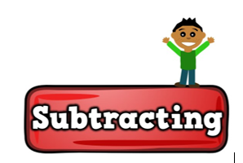Maths
* * * Please keep practising temperature, mass, capacity, time telling, adding, subtracting and counting in 2s, 3s, 5s and 10s to learn your times tables. There are also maths challenges for year 1 and year 2 in the files at the bottom of this page. * * *
As mathematicians- Can you subtract numbers?
Warm up-
1. Try counting backwards in 1s from 20, 2s from 20, 5s from 50 and 10s from 100.
(If these get too easy then try counting back in 3s from 30.)
2. Quick mental addition/ doubles-
(Put the number on your fingers and count them twice if you get stuck.)
3 + 3 = 6 + 6 = 2 + 2 = 5 + 5 = 1+ 1 =
10 + 10 = 7 + 7 = 0 + 0 = 4+ 4 = 8 + 8 = 9 + 9 =

Subtraction
This week your activities are all linked to subtraction.
Subtraction is the opposite of addition.
When we subtract we always start with the biggest number first and we count backwards.
Let's remind ourselves again about tens and ones in numbers. This will help us with our subtraction as well as our addition.
The sticks represent ten cubes and the small cubes represent one.
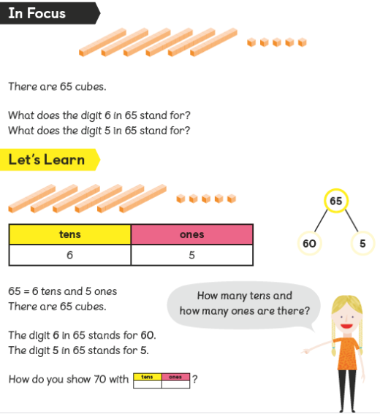
Can you read these numbers below and point out the tens and ones digits?
1 8 2 3 5 4 4 0 96

Click on the links below to find your activities for this week. You don't have to print these you can just write the answers down if you like.
There is also a number line 0-20 and a 100 square should you want to use them.
Subtraction activities- Year 1 objectives
Subtraction activities- Year 2 objectives
Number line 0-20
100 square


Science
As scientists- Can you name some reptiles and their characteristics?

So far in science we have learned about 5 types of animals-
insects, birds, fish, mammals and arachnids.
Do you still have the same favourite?

This week we are going to learn about another type of animal called reptiles.
When Sunny gets to the Dive-in restaurant on Saturday it says there are small reptiles on the menu but what could these be?
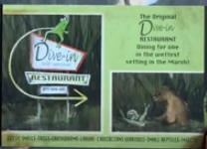
Reptiles are vertebrates. Can you remember what this word means?
It means that they have a back bone.

Challenge 1- Watch the video clip below and tell an adult about the characteristics of reptiles.
All about reptiles-https://www.youtube.com/watch?v=DefLKnKyQfAvideo clip

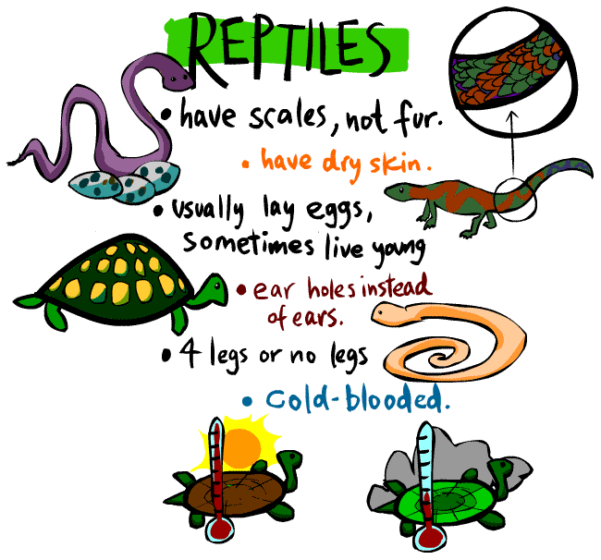
Here are some reptiles that live in Africa.
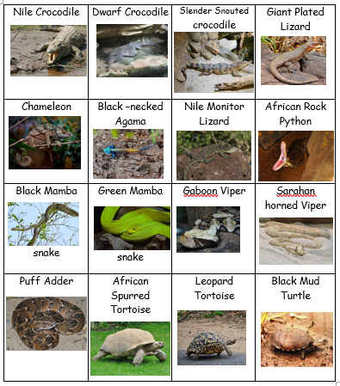
Challenge 2- Draw a reptile of your choice.
You might want to write some facts too!

Writing
As writers- Can you write Sunny's diary, spelling the days of the week correctly and using different conjunctions?
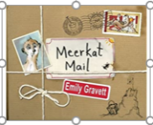 Meerkat Mail by Emily Gravett- https://www.youtube.com/watch?v=7lEigAZpusIstory video

Our main character Sunny keeps a diary for each day of the week when he is away from home.
He is practising spelling the days of the week...
Monday, Tuesday, Wednesday, Thursday, Friday, Saturday, Sunday

and using the following conjunctions (joining words) in his writing...
and, because, but, so, when, that, if, or

Each day he starts a page with the date and the words
'Dear Diary'.
Here is an example for Monday with his conjunctions highlighted in red...
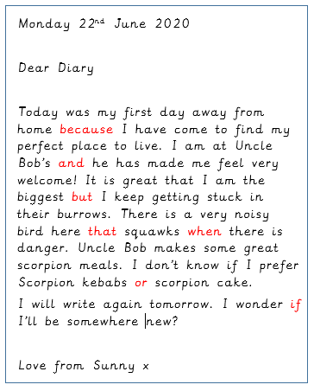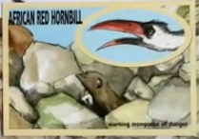
Can you write some diary entries for Sunny?
You might want to do short entries for each day of the week or just pick a couple of your favourite days from the book.
Make sure you help Sunny spell the day correctly and use some conjunctions to join his sentences.
You can illustrate your diary pages too.
Don't forget to use punctuation in sentences such as capital letters, full stops, commas, maybe even exclamation marks and question marks. Try to use interesting adjectives (describing words) and conjunctions (joining words) such as 'and, but, so, because, when, that, if, or'.

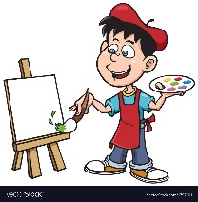Art
As artists-Can I imitate patterns in nature?

There are so many amazing patterns in nature!
Especially in the animals skins of the African animals that we have been learning about!
Skin patterns are usually for when the animals need to camouflage (hide) within the plants, rocks and other things in their habitat.
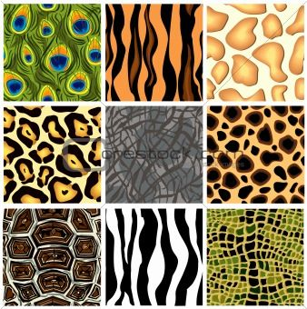
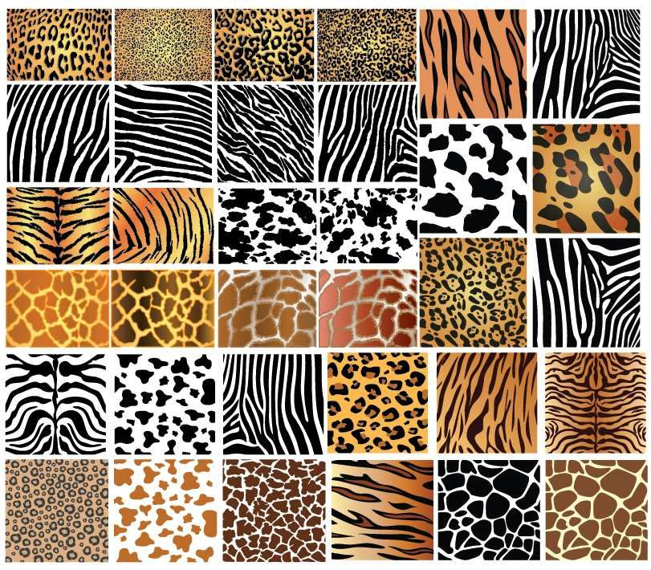
Can you recognise the patterns from the skins below? Which animal do they belong to?

Here are patterns from different reptile skins...
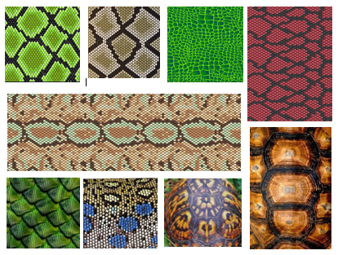
Have a go at copying one or a few of the animals skin patterns above.
You could even create a camouflage picture for an animal using their pattern like the ones below.
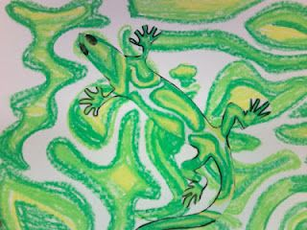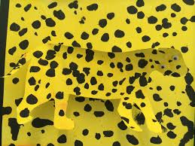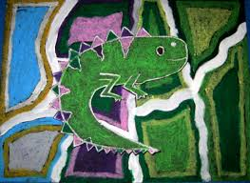

Geography
As geographers can you locate Madagascar on a map and name some animals that live there?

By Friday evening Sunny arrives in Madagascar.
Can you find Madagascar on the map of Africa below?
How do you think Sunny may have got there?
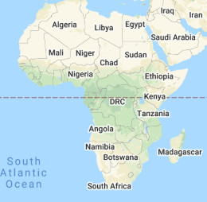
Madagascar is somewhere I would love to visit because it has amazing wildlife!
Watch this video clip below to see some of the fascinating plants and animals that live there.

All about Madagascar - https://www.youtube.com/watch?v=Vtfp27g2_mkVideo clip
You probably already knew some of the animals that live in Madagascar from watching this film. It is all about animals who escape from a zoo, go on an adventure and end up washed up on the shores of Madagascar.
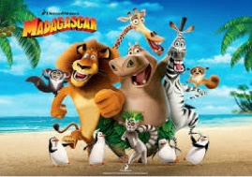
Computing
In computing can I play addition and subtraction games?
On Purple Mash I have set you some 'to do' addition and subtraction games.
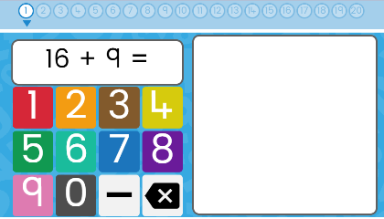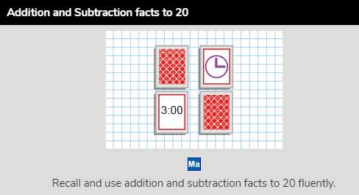
You may want to write yourself out the numbers 0-20 first (like below) so that you can use this as a number line if you get stuck.
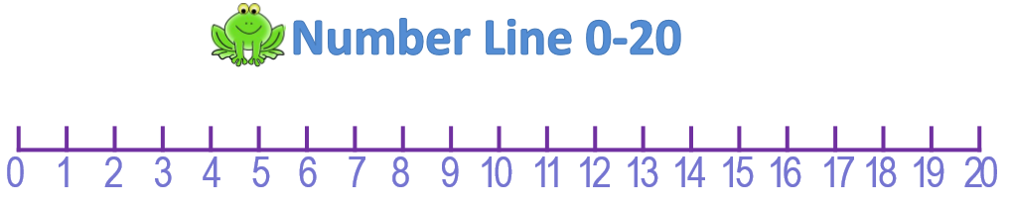

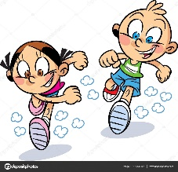PE
As sports people- Can you try out some new athletics activities?
Mr Dooley has sent you the following message...
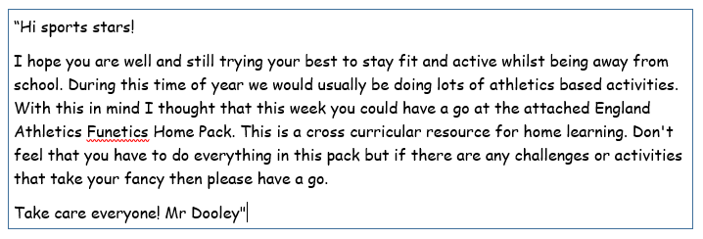
Athletics Activities- Link
Have fun!

