Snake subtraction
Can you subtract these 1 digit numbers from 2 digit numbers? Use the hundred square to help you to count back. Remember we always put the biggest number first to subtract.



26 - 3 = | 90 - 5 =
45 - 2 = | 83 - 8 =
53 - 6 = | 99 - 1 =
57 - 5 = | 66 - 7 =
71 - 4 = | 88 - 0 =
39 - 0 = | 29 + 7 =
77 - 5 = | 64 - 8 =
81 - 4 = | 91 - 9 =
50 - 6 = | 100 - 5 =

Money subtraction
10p - 10p = 40p - 10p = 73p - 5p =

Draw your own subtraction picture
In the box below is the word problem and picture for the calculation
7 - 2 = 5

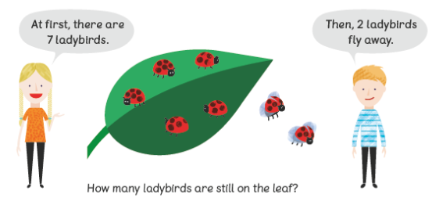

Can you write your own word problem and draw the picture for this calculation
9 – 6 =


Can you subtract tens numbers from a 2 digit number? When we subtract a tens number from a 2 digit number only the tens digit changes. Eg 35 - 10 =25 The ones digit stays the same.
When we back ten on a hundred square we jump upwards to the next box. See the examples below.

24 - 10 (1 ten) = 14 47 - 30 ( 3 tens) = 17
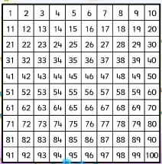

Can you solve these?
56 - 10 = | 71 - 20 =
97 - 10 = | 54 - 20 =
33 - 10 = | 99 - 30 =
70 - 10 = | 82 - 40 =
65 - 20 = | 100 - 50 =
Can you subtract two 2 digit numbers?
We call this way of laying out our maths column subtraction.
We start by subtracting the numbers in the ones column (o), then subtract the numbers in the tens (t) column to get our answer.
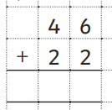
Example
o
o
t
t
Subtract the ones Then subtract the tens
6 - 2 = 4 4 tens - 2 tens = 2 tens
-
-
4
4
2

Can you solve these?
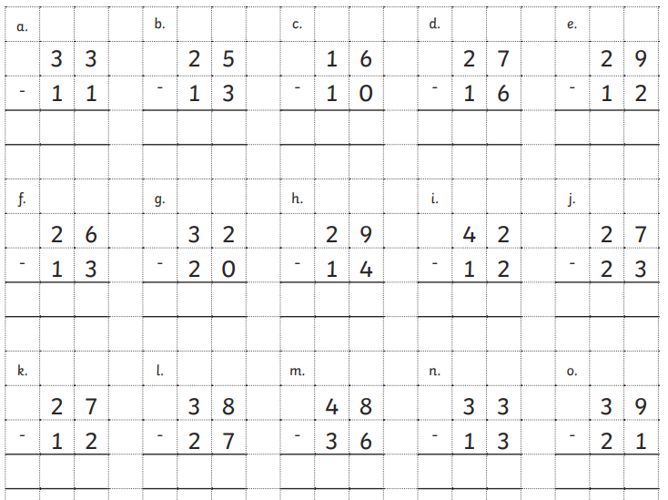
Can you solve these word problems using one of the subtraction methods you have practised above?

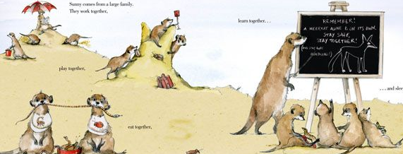
- Sunny has 12 brothers and sisters.
5 of them are boys.
How many are girls?

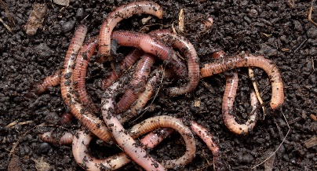
- Sunny has 26 earthworms on his plate at the Dive-in restaurant.
He then eats 7.
How many earthworms does he have left?

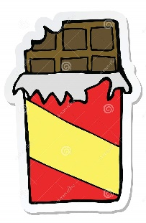
- Sunny has 55p to spend in the sweet shop.
He buys a termite chocolate bar for 12p.
How much money does he have left?

- Sunny’s suitcase weighs 9kg.
He takes out his umbrella when it rains which weighs 2kg.
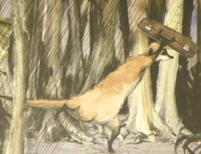
How heavy is his suitcase now?

- The temperature is 40°C on Wednesday.
On Thursday it drops by 3°C.
What is the temperature on Thursday?


- Sunny collects 64 eggs on Uncle Bob’s farm.
He accidentally drops and breaks 20 of them.
How many eggs are left?

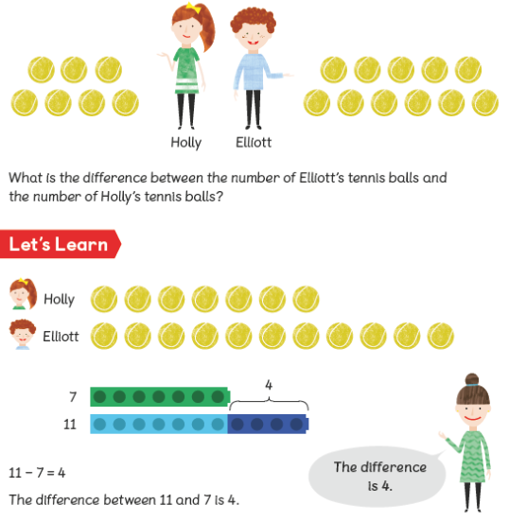
Can you find the difference between 2 numbers?

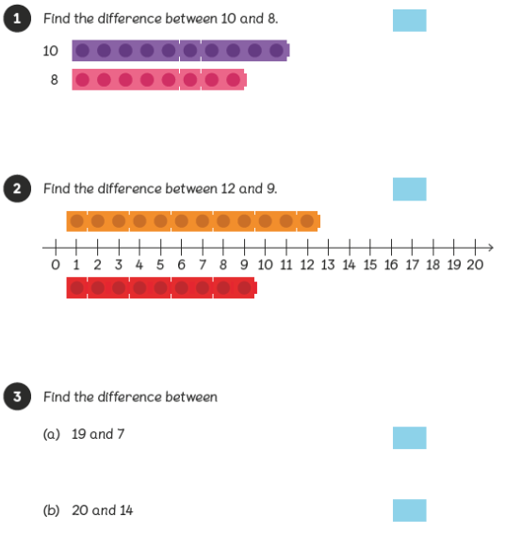

Can you solve these missing number problems?
Remember you can count up from the smallest number to the biggest number. You may have to count up in tens for some.
20 - ___ = 15 30 - ____ = 20 14 - ___ = 7

11 - ____ = 2 100 - ___ = 50 60 - ___ =30

