Snake Subtraction

Can you subtract these numbers using the number line to help you count back? The biggest number must always go first when we subtract.

5 - 1 = | 14 - 1 =
4 - 3 = | 15 - 6 =
8 - 4 = | 18 - 4 =
10 - 5 = | 17 - 7 =
10 - 2 = | 10 - 10 =
10 - 3 = | 20 - 1 =
5 - 5 = | 19 - 7 =
6 - 4 = | 9 - 9 =
11 - 5 = | 20 - 10 =
12 - 3 = | 20 – 8 =

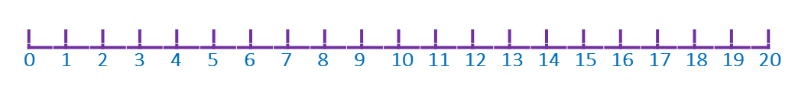
Draw your own subtraction picture
In the box below is the word problem and picture for the calculation
7 – 2 = 5
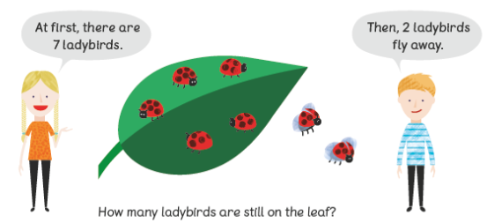
Can you draw the picture for these calculations and tell an adult the word problem to go with it.
9 – 2 = 7

10 - 6 = ___

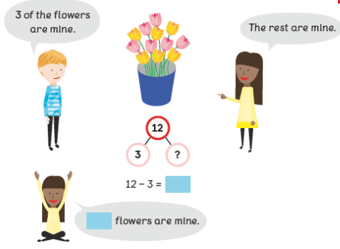
Can you solve these subtraction problems?

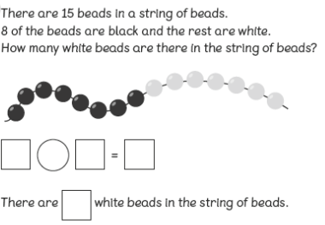

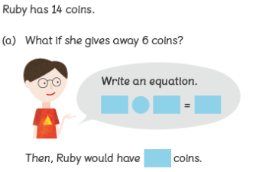

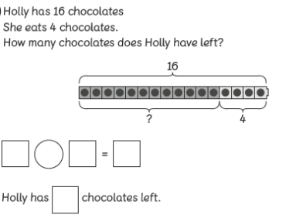

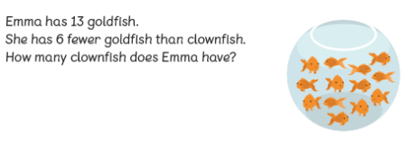

Sunny the meerkat subtraction word problems

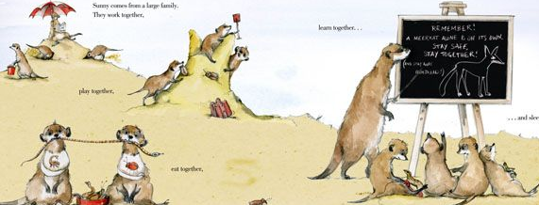
- Sunny has 12 brothers and sisters.
5 of them are boys.
How many are girls?

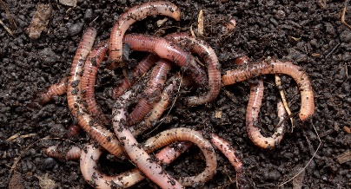
- Sunny has 15 earthworms on his plate at the Dive-in restaurant.
He then eats 7.
How many earthworms does he have left?

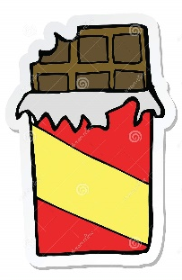
- Sunny has 20p to spend in the sweet shop.
He buys a termite chocolate bar for 5p.
How much money does he have left?

- Sunny’s suitcase weighs 4kg.
He takes out his umbrella when it rains which weighs 1kg.
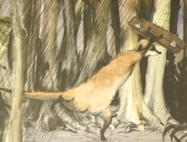
How heavy is his suitcase now?

- The temperature is 20°C on Wednesday.
On Thursday it drops by 3°C.
What is the temperature on Thursday?


- Sunny collects 18 eggs on Uncle Bob’s farm.
He accidentally drops and breaks 6 of them.
How many eggs are left?
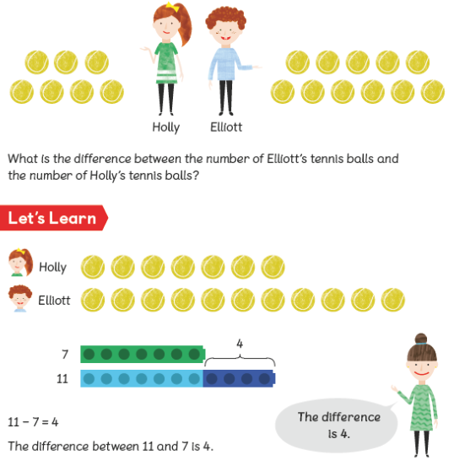
Can you find the difference between 2 numbers?

