Adding
Can you add these numbers using the number line to help you count on? Remember that it is easier to count on from the biggest number.

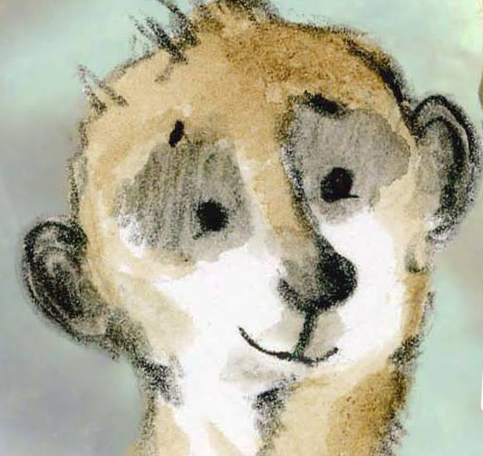

3 + 1 = | 11 + 5 =
4 + 2 = | 2 + 12 =
3 + 2 = | 11 + 4 =
4 + 4 = | 7 + 6 =
5 + 2 = | 10 + 5 =
3 + 3 = | 2 + 17 =
7 + 5 = | 6 + 11 =
6 + 4 = | 9 + 9 =
5 + 5 = | 8 + 12 =
6 + 6 = | 13 + 8 =

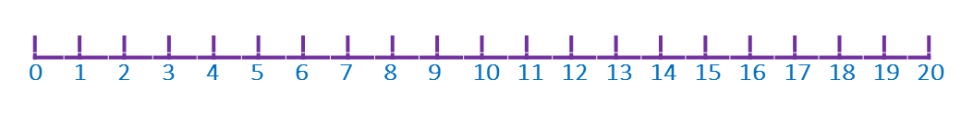

Draw your own addition picture
Bin the box below is the word problem and picture for the calculation
5 + 3 = 8
Beth has 5 purple flowers and 3 pink flowers in her garden.

How many flowers does Beth have altogether?

Can you draw the picture for these calculations and tell an adult the word problem to go with it.
4 + 3 = 7

7 + 3 = ___

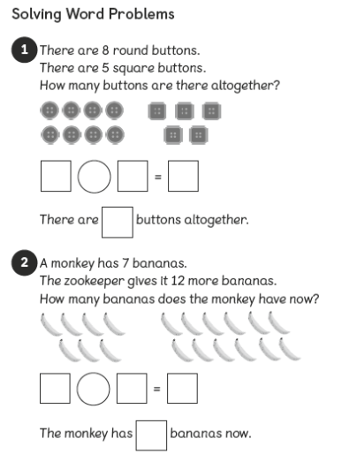
Can you solve these addition word problems?



Sunny the meerkat addition word problems


- Sunny walks 6 miles on Monday and 4 miles on Tuesday.
How many miles has he walked altogether?

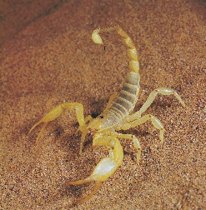
- Sunny eats 7 scorpions in the morning and 5 scorpions in the afternoon.
How many scorpions has he eaten altogether?


- There are 10 yellow balloons at Sunny’s party and 9 red balloons.
How many balloons does he have altogether?


- Sunny buys a sweet for 15p and a lollipop for 6p.
How much does he spend altogether?
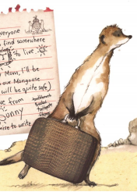

- Sunny’s suitcase weighs 3kg to start with.
He adds 2kg of scorpion snacks.
How heavy is his suitcase now?
Can you solve these missing number problems?
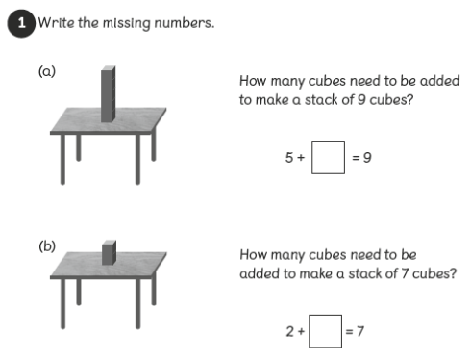
Count up from the first number to find the missing number.

