Year 1/2
Week beginning: Monday 8th June 2020 Summer term 2- Week 2 out of 7
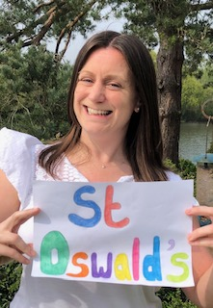 Hello wonderful Deer Class!
I hope you have all had a lovely weekend despite the windy, rainy weather!
If you have been having a go at the Wildlife Trust's 'Random acts of wildness' challenges this week then you will have probably looked up at the clouds on Tuesday to see what shapes you could see.
I thought I'd share my cloud picture with you that I saw through my bedroom window. Do you see Sunny the meerkat in my cloud too?
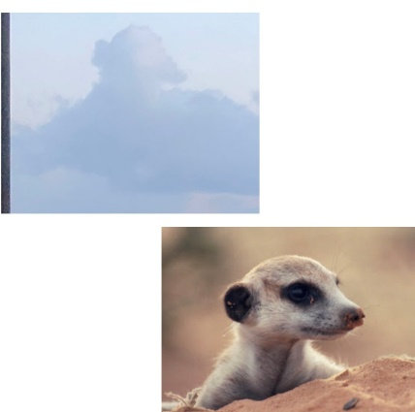

I hope you have enjoyed reading or listening to our book Meerkat Mail by Emily Gravett. We will continue to learn through this book over the next half term.
This week I have set you maths work (money week 2), writing (African mammal report/ fact file), science (mammals), geography (Describing Africa) and computing (money games).
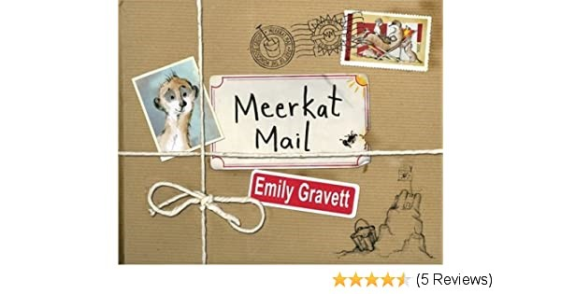
Have fun completing some of these activities and I look forward to seeing your work if you would like to share it!
Have a lovely week.
Missing you all lots!
Love from Miss Dutton x

Click here to enter online Purple Mash resources
Click here to enter Mathletics
Click here to enter TT Rockstars

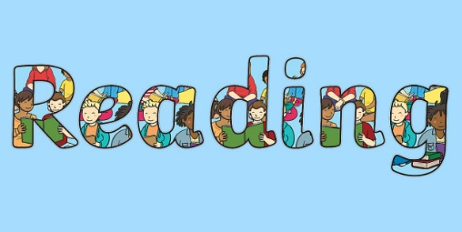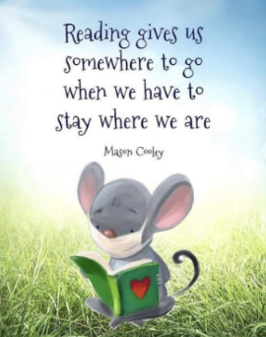
Use the link below to register on the Oxford Owls website. It is easy to set up the registration and it will give you access to a range of ebooks for ages 3-11.
Oxford Owl E Book Registration- link
See the files at the bottom of the page to find a 'Ronald the rhino' reading comprehension activity which has three levels of questions.
Try to read some or all of the story yourself or if it's a little tricky then get an adult to read it to you then answer the questions.

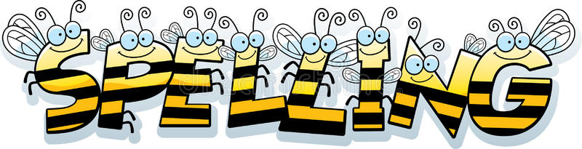
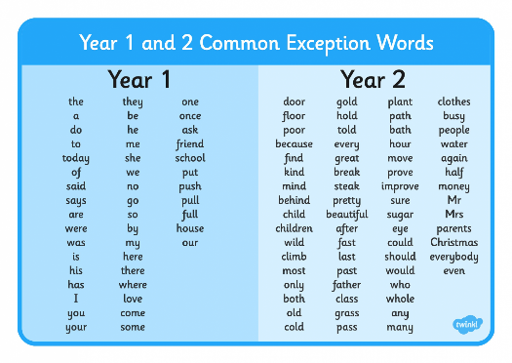
Reading and Spelling - It is really important that you can all read and write words with the sounds below. Keep practising them! Can you choose a sound and write 6 words for it. Try to learn to spell 5 common exception words each week too.
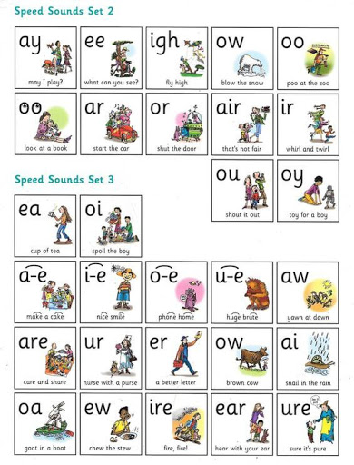

Year 1 children- Check you can spell these six words from the list above

do today said says are were

Year 2 children-
Learn to spell these 6 words that sound like they should start with a 'n' sound but actually start with 'kn'. In days gone by they would have pronounced the 'k' sound in these words!
4 of the words below are homophones (Words which have the same sound as another word but are spelled differently). Can you spot them?
knee knot know knew knock knight

The homophones are
not/knot (I am not sad/ I tie my laces in a knot)
no/ know (No thank you/ I know your name)
new/ knew (I had a new pen/ I knew your name)
night/ knight (I see stars at night time/ The brave knight defeated the dragon)

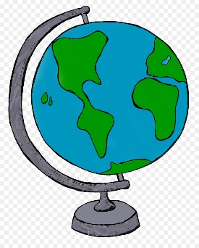
Geography
As geographers can I start to describe what the continent of Africa is like?
Can you remind yourself where Africa is on this world map
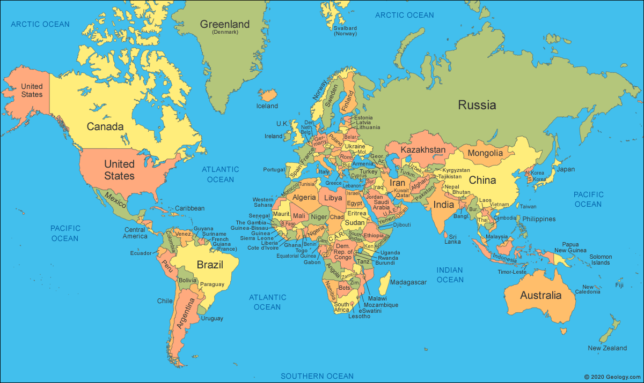

Challenge 1- Go through each of the photographs below. Which ones do you think were taken in Africa and which were not?
Explain your thinking each time to an adult.
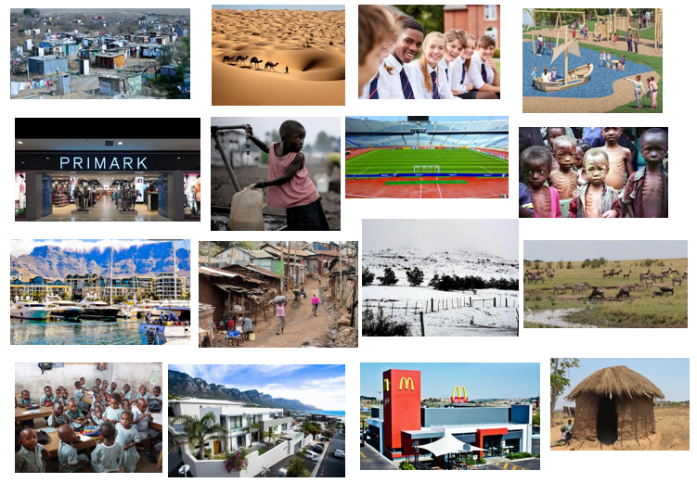

Do you think you've worked them all out?
Well, I may have tricked you a little bit because ALL of the photographs above were taken in Africa!
Africa is a very diverse continent, which means that just like the UK where we live there are many different places. There are cities and countryside, poor and rich places and people, busy and quiet places, warm and cold places.

We often picture Africa like these 4 photos below.
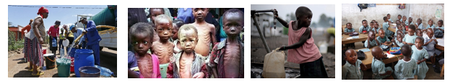
This is probably because the poorer parts of Africa are often on the news and we see photographs of children having to walk long distances to school or when people have no food or water because of the dry seasons when they is little rain.

This week we are going to learn about the African country of South Africa and choose our favourite part to sketch.
Remind yourself where South Africa is on our Africa map.
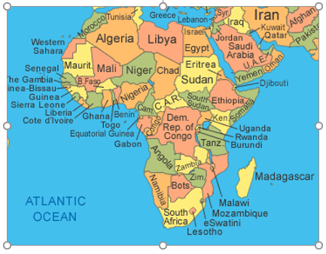
I was very lucky a few years years ago because I got the chance to go out to teach children in a South African school. I first thought that there would be wild animals like elephants and zebras all around me but I found that it was very different to my thoughts and I had to travel quite a long way to see any wild animals like those. I did see lots of sharks in the sea and cheeky baboons on land though!

The capital city of South Africa is Cape Town.
It is a very beautiful city and is famous for its mountain called 'Table mountain', its huge sports stadium and harbour by the sea with posh yachts, shops and restuarants. Can you spot any these on the two photos below?
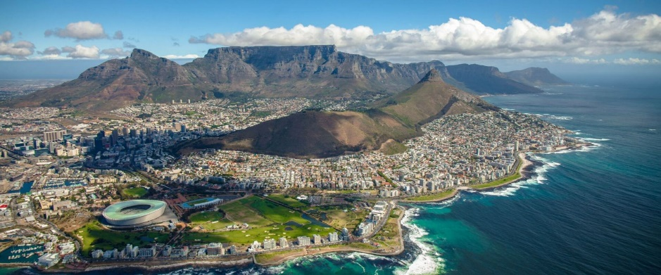
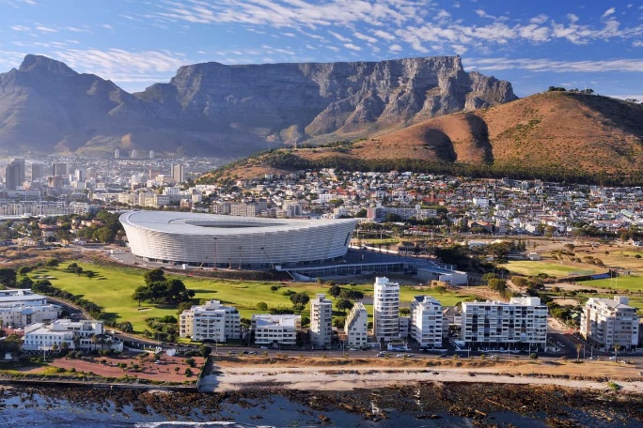
Here I am at the top of table mountain with 3 other teachers. We got to the top by cable car and it was very windy up there!

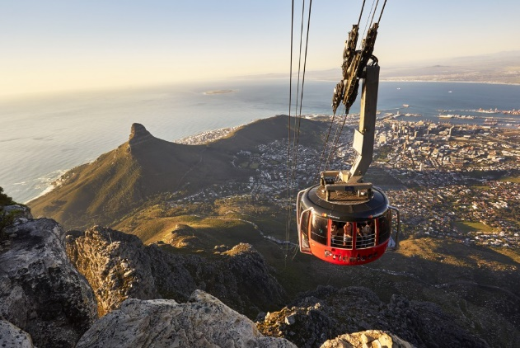
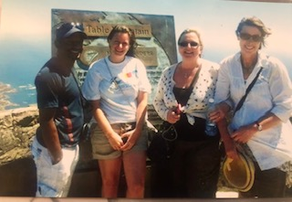

South Africa is very diverse.
It also has
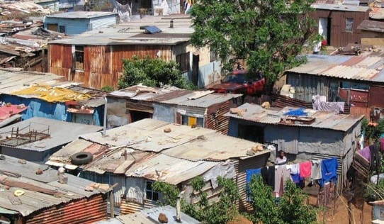
poor township areas where some people live

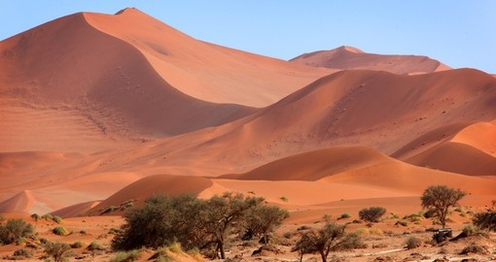
part of the Kalahari Desert (where Sunny lives)

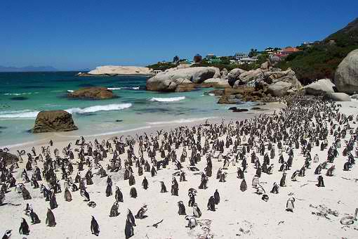
Boulders Bay penguin beach in Cape Town

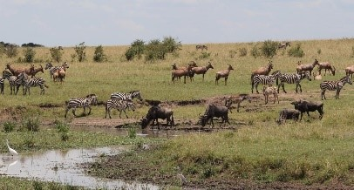
Kruger Park Game Reserve
(where you can go to see the wild African animals like lions, elephants, giraffes and leopards.)

I have marked some of these places on our South Africa map.

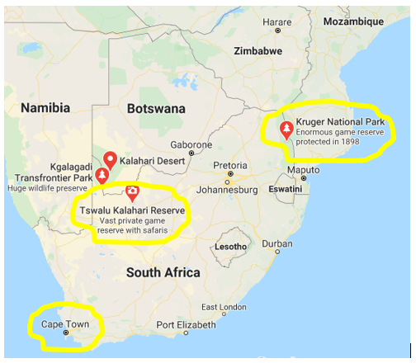
South Africa is amazing and I recommend a visit there one day!
Challenge 2- Now pick your favourite place/ places that you have heard about in South Africa and draw it using the pictures above to help you


Science
As scientists- Can you name some mammals and their characteristics?
So far in science we have learned about 3 types of animals- insects, birds and fish. You may found some of these amazing African animals below through your research project last week. They are quite different to the ones we get here in the UK. Can you point out the African insects, then the birds, then the fish in the collage below?
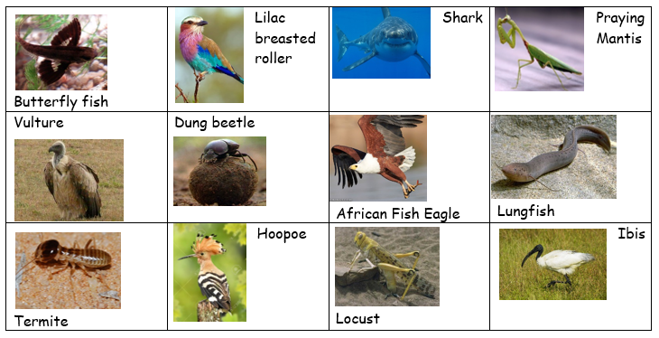
This week we are going to learn about another type of animal called mammals.
Sunny the meerkat and the cheeky jackal in our book are both mammals!
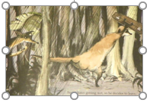
Some mammals are herbivores which means they eat plants.
Some mammals are carnivores which means they eat meat.
Some mammals are called omnivores which means they eat both plants and meat.

Challenge 1- Watch the video clip below and tell an adult about the characteristics of mammals.
Mammals -video clip https://www.youtube.com/watch?v=kACaok7DRlM

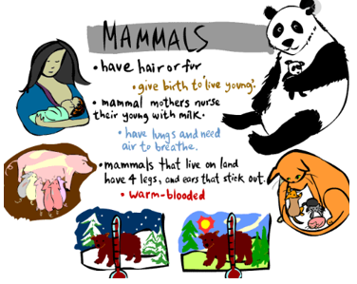
Challenge 2- Write your whole alphabet a-z down the side of a page of paper like this
Can you think of a mammal to write next to every letter? This is a big challenge and there may be a couple of letters you need to miss out!

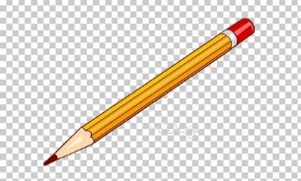
Writing
As writers- Can you write a report/ fact file about an African mammal?
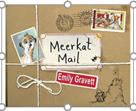 Meerkat Mail by Emily Gravett- videohttps://www.youtube.com/watch?v=7lEigAZpusI
This week I would like you to choose an African mammal of your choice to write a fact file about.
You could lay it out in this order with headings if you would like to

Title
Short introduction (maybe include the word mammal and herbivore, carnivore or omnivore)
What does it look like?
Where does it live?
What does it eat?
Ending (Maybe finish with a 'wow' fact using an exclamation mark or a 'Did you know...? sentence using a question mark)
Don't forget to use punctuation in sentences such as capital letters, full stops, commas, exclamation marks and question marks. Try to use interesting adjectives (describing words) and conjunctions (joining words) such as and, but, so, because, when, that, if, or
You may choose to write about meerkats if you love our main character Sunny in 'Meerkat Mail' or maybe a pick another mammal from the video below? Watch out for the 2 birds who pop up in the video though!
African animals -video clip https://www.youtube.com/watch?v=YCmHZWy6xS8
Click on the African mammals below to hear more information about them. If the animal that you want to write about is not here then why not try using 'Google' to find out about it?
Tip- Always put the two words 'for kids' at the end of your search words in Google and it should bring up child- friendly websites and information.
Meerkats 1- video https://www.youtube.com/watch?v=uIILtxz0pNw
Meerkats 2- video https://www.youtube.com/watch?v=W4og8g_X22o

Lions- video https://www.youtube.com/watch?v=PlwCtdiF0hI

Leopards- video https://www.youtube.com/watch?v=uxPMj-lq_aA

Elephants –video https://www.youtube.com/watch?v=CP5uJVpHrVw

Zebras –video https://www.youtube.com/watch?v=oLASCFh-JxQ

Giraffes –video https://www.youtube.com/watch?v=5aMASHwBaqc


Maths
* * * Please keep practising temperature, mass, capacity, time telling, adding, subtracting and counting in 2s, 3s, 5s and 10s to learn your times tables. There are also maths challenges for year 1 and year 2 in the files at the bottom of this page. * * *
As mathematicians- Can you find the total of a set of coins or notes by counting on from the largest amount?

Warm up- Practise counting in 2s, 5s and 10s. This will help with today's money work.
Have a go at counting in 20s- (20, 40, 60, 80, 100)

This is our second week of two on the topic of money.
Last week we learned that we can use coins and notes to pay for things. We learned that we use the units pence (p) and pounds (£) when talking about money.
There are 100 pennies in one pound.
Did you know that two 50p coins make £1.00?
* Can you work out how many 10p coins make £1.00? (Count up in 10s to 100)

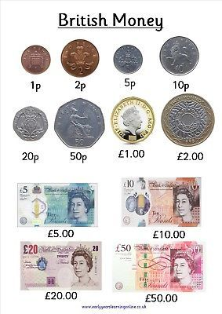

This week we are going to count up sets of coins or notes to find a total.
It is easiest if we start by counting on from the largest amount like this.
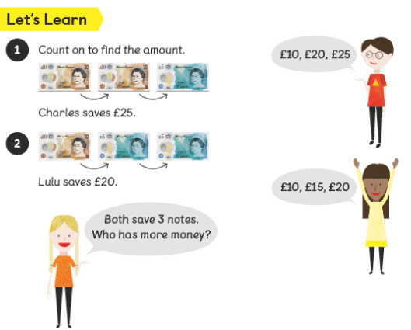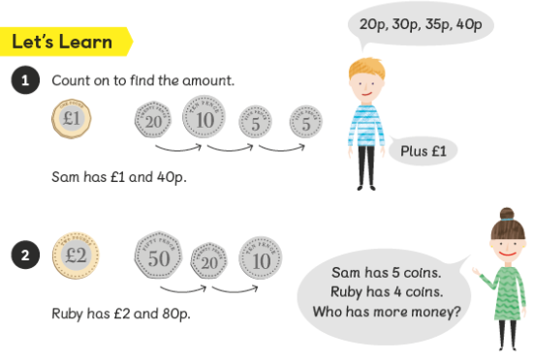
Challenge 1- Can you find different ways of making 10p using these coins?
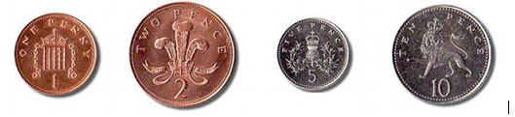
( If you found this activity easy then have a go at different ways of making 20p or 50p)
Challenge 2- Can you count up money totals?
Have a go at one or all of the worksheets below. Start with number 1.
Maybe an adult at home could give you some real life coins or notes to count up or a total to make using the coins!
1.Counting money in pence- easier

2.Counting money in pence- harder

3.Year 2- Counting money in pounds and pence

4.Coin word problems


Computing- In computing can I play money games?
I have set you some 'to do' money games on Purple Mash again this week making totals up to 50p.
If you would like to have a go at easier or harder games then search for 'Money' on Purple Mash and click on 'Maths through money'. Here you will find lots of different games to try.
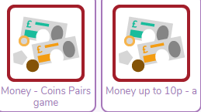
Have fun!

