Counting pence harder
If you write the answers down then don’t forget to record your answers using the pence (p) sign.
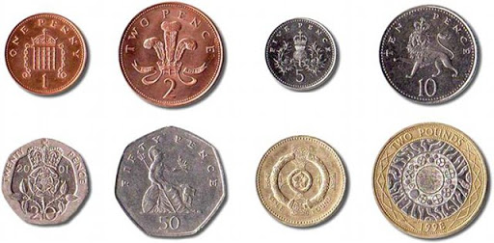
1.
2.
3.
4.
5.
6.
6.
7.
8

