Counting pence
It might help to tap on the coin one time for 1p and 2 times for 2p as you count them.
If you write the answers down then don’t forget to record your answers using the pence (p) sign.
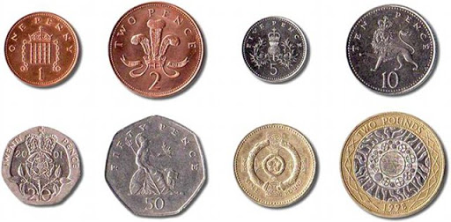
1.
2.
3.
4.
5.
6.

6.
7.
8

