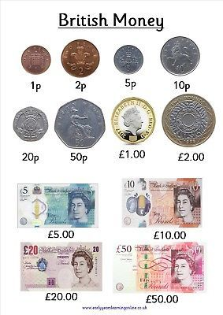
- How many British coins are there?

- How many of our coins are

- copper coloured?
- silver?
- gold and silver?
- heptagons (7 sided)

- Which coin is worth the smallest amount?

- Which coin is worth the greatest amount?

- Would you rather be given 50 pence or 20 pence?

- Would you rather have 10p or £10.00?

- Can you write out the coins in order from smallest amount to greatest amount? You could order real coins if you have any at home.

We can use the 9 coins and 4 notes above to make other money amounts.

Which 2 from above would you use to make these amounts?

- 3 pence G. 15 pence

- 4 pence H. 21 pence

- 6 pence I. 52 pence

- 7 pence J. £1.10

- 11 pence K. £2.50

- 12 pence L. £30.00

