Year 1/2
Week beginning: Monday 18th May 2020 Summer term 1- Week 5 out of 5
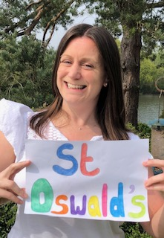 Hello fabulous Deer Class!
We have one more week learning together online until the May holiday when you all get a whole week off!
You will definitely deserve the break after all of the hard work you have been doing!
I am very proud of you all!
I spotted this baby bird yesterday. Can you guess what type of chick it is? I had to look it up...
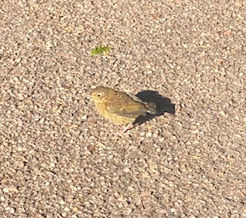
Answer- It's a robin chick that hasn't grown his red tummy feathers yet.

This week you are going to learn all about fish.
On my walks I have seen lots of fish jumping in the River Dee near to where I live in Chester. Apparently it means they are being chased by bigger fish!
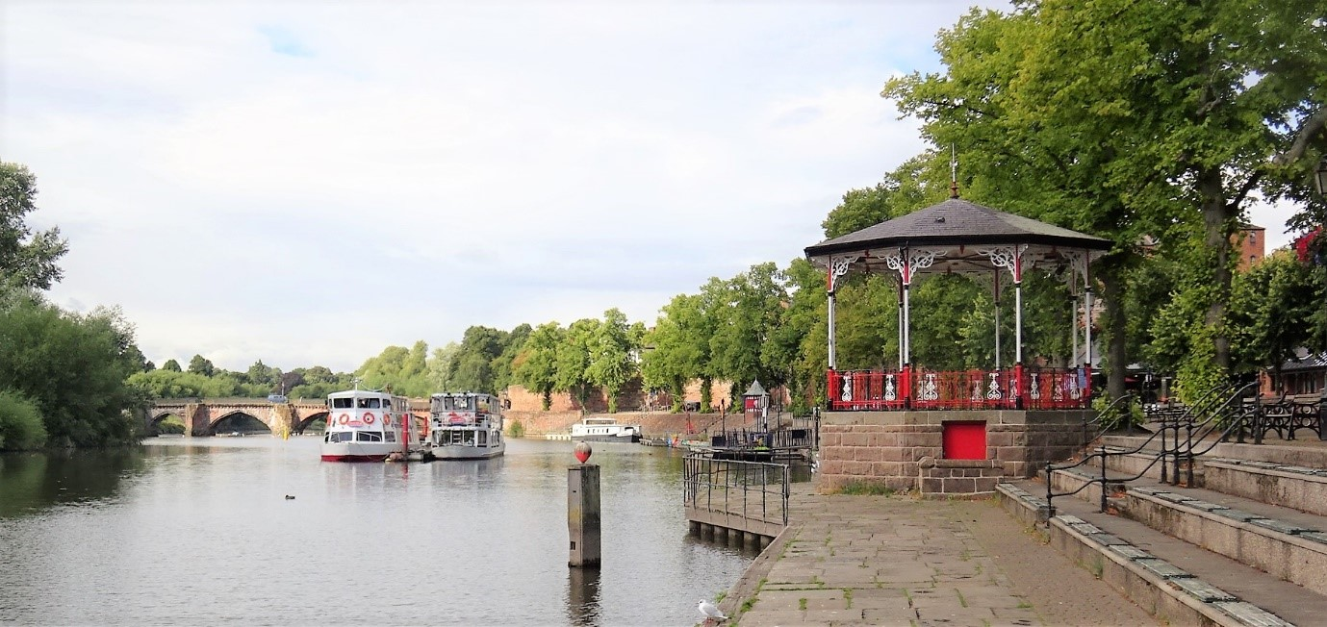
You can see them in the video below!
Fish Jumping
Also my mum and dad sent me a video of the koi fish and goldfish in their pond for you to see. Click on the link below to see them swimming in the sunshine.
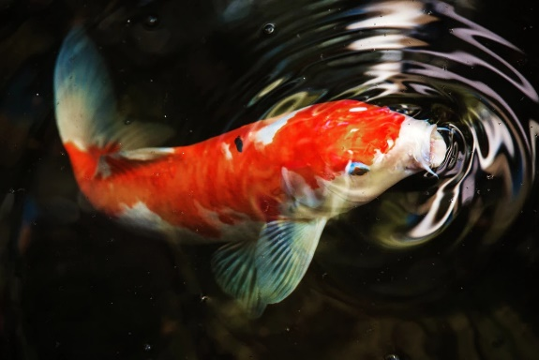 Koi
What do you already know about fish?

This week I have set maths work (temperature), science (fish and their characteristics), writing (Rainbow Fish character description), art (create your own Rainbow Fish) and computing (counting game and fish design).

Have fun completing some of these activities and I look forward to seeing your work if you would like to share it!

Missing you all lots!

Love from Miss Dutton x

Click here to enter online Purple Mash resources
Click here to enter Mathletics
Click here to enter TT Rockstars

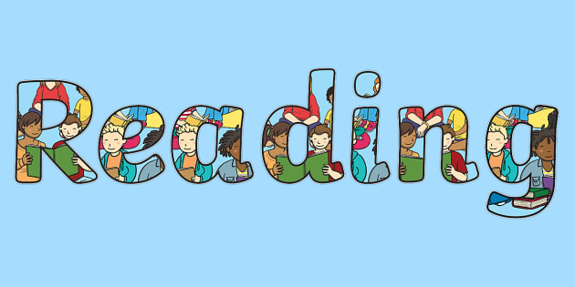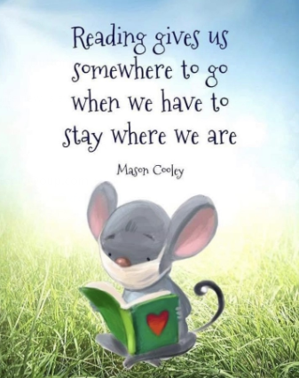
Use the link below to register on the Oxford Owls website. It is easy to set up the registration and it will give you access to a range of ebooks for ages 3-11.
Oxford Owl E Book Registration- link

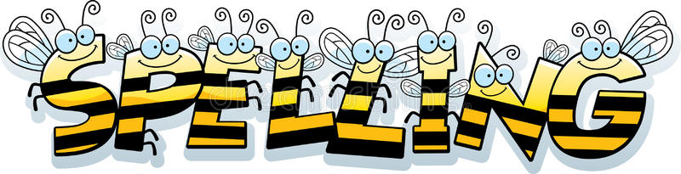
Reading and Spelling - It is really important that you can all read and write words with the sounds below. Keep practising them! Can you choose a sound and write 6 words for it. Try to learn to spell 5 common exception words each week too. 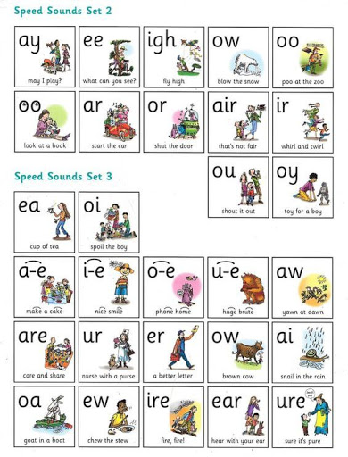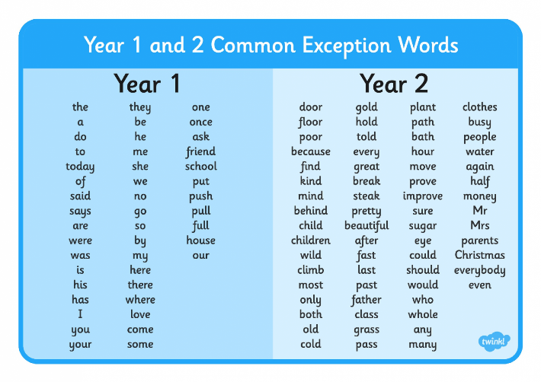

Year 2 children- Can you learn these next 5 homophones?
Homophones are words which sound the same but look different.
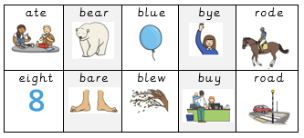
Can you think of any other words which are homophones?

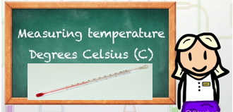
Maths
* * * Please keep practising mass, capacity, time telling, adding, subtracting and counting in 2s, 3s, 5s and 10s to learn your times tables. There are also maths challenges for year 1 and year 2 in the files at the bottom of this page. * * *
As mathematicians- Can you estimate and read temperatures?
Can you remember how we measured the capacity and mass of objects and what the units of measure were called? (measuring jug- mililitres and litres, weighing scales- grams and kiligrams)

This week we will be learning about measuring temperature.

Maybe you have got a thermometer a bit like one of these at home?
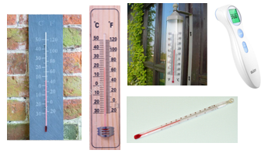
A thermometer measures temperature which is how hot or cold something is. Can you spot the thermometer that we use to measure our body temperature?
We measure temperature using the unit degrees celcius
or it is more simply written like this...
The internet and mobile phones are very clever as they can tell us the temperature too. This is what my phone and the internet says about the weather and temperature right now in Chester where I live.
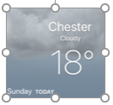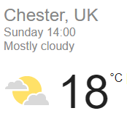
I have just eaten my lunch outside so 18 is quite warm.
Our hottest day in the UK last summer was 35!
The kettle in your house boils at 100 and this is so hot that it would burn us.
In the winter our UK temperature can drop down to 0and even below zero!
This is called 'freezing' and when we reach this temperature we can get snow and ice.

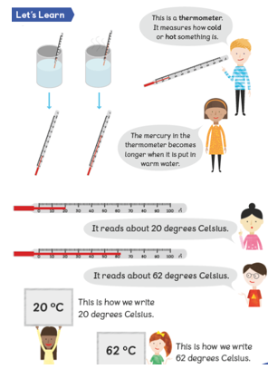
Activity 1: This is the weather and temperature forecast on my mobile phone for the week ahead in Chester. Can you answer my questions?
1. Which day is meant to be the warmest?
2. Which day is meant to be the coolest?
3. Which day should it be 22
4. What is the weather meant to be like on the coolest day?
5. How many degrees warmer is it meant to be on Wednesday than Tuesday?
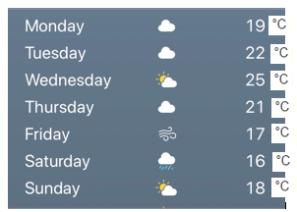

Activity 2: Can you keep your own weather and temperature diary for where you live this week?
Each day write down the name of the day, draw a picture of the weather and then find the temperature by using a thermometer you may have, using a mobile phone or the internet.

Activity 3: Can you estimate (make a guess) the temperature for each season below?
Remember 0 is freezing and our hottest day last summer was 35.
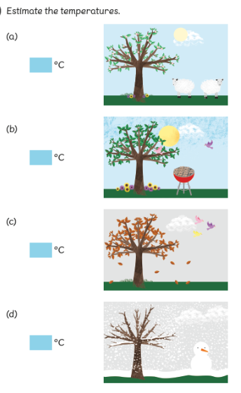
Activity 4: Click on the link below to have a go at reading temperatures from thermometers.
Temperature worksheet

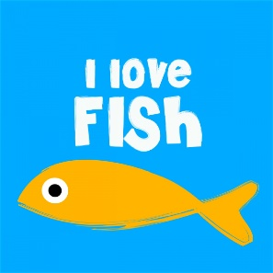
Science
As scientists- Can you name the characteristics of fish?

Over the last couple of weeks we have learned about two groups of animals- insects and birds.
This week we are going to learn about fish.
Insects have 6 legs, birds have 2 legs- How many legs do fish have?
Challenge 1- Watch the video clip below and then explain to an adult the characteristics of fish.

All about fish - Video clip

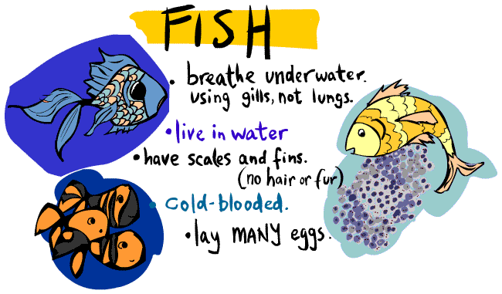
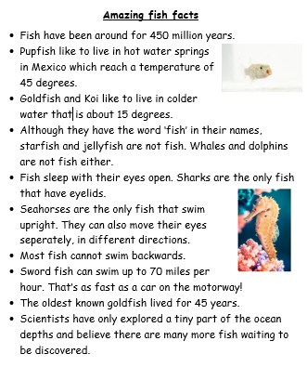
Challenge 2- Draw your own diagram of a fish and label it using the words below
fin tail gill scales
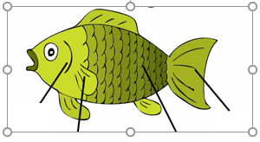

 Writing

As writers- Can you write a description of Rainbow Fish?
One of my favourite books is 'The Rainbow Fish' by Marcus Pfister because it is about being kind and sharing.
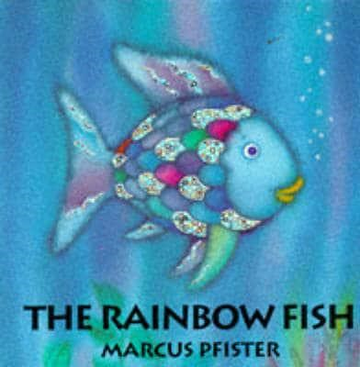
Listen to the story below.
The Rainbow Fish -Video clip

Can you write a character description for Rainbow Fish?
Start by writing some interesting adjectives (describing words) for
* what he looks like
* where he lives
* what kind of character he is- remember that his character changes at the end of the story.
Then put your adjectives into sentences about him.
Challenge- Try to start your sentences in different ways instead of writing 'Rainbow fish...' at the start of every sentence.
Don't forget to use punctuation such as capital letters, full stops, commas, question marks and exclamation marks in your writing.
Try to use adjectives (describing words) and maybe some of the following conjuctions to join any sentences you write - and, but, so, because, that, when, if, or


Art/ design
As an artist and designer- Can you create your own Rainbow Fish?
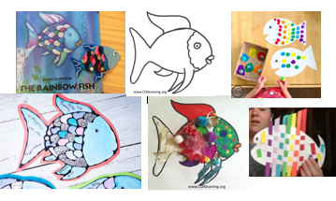
Have a go at creating your own Rainbow fish with beautiful scales. You may even find a way to give him some shiny scales. Tin foil is always good as a shiny material.
Have fun and be creative! Anything goes!


Computing- In computing I can work out how to play a game and create my own design.
This week I have set 2 'To dos' on Purple Mash. These are a quick paced counting game and a design your own fish activity.
Have fun!
