YEARS 5/6 DOJO HOMEWORK – SUMMER HALF TERM 2
Homework activities for this term are outlined below.
You will receive ‘Dojo Points’ for each task completed and at the end of term; your homework will be displayed in the hall for everyone to see.
If you complete all of the tasks, you will receive a homework celebration certificate and a bonus 10 dojo points!
All tasks need to be completed and returned by Tuesday 14th July.
HOMEWORK TASKS WORTH 1 DOJO POINT | HOMEWORK TASKS WORTH 3 DOJO POINTS | HOMEWORK TASKS WORTH 5 DOJO POINTS
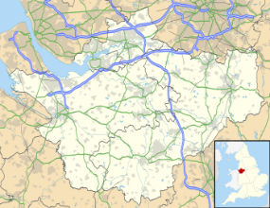  Geography: Have a look at the county of Cheshire. Name the main towns and cities. | 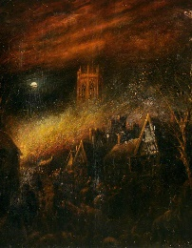  English: Write a diary entry from the night of the fire of Nantwich. What was it like being there? | 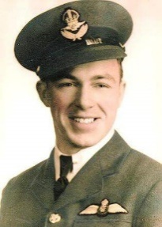  English: Who was Lieutenant Arthur Brown? Why was he important in Nantwich history? Write a newspaper report about the pilot.
Maths: Explore the populations of Nantwich, Crewe, Chester, Northwich, Worleston and Tarporley. | 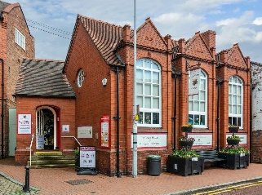  History/DT: Nantwich Museum wants to celebrate its past. Can you create a sculpture the represents the people who live in the town now and those who have lived there in the past? | 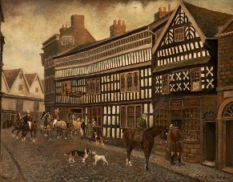  Art: Explore the work of the artist Herbert St John Jones. Have a go at creating your own artwork taking inspiration from his.

