YEARS 1/2 DOJO HOMEWORK – SUMMER HALF TERM 2
Homework activities for this term are outlined below.
You will receive ‘Dojo Points’ for each task completed and at the end of term; your homework will be displayed in the hall for everyone to see.
If you complete all of the tasks, you will receive a homework celebration certificate and a bonus 10 dojo points!
All tasks need to be completed and returned by Tuesday 14th July.
HOMEWORK TASKS WORTH 1 DOJO POINT | HOMEWORK TASKS WORTH 3 DOJO POINTS | HOMEWORK TASKS WORTH 5 DOJO POINTS
Maths: Create as many number bonds to ten using the bus below. How many different combinations can you find?  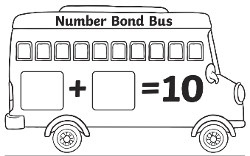 | 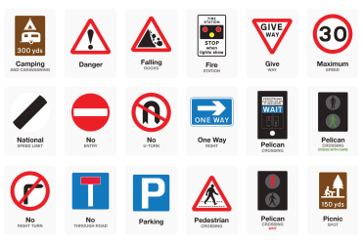  Geography: Are you off on a journey? Or even coming to school? Make a list of all the signs you pass. Do you know what any of them mean? |   Geography: Create your own journey and map for Naughty Bus. Where in the world did Naughty Bus end up?
  Purplemash: Have some fun on Purplemash using the ‘Simple City Garage’ game. Create your own transport and fix cars in the garage. |   English: Imagine you are Naughty Bus and you have arrived in London. Write a postcard from London home. |   DT: Can you create a fun healthy snack based on what you have been doing in class?

