YEARS 5/ 6 DOJO HOMEWORK – SUMMER HALF TERM 1
Homework activities for this term are outlined below.
You will receive ‘Dojo Points’ for each task completed and at the end of term; your homework will be displayed in the hall for everyone to see.
If you complete all of the tasks, you will receive a homework celebration certificate and a bonus 10 dojo points!
All tasks need to be completed and returned by Thursday 23rd May.
HOMEWORK TASKS WORTH 1 DOJO POINT | HOMEWORK TASKS WORTH 3 DOJO POINTS | HOMEWORK TASKS WORTH 5 DOJO POINTS
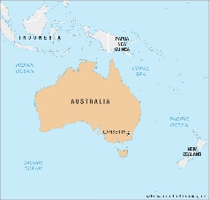  Maths: Explore the main cities of Australia. Place them in order of population from largest to smallest. | English: Write a non-chronological report on an Australian animal of your choice.  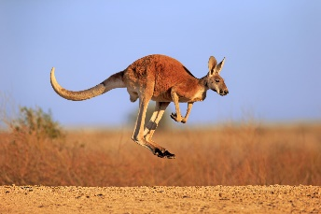 |   English: Explore the life of Cathy Freeman. Write a biography all about her and her accomplishments.
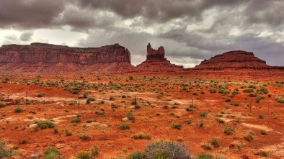  Geography: Name and locate the four main deserts of Australia. | 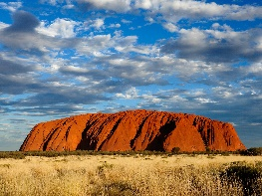  History: What is Uluru and why is it so important? Find out where it is in Australia and why it is so significant. | 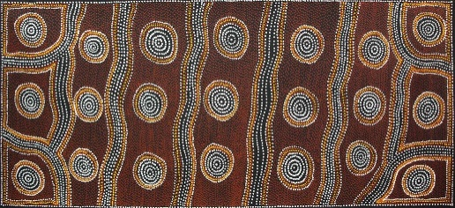  Art: Fancy something with a lot of detail. Explore Australian dot paintings and have a go at creating your own.

