YEARS 5 / 6 DOJO HOMEWORK – SPRING HALF TERM 2
Homework activities for this term are outlined below.
You will receive ‘Dojo Points’ for each task completed and at the end of term; your homework will be displayed in the hall for everyone to see.
If you complete all of the tasks, you will receive a homework celebration certificate and a bonus 10 dojo points!
All tasks need to be completed and returned by Monday 23rd March 2026.
HOMEWORK TASKS WORTH 1 DOJO POINT | HOMEWORK TASKS WORTH 3 DOJO POINTS | HOMEWORK TASKS WORTH 5 DOJO POINTS
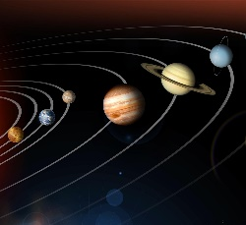  Maths: How far away is each planet from the sun? Create a diagram showing where each planet in the solar system is and how far away they are from the moon. |   English: Explore the astronaut Tim Peaks. How did he find his time out in Space? Write a non-chronological report about him. | 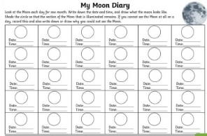  Science: Create a moon diary for a month. What does the moon look like each day? Have you spotted any patterns?
  Computing: Use purple mash to undertake a planet quiz. On purple mash look up ‘planets database quiz’ and test your knowledge. | 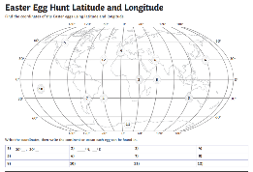  Geography: Test your knowledge of latitude and longitude to find the hidden Easter eggs. | 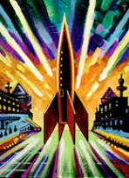  Art: Explore space art by Peter Thorpe. Consider how he uses colour and bold lines to create effect. Then, have a go at making your own.

Reading:
WORTH 5 DOJO POINTS Write a book review of your favourite book, or a book you have recently read It can include who your favourite character was and why, marks out of 10 or a star rating. Give your opinion on the book using phrases including ‘because’, ‘in my opinion’ and ‘I think that’. As a class, we can add our book reviews to our reading area!

