YEARS 5 / 6 DOJO HOMEWORK – SPRING HALF TERM 1
Homework activities for this term are outlined below.
You will receive ‘Dojo Points’ for each task completed and at the end of term your homework will be displayed in the hall for everyone to see.
If you complete all the tasks, you will receive a homework celebration certificate and a bonus 10 Dojo points!
All tasks need to be completed and returned by Monday 9th February, and the Dojo showcase will be held on Wednesday 11th February*.
*This will be confirmed via Dojo nearer the time.
HOMEWORK TASKS WORTH 1 DOJO  POINT | HOMEWORK TASKS WORTH 3 DOJO  POINTS | HOMEWORK TASKS WORTH 5 DOJO  POINTS
Maths: Can you crack the Viking ruins? Have a go at the ruins below which will also help you learn more about the Norse gods.  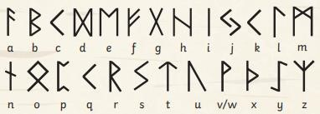 | 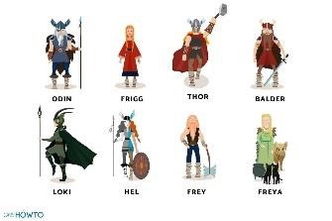  English: Explore the Norse Gods. Why were they important? Have a go at creating your own and describing them. | English: Lindisfarne is under attack! Imagine that you are there watching.  Write a short narrative about what you can see and how you escaped.  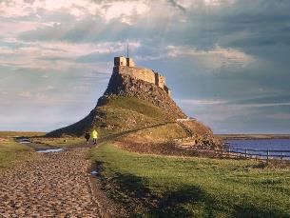
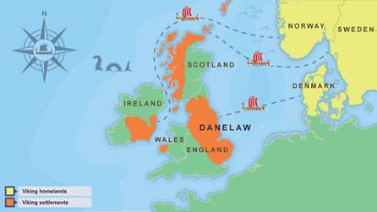  Geography: Where did the Vikings settle in the UK? Are there still traces of them there? Have a look at Viking settlements in the UK. You may even want to look at place names. | Art: Viking longboats were impressive vessels to be proud of. Can you draw/paint one considering your line work and detail for the waves?   | 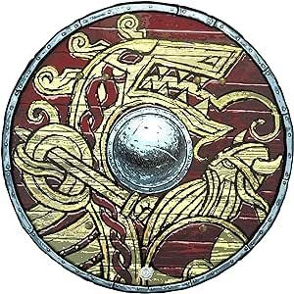  DT: Get creative! Create your own Viking shield. Consider the colours and designs that they would have used. Be ready for battle.
