
RCSAT Relationships, Sex and Health Education (RSHE)
Long Term Provision

 | Autumn Term | Spring Term | Summer Term
 | The Right to be Me  British Value: Individual Liberty  Articles: 7,12,13,15 | The Right to Learn  British Value: Democracy  Articles: 28,29,31 | The Right to be Safe and Healthy  British Value: Mutual Respect and Tolerance  Articles: 16,17,19,24,27
 | Heartsmart - Weekly  No Outsiders enhanced with P4C | Heartsmart – Weekly  Christopher Winters – SRE | Heartsmart - Weekly  No Outsiders enhanced with P4C
EYFS | NSPCC My Pants Are Private  Table Manners including how to use a knife and fork  Hand washing, coughing and sneezing – good practise  Dental visit
Y1&2 | BRAKE BEEP BEEP - Road Safety www.brake.org.uk  Countryside Code  School Nurse – Hygiene, Dental Health  School Grounds project
Y3&4 | Water Safety - Canal/River/Swimming Pool  Community Environment Project  Railway Safety  Enterprise Project
Y5&6 | Fire - Smoke Busters visit  Bikeability – Level 1 & Level 2 (Repeat in Y6 if they don’t meet the required standard)  Environmental Project  Fire and personal safety - Safety Central Visit  First Aid Training  Council, MP or Parliament Visit  Barclays Money Skills Project  Puberty
Whole School | Sports Champions  PCSO Visits and NSPCC Talks  School Council, Ethos and Eco Council Events  Countryside Code & Community Events  Change 4 Life Days
Online Safety covered as part of our Computing Curriculum (Purple Mash Scheme of Work)
Heartsmart – Mental Health & Resilience
It equips our children with foundational principles, skills, habits and a mind-set which will improve their mental health, relationships and academic achievement.
Theme | Autumn 1 | Autumn 2 | Spring 1 | Spring 2 | Summer 1 | Summer 2
Theme | Get Heartsmart! | Don’t Forget  to Let Love In! | Too Much Selfie  Isn’t Healthy! | Don’t Rub it in,  Rub It Out! | Fake Is a Mistake! | No Way Through  Isn’t True!
Y1 | A1, B8, B10, C5 | AC, B4, B8, C5 | A3, B3, B9, C5 | A1, B6, C5 | A1, B4, C2, 5 | A2, B6, C2, C5
Y2 | B3, B6, C1, C4 | B6a, B9, C2, C3 | B3, B6, C3, C7 | B1, B9, C1 | B3, B8, C4 | B3, B9, C4a, C7
Y3 | A2, B4, C7 | A2, B5, B10, C1 | A2, B2, B5, B10 | A2, B4, C3 | A2, B6, C1 | A1, B5, B10
Y4 | B2, B7, C3 | B1, B7, B10, C6 | B2, B8, C2, C4 | B2, B7, C7 | B2, B9, C6 | B2, B7, C1, C4b
Y5 | A3, B5, C2 | A1, B3, B8, C7 | A1, B4, C1 | A3, B5, C2, C4 | A3, B5, C7 | A3, B4, C3,
Y6 | B1, B9, C6 | B2, B3, B6b, C4 | B1, B7, C6 | B3, B8, B10, C6 | B1, B7, B10, C3 | B1, B8, C6  
All | Plenary - Unit D to be included with every theme of work
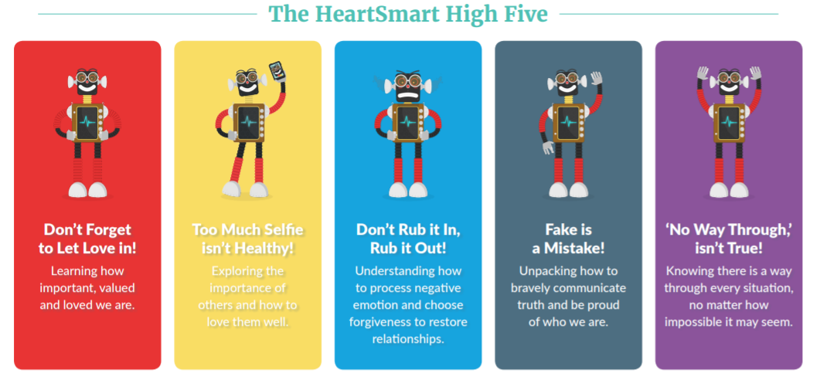

No Outsider In Our School – Everyone is welcome in our school.
Ensuring our children are excited about living in a community full of difference and diversity.
R | 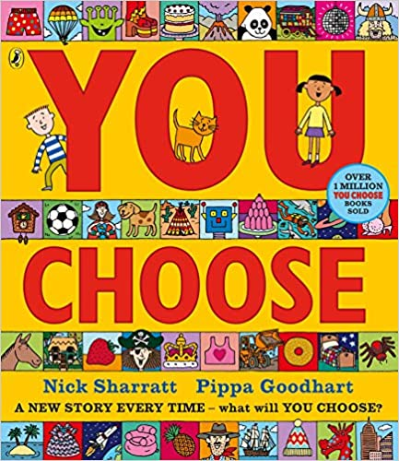 |  | 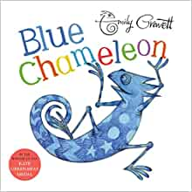 | 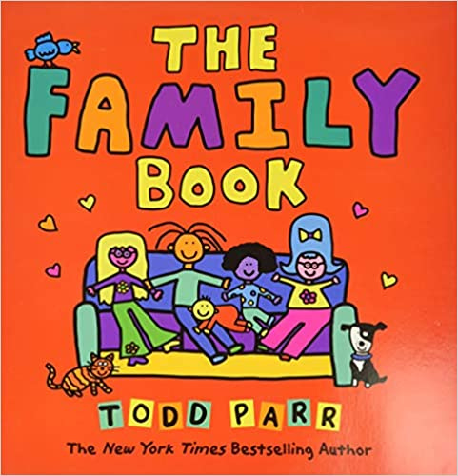 | 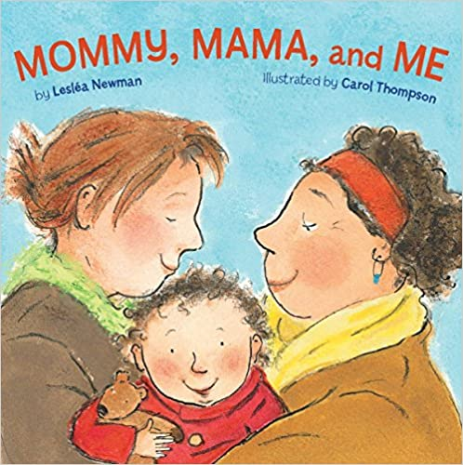
R | Learning Intention: To say what I think. | Learning Intention: To understand that it’s okay to like different things. | Learning Intention: To make friends with different people. | Learning Intention: To understand that all families are different. | Learning Intention: To celebrate my family.
Y1  (A) | 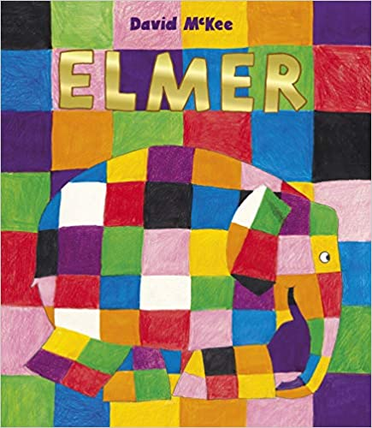 | 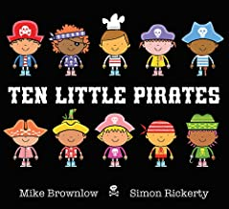 | 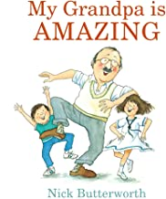 | 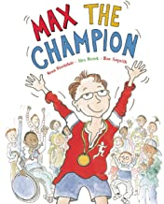 | 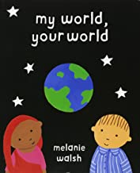
Y1  (A) | Learning Intention: To like the way I am. | Learning Intention: To play with boys and girls. | Learning Intention: To recognise that people are different ages. | Learning Intention: To understand that our bodies work in different ways. | Learning Intention: To understand that we share the world with lots of people.
Y2  (B) | 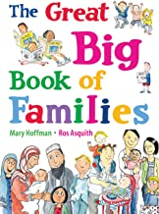 | 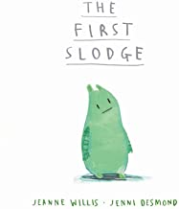 | 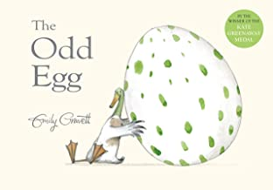 | 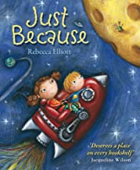 | 
Y2  (B) | Learning Intention: To understand what diversity is. | Learning Intention: To understand how we share the world. | Learning Intention: To understand what makes someone feel proud. | Learning Intention: To feel proud of being different. | Learning Intention: To be able to work with everyone in my class.
No Outsider In Our School – Everyone is welcome in our school.
Ensuring our children are excited about living in a community full of difference and diversity.
Y3  (A) | 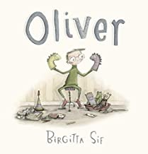 | 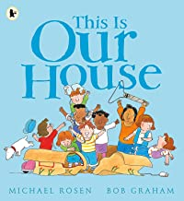 | 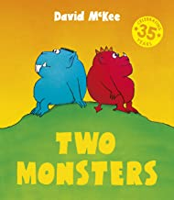 | 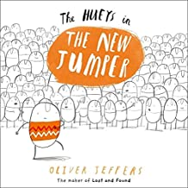 | 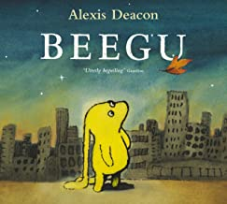
Y3  (A) | Learning Intention: To understand how differences can affect someone. | Learning Intention: To understand what ‘discrimination’ means. | Learning Intention: To find a solution to a problem. | Learning Intention: Use strategies to help someone who feels different. | Learning Intention: To be welcoming.
Y4  (B) | 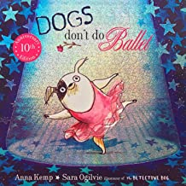 | 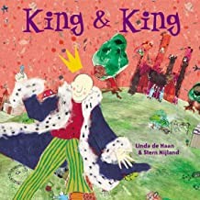 | 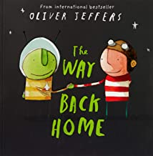 | 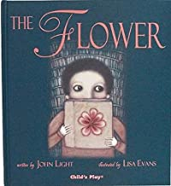 | 
Y4  (B) | Learning Intention: To know when to be assertive. | Learning Intention: To understand why people choose to get married. | Learning Intention: To overcome language as a barrier. | Learning Intention: To ask questions. | Learning Intention: To be who you want to be.
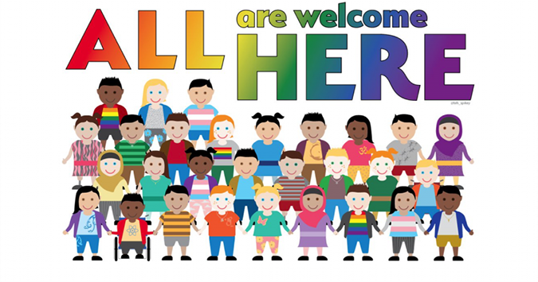
No Outsider In Our School
Ensuring our children are excited about living in a community full of difference and diversity.
Y5 |  |  | 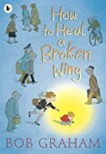 |  | 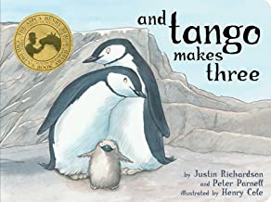
Y5 | Learning Intention: To learn from the past. | Learning Intention: To justify my actions. | Learning Intention: To recognise when someone needs help. | Learning Intention: To appreciate artistic freedom. | Learning Intention: To accept people who are different from me.
Y6 | 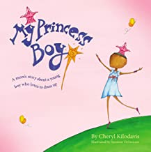 | 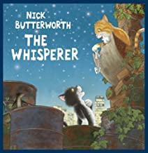 | 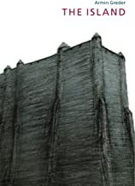 |  | 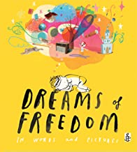
Y6 | Learning Intention: To promote diversity. | Learning Intention: To stand up to discrimination. | Learning Intention: To challenge the cause of racism. | Learning Intention: To consider how my life may change when I grow up. | Learning Intention: To recognise freedom.

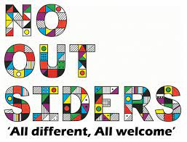

Sex & Relationships Education
Christopher Winters Programme 2019
R | Theme: Family and Friends  To recognise the importance of friendship  To recognise the importance of saying sorry and forgiveness  To recognise that all families are different
1/2 | Theme: Growing & Caring For Ourselves  To understand that we are all different but can still be friends  To discuss how children grow and change  To explore different types of families and who to ask for help  To identify who can help when families make us feel unhappy or unsafe  Theme: Differences  To introduce the concept of gender stereotypes  To identify differences between males and females  To explore some of the differences between males and females and to understand how this is part of the lifecycle
3/4 | Theme: Valuing Differences & Keeping Safe  To identify that people are unique and to respect those differences  To explore the differences between male and female bodies  To consider appropriate and inappropriate physical contact and consent  To explore different types of families and who to go to for help and support  Theme: Growing Up  To explore the human lifecycle  To identify some basic facts about puberty  To explore how puberty is linked to reproduction  To explore respect in a range of relationships  To discuss the characteristics of healthy relationships
5/6 | Theme: Puberty  To explore the emotional and physical changes occurring in puberty  To understand male and female puberty changes in more detail  To explore the impact of puberty on the body and the importance of physical hygiene  To explore ways to get support during puberty  Theme: Puberty, Relationships & Reproduction  To consider puberty and reproduction  Exploring the importance of communication and respect in relationships  To consider different ways people might start a family  To explore positive and negative ways of communicating in a relationship
