YEARS 3 / 4 DOJO HOMEWORK – Autumn Half Term 1
Homework activities for this term are outlined below.
You will receive ‘Dojo Points’ for each task completed and at the end of the half term; your homework will be displayed in class for everyone to see.
If you complete all of the tasks, you will receive a homework celebration certificate and a bonus 10 dojo points!
All tasks need to be completed and returned by Wednesday 23rd October.
HOMEWORK TASKS WORTH 1 DOJO POINT | HOMEWORK TASKS WORTH 3 DOJO POINTS | HOMEWORK TASKS WORTH 5 DOJO POINTS
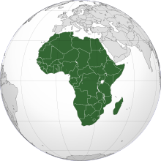  Geography: Create a list of as many countries in Africa as you can. See if you can find any capital cities too. | 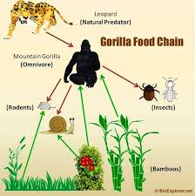  Science: Create a life cycle for a gorilla. Are they herbivores, carnivores or omnivores? | English: Write a fact file all about another animal found in the Congo rainforest.  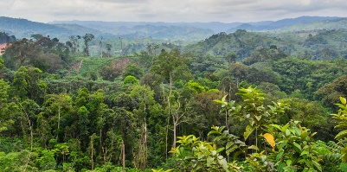
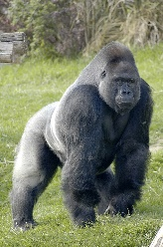  English: Write 5 Noun phrases all about gorillas. Eg. They have dark, thick fur. | Art: Have a go at sketching a gorilla. Consider how you could use shading.  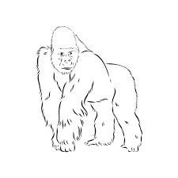 | 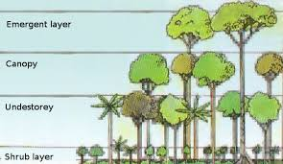  Art: Create a piece of artwork showing the different layers of the rainforest and the animals found there.

