As Sports People we will be
refining movement skills, and developing our agility, balance, coordination and spatial awareness skills. We will also be developing our ball skills, learning to control balls with our hands and feet.

As Scientists we will
Be looking at living things and how they are suited to their environments. We will be identifying plants and animals that live in different regions. We will be sorting them into different groups before looking at why it is the perfect environment for them. Finally, we will be looking on a micro scale and exploring some of the micro-habitats we have in school.
As Geographers we will
Be exploring the United Kingdom. We will start by looking at the world as a whole and exploring maps and atlases. We will be identifying the 7 continents and 5 oceans. Afterwards, we will be delving deeper into the United Kingdom. We will be locating the UK on a range of maps and identifying some of its key physical features. Finally, we will be looking at the four countries of the United Kingdom. We will be naming their capital cities and be exploring some of the key features.
As Mathematicians we will
Explore place value within 20, learning to recognise, represent and compare numbers, and understand the value of numbers 0-20. We will then build on this knowledge through addition and subtraction within 20, using practical resources and pictures to solve calculations and simple problems. We will develop our fluency, reasoning and problem-solving skills while becoming more confident with numbers.

St Oswald’s Primary School, Worleston

Year group:1/2 Term: Autumn Half term 1 Topic: Where we live

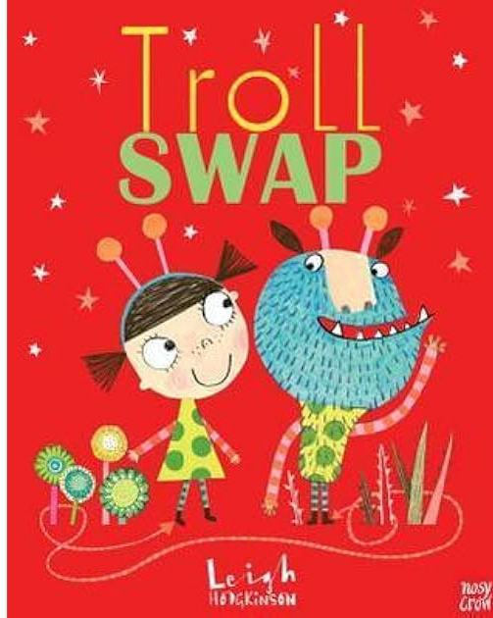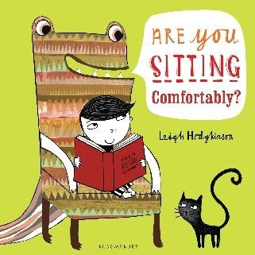

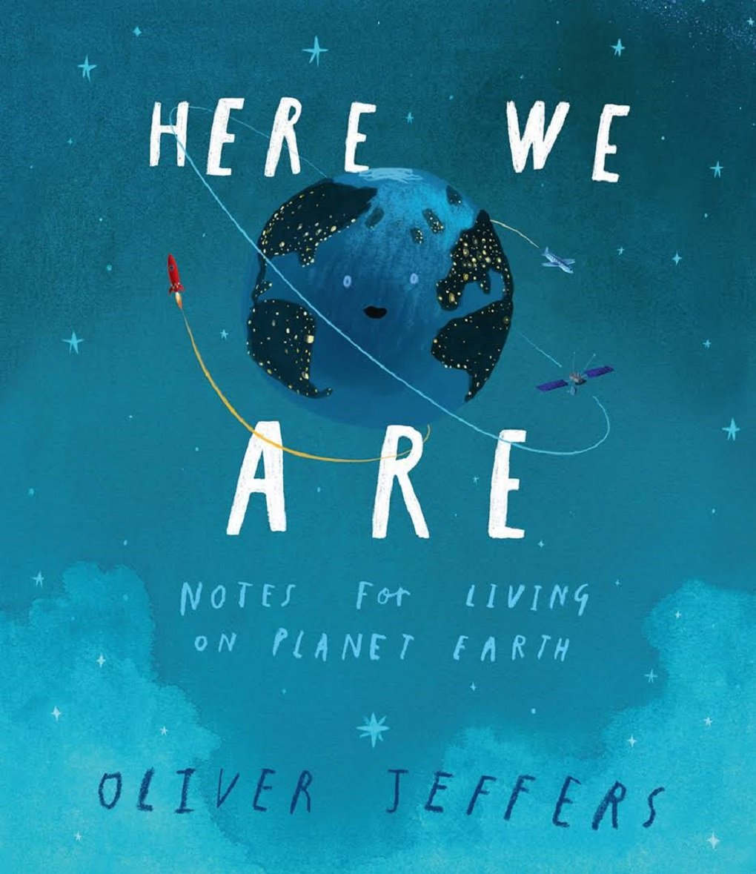
As Writers we will
Begin to learn about basic grammar through the Grammarsaurus scheme. We will learn to identify and use common nouns, proper nouns and verbs while beginning to understand how these word types work together. We will also practise building sentences, developing vocabulary and confidence in using grammar accurately in our speaking and writing.

As Designers we will
Be learning about bread and how it can be made and eaten as part of a healthy, balanced diet. We will explore a variety of different breads and discuss their purpose. Then, we will follow food hygiene rules to design, make and evaluate our own homemade bread.

In Religious Education we will
Explore how Harvest is celebrated in the Christian and Jewish faiths, and consider how we can help those who do not have a good Harvest.

In Computing we will
Learn about digital art creation, using the programme ‘2Paint a Picture’ We will explore the digital art tool to recreate some famous art styles. We will then move onto digital music creation using ‘2Sequence’; relating functions within the tool to musical terms and composing music digitally.
As Musicians we will
Be heading to the jungle. We will be looking at composing scores of music and how we can create our own rhythm. Then, we will be looking at how we can use musical instruments to accompany the scores. Finally, we will be playing our scores to an audience building up our confidence.

