YEARS 5/6 DOJO HOMEWORK – AUTUMN HALF TERM 1
Homework activities for this term are outlined below.
You will receive ‘Dojo Points’ for each task completed and at the end of term; your homework will be displayed in the hall for everyone to see.
If you complete all of the tasks, you will receive a homework celebration certificate and a bonus 10 dojo points!
All tasks need to be completed and returned by Wednesday 21st October.
HOMEWORK TASKS WORTH 1 DOJO POINT | HOMEWORK TASKS WORTH 3 DOJO POINTS | HOMEWORK TASKS WORTH 5 DOJO POINTS
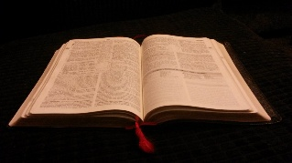  RE: Create a simple fact page explaining why sacred texts are important to Christians and when they might use or read from one. |   English: Evacuee Diary Write a diary entry as a child evacuee arriving in the countryside. Show the “place value of punctuation” using a wide range of proper nouns, common nouns, collective, partitive and abstract nouns | DT – Build your own air raid shelter which would be effective in WWII.  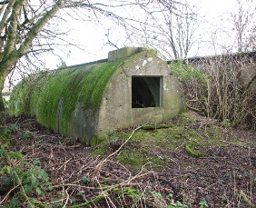  This Photo by Unknown Author is licensed under CC BY-SA  You can be as creative as you like!
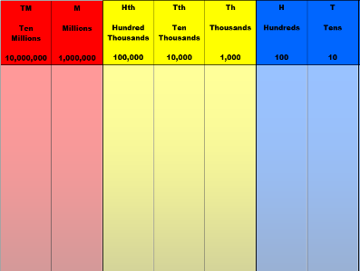  Maths: Explore large numbers linked to WW2. Find Britain’s population in 1939 and today. Write both numbers using a place value chart up to 10 millions |   Computing: Create a poster explaining how people communicate online in the modern day, in comparison how people communicated during WWII.  This Photo by Unknown Author is licensed under CC BY-SA |   Art: Research a WW2 artist (e.g., Ethel Gabain). Create your own artwork inspired by their style, showing an everyday wartime moment.

