|  |  |
| --- | --- |
| **Key vocabulary** | |
| **Continent** | A very large area of land on Earth. Often compared to a jigsaw piece. |
| **State** | A specific area of land with its own governing body within a larger country. |
| **Time zone** | An area in which all the clocks are set to the same time. |
| **Arid** | Somewhere that is extremely dry often from lack of rainfall. |
| **Polar** | An extremely cold area. |
| **Climate** | Refers to the weather of a particular area. |
| **Tropical** | A warm humid area often close to the Equator. |
| **Hemisphere** | There are two halves of the Earth. |
| **Currency** | The money that is used in a country. |

**UKS2 North America**

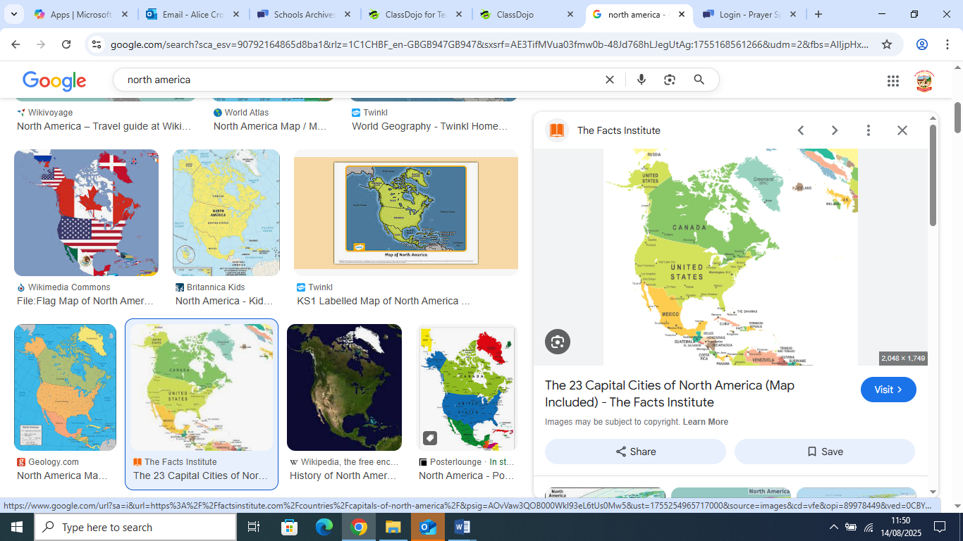

There are 23 countries in North America including Canada and the USA.

Sticky Knowledge

|  |
| --- |
| **Exciting books related to our topic** |
| Queen of the Falls: Amazon.co.uk: Van Allsburg, Chris: 9781849392860: Books The Man Who Walked Between the Towers: (Caldecott Medal Winner) : Mordicai  Gerstein: Amazon.co.uk: Books |

North America has many different climate zones from the polar regions of the North to the tropical regions of the South.

Niagara Falls is a waterfall that crosses the US and Canadian border.

There are 11 time zones in North America.