Name:__________________ Class:______
___
55
Year 6 Italy End of Topic Assessment
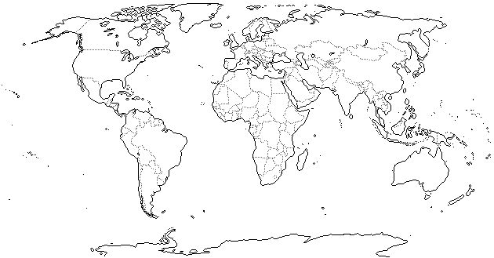
- Draw a circle around Italy on the map of the world below: (1 mark)
- In which continent is Italy? (1 mark) Europe

- Name the 4 countries which border Italy (4 marks) France, Switzerland, Austria, Slovenia
- There are two different types of map, physical and political. Identify which type of map is shown below and give 4 things you usually find on this type of map:

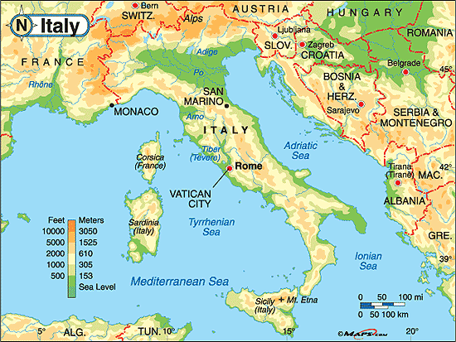
Type of map (1 mark): physical
4 things this type of map usually shows (4 marks):
- Height of the land
- Mountain Ranges
- Seas and Oceans
- Rivers

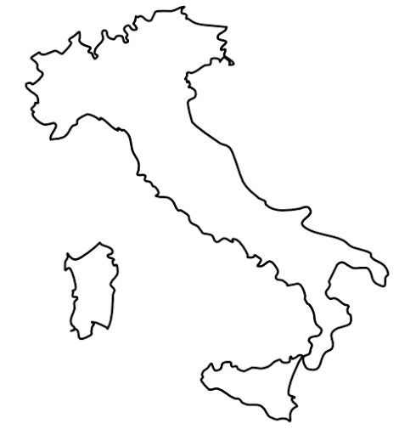
- There are 3 mountain ranges in Italy, The Alps, The Apennines and The Dolomites. Label them in the correct places on the map of Italy to the right: (3 marks)
The Dolomites
The Alps
The Apennines

- This is Ben, he has recently moved to Italy and wants to work in one of the mountain ranges. Identify one type of job that Ben could do in each mountain range, and describe why he is likely to get that sort of job there. (3 marks)
Mountain Range | Type of job Ben could do | Describe why that sort of job is available there
The Alps | An instructor or guide/work in a hotel or restaurant. | Lots of tourists visit The Alps to use the ski resorts in the mountains or to hike/bike in the mountains. So, Ben could be an instructor for one of these activities, or he could work in a hotel or restaurant (somewhere tourists would use a lot!)
The Dolomites | An instructor or guide/work in a hotel or restaurant. | Lots of tourists visit The Alps to use the ski resorts in the mountains or to hike/bike in the mountains. So, Ben could be an instructor for one of these activities, or he could work in a hotel or restaurant (somewhere tourists would use a lot!)
The Apennines | Farmer, railway worker, quarry worker | The Apennines are full of villages where Italian people live and they do jobs such as farming and mining. There is also a large railway to help people get around so Ben could work on the railway.

- The mountains have also been responsible for the creation of some amazing lakes in Italy. Use the diagrams below to help you to explain how the lakes were formed (remember- you should be using key terminology! The first one has been done for you) (5 marks)
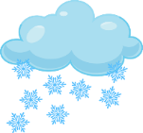  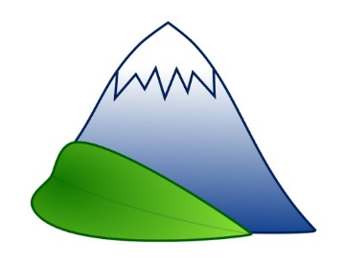  1) | The mountains have their own climate where it is very cold and often snowy.
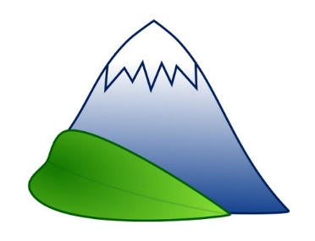  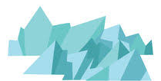  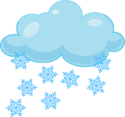  2) | The snow piles on top of each other and the stuff at the bottom turns into ice! This is called a glacier.
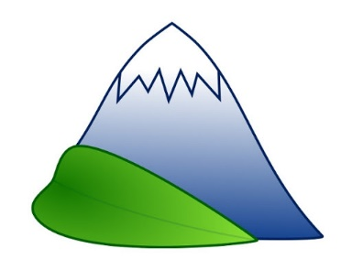  3) | As the glacier (ice) is so heavy, it very slowly moves down the mountain
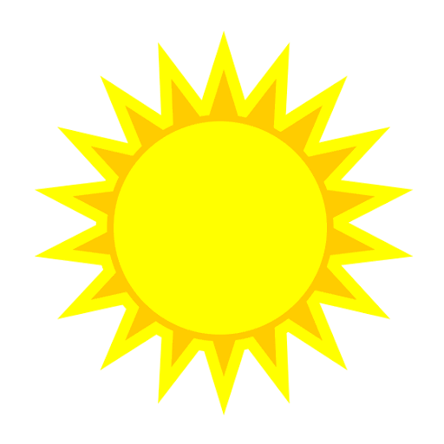  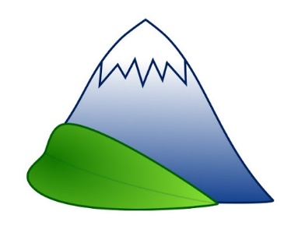  4) | The climate at the bottom of the mountain is much warmer than at the top of the mountain which means the glacier (ice) melts…
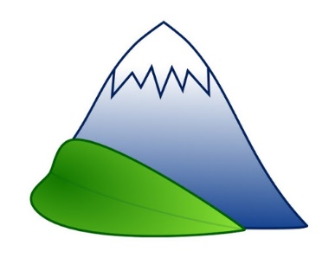  5) | When the glacier (ice) melts, a lake is formed at the bottom of the mountain.

- Due to the many mountain ranges, Italy also has volcanoes! Volcanoes can be active, dormant or extinct. Explain what those 3 terms mean (3 marks):
If a volcano is active it means it can erupt at any time!
If a volcano is dormant it means it hasn’t erupted for thousands of years but it still could
If a volcano is extinct it means it hasn’t erupted for millions of years and will not erupt again.

- When researching Italy’s volcanoes you recorded some primary (things that happened straight away) and secondary (things that happened a while after the eruption) effects of their eruptions. Pick one volcano and describe one primary and secondary effect. (3 marks) I’ve included lots of information for all three- you just need to have picked on volcano and picked on primary and secondary effect.
Name of Volcano | Primary Effect | Secondary Effect
Vesuvius | Lava flows and ash clouds destroy towns and villages and kill people! | Many families were completely wiped out because every generation (grandparents, parents and children) was killed  Some of the destroyed towns and villages were never rebuilt and still exist in Italy as ghost towns.
Etna | The volcano has caused lots of damage to people’s homes and property | Homelessness  Farmers lose land and crops meaning they lose money  People can suffer from depression and shock
Stromboli | The volcano emits smoke, gas and lava but doesn’t really cause much damage. Once it shattered some windows and it was also responsible for causing a tsunami | Fire damage  The lava makes the island bigger!  The lava can cool into special and expensive rock, like granite!

- Look at the climate graphs on the next page which show the different climates in north, mid and south Italy.

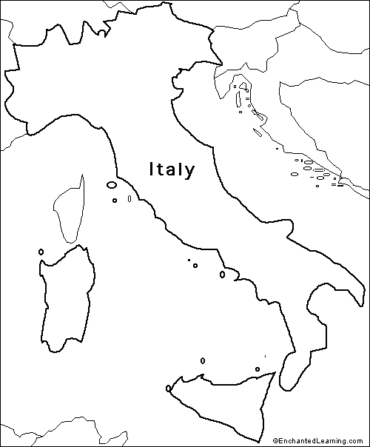
Analyse the information from the climate graphs, describe one difference and one similarity between the climate in different parts of Italy (4 marks)
By analysing the information from the climate graphs, I can see that Mid Italy and South Italy have a similar climate. It is similar because they both have very little rainfall in the summer months and their temperatures are very similar because they are both very warm in the summer and cooler in the winter (but they do not go below freezing).
I can also see that North Italy and South/Mid Italy have very different climates. They are different because The North of Italy gets rainfall throughout the whole year (even in the summer) whereas The Mid/South of Italy don’t get much in the summer. Also, the temperature in The North of Italy drops below freezing during the winter and it only reaches about 13⁰c in the summer so it’s quite cold throughout the year- whereas Mid/South Italy has mild winters and very warm summers.

- In some ways, Italy and The UK are very similar, but in other ways they are very different! Compare Italy and the UK by describing 2 things that are similar about both countries and 2 things that are different. (Remember: you compared the following areas: Population, Mountains, Lakes, Rivers, Volcanoes and Coasts) (4 marks)
You only need to pick one idea for each answer- I’ve just given all the possible answers.
Something very similar about Italy and The UK is population/rivers/coast. It is similar because:
- Population: both countries populations are a similar size
- Rivers: both countries have large rivers which they have built major cities along to use for water supply, farming, trade etc.
- Coast: Both countries have a large amount of coast and so tourists visit them to use the beaches and sea
Something very different about Italy and The UK is Volcanoes/mountains/lakes. It is different because:
- Volcanoes: Italy has 3 active volcanoes but England doesn’t have any so we are safer (but Italy gets more tourism from their volcanoes)
- Mountains: Italy is extremely mountainous with huge mountains in their mountain ranges. England is relatively flat and our mountain ranges have much smaller mountains in them.
- Lakes: Italy has far more lakes than England and the their lakes were created by glaciers from the mountains melting.
Italy is a developed country. We know this because the people who live there have a good quality of life. We can measure development using the Human Development Index (HDI). HDI is calculated by looking at 3 categories; living standard, health and education.
- What do we measure to find out about a country’s living standard? (1 mark)
GDP
- What do we measure to find out about a country’s health? (1 mark)
Life Expectancy
- What do we measure to find out about a country’s education? (1 mark)
Literacy Rate
- Is Italy more or less developed than the UK? Explain how you know this (what evidence is there?) (3 marks)
Italy is more / less (circle correct answer) developed than the UK. I know this because Italy has a slightly lower GDP which means that the people don’t get paid as much as people in The UK and they also have a slightly lower literacy rate which means their education system isn’t quite as good as ours. However, people in Italy live longer than people in The UK!
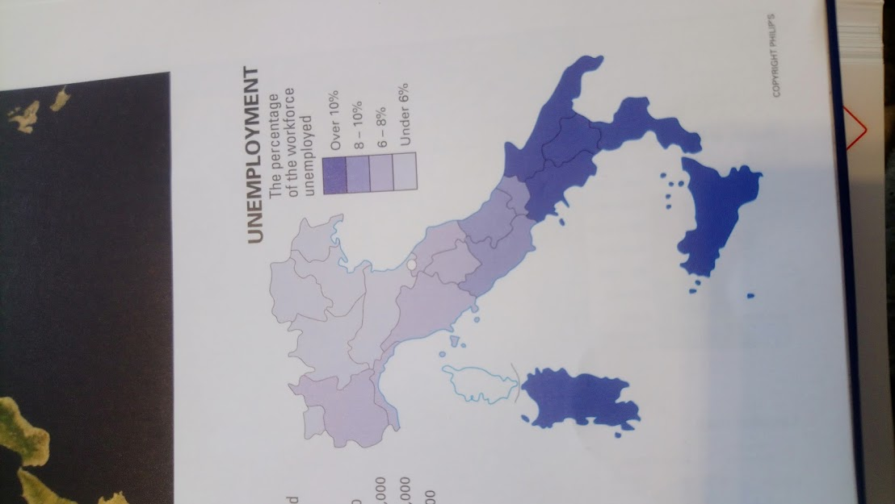
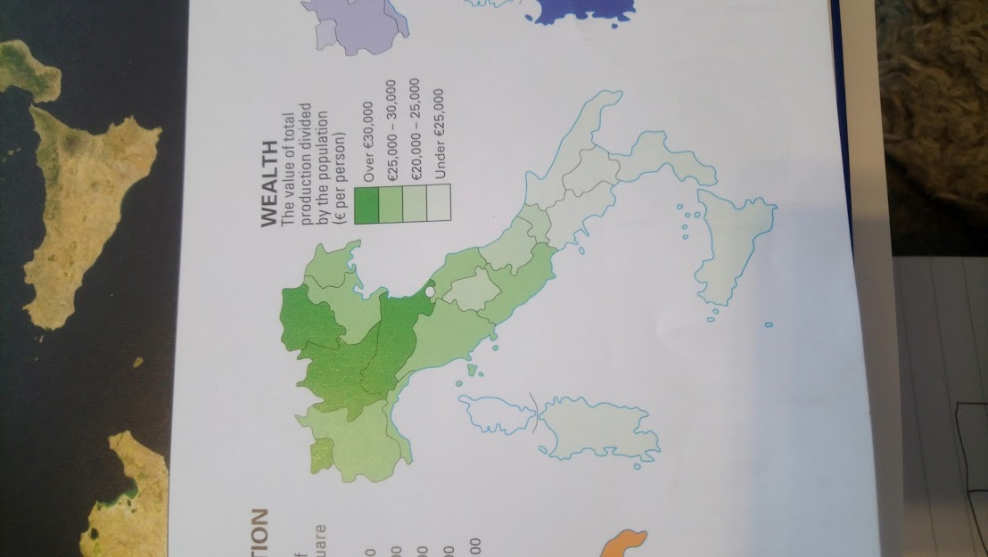
- Analyse the two maps below to help you compare whether North or South Italy is more developed and give two reasons why:
(3 marks)

By analysing the maps I can see that North Italy is more developed than South Italy.
One reason why I know this is because North Italy has far less unemployment than South Italy which means that more people have jobs and so will have a better quality of life. Another reason I know this is because people in North Italy get paid more money than people in South Italy, for example, in North Italy the average wage is over €30,000, but in South Italy it is under €25,000.
- The jobs that people do can be split into 3 sectors; primary, secondary and tertiary. Describe each sector and give an example of a job in that sector. (6 marks)
Employment Sector | Description | Example of a job
Primary | Jobs which involve getting, finding, growing etc. a natural resource | Anyone who finds natural resources like miners, farmers, fishermen etc.
Secondary | Jobs which involve using the natural resources from the primary sector and making them into a product to sell. | Anything that turns natural resources into a product such as bakers, jewellery makers, wood workers etc.
Tertiary | Jobs which provide a service to the people (they don’t involve natural resources at all) | Anything where a service is being given e.g. teacher, lawyer, shop worker etc.

- The pie chart below shows how employment in Italy is spread across the three sectors. Colour the sections in three different colours and then complete the key to show which section is which (think about which section should be the biggest and smallest) (3 marks)

- Justify (give a reason) why developed countries, like Italy, have more people employed in a certain sector. (2 marks)
In developed countries, like Italy, more people are employed in the tertiary sector because people have a better standard of life which means they have more money to spend on services such as going to hotels and restaurants or buying themselves treats in shops!
20) Justify why in less developed countries, such as India, more people are employed in a different sector. (3 marks)
In less developed countries, such as India, more people are employed in the primary sector. This is because people are much poorer and can’t afford to pay for the services in the tertiary sector. This means most people are employed in jobs where they are finding or growing natural resources to help them to live e.g. growing food.

