Investigation task:
Is Italy more or less developed than the UK (using the HDI criteria)?
Use the evidence below to answer the following questions:
- In which country do people earn more money? The UK
- In which country do people live longer? Italy
- In which country can more people read and write? The UK
- So, which country is more developed (a better place to live)? Technically, The UK is slightly more developed as people earn more money and more people can read and write. However, Italy is still very developed as they are only just behind The UK in terms of GDP and Literacy rate and actually they have a better life expectancy!
Evidence:
GDP: The average amount of money people earn over a year
Life Expectancy: How long, on average, people live for
Literacy Rate: How many people can read and write (as a percent)
Italy: The UK:
GDP | £27,895
Life Expectancy | 82.8
Literacy Rate | 98.85%
GDP | £32,700
Life Expectancy | 80.17
Literacy Rate | 99%
Explanation:
The evidence supports my decision that The UK is a slightly more developed country because the 3 bits of information in the table are used to judge a country’s HDI. The higher a country scores, the more developed it is.
GDP means the average amount of money people earn over a year, so a higher number is better because if people earn more money it means they can afford not only the basic necessities like food, but also luxury items like nice houses, cars and phones etc.
Life expectancy means how long, on average, people live for, so a higher number is better because if people live for a long time it must mean they have access to good health care in their country and so can get treatment/medicine if they are unwell.
Literacy rate means how many people can read and write (as a percent), so a higher number is better because it means that more people have gone to school in order to learn so they must have access to good education.
The UK had better scores for GDP and Literacy Rate which means it is slightly more developed than Italy.

Does the UK or Italy make more money from trading with other countries (selling their goods)?
Use the evidence below to answer the following question:
Which country makes the most money from trading? Italy
Evidence:
- An export is something that a country sells to another country in order to make money
- An import is something that a country buys from another country so this costs money
- Therefore, the money made from trading is calculated by subtracting the amount of money a country spends on imports, from the amount it earns from exports.
The UK’s Trade: Italy’s Trade:
Exports | £383 billion
Imports | £351 billion
Money made from trading | £32 billion
Top exports | Medicines, cars, petrol, building materials
Exports | £314 billion
Imports | £491 billion
Money made from trading | -£177 billion
Top exports | Cars, medicines, petrol, gold

Explanation:
The evidence supports my decision that Italy makes the most money from trading because this country makes £32 billion from trading.
To work out how much money is made from trading you have to subtract the amount of money a country spends on imports, from the amount it earns from exports. An import is something that a country buys from another country so this costs money. An export is something that a country sells to another country in order to make money. The evidence tells us that Italy’s top exports include medicines, cars, petrol and building materials, and The UKs top exports include cars, medicines, petrol and gold.
In fact, the evidence shows us that the UK doesn’t trade very successfully as they lose money (-£177 billion)! This is because the amount they import is greater than the amount they export.

Is the North or South of Italy more developed?
Use the evidence below to answer the following questions:
- Which part of Italy (the north or south) suffers from the most unemployment? (The darker the colour, the higher the percentage of people who are unemployed) The South
- Which part of Italy (the north or south) has more wealth? (The darker the colour, the more money is earned there) The North
- So, which part of Italy is more developed (a better place to live)? The North because it is wealthier and less people are unemployed which means they will have better lives
Evidence:
Unemployment= People without jobs
Wealth= The amount of money made
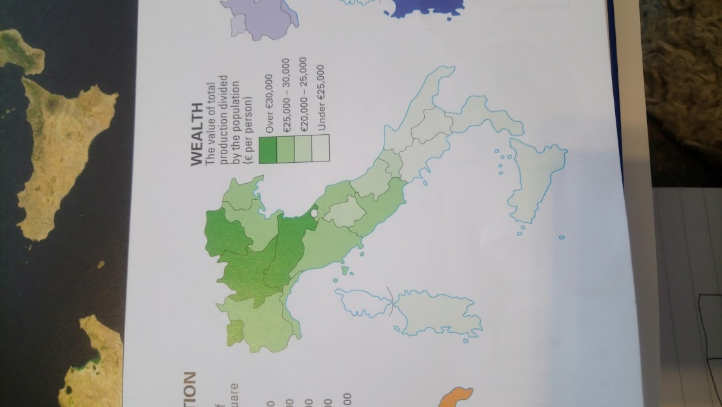
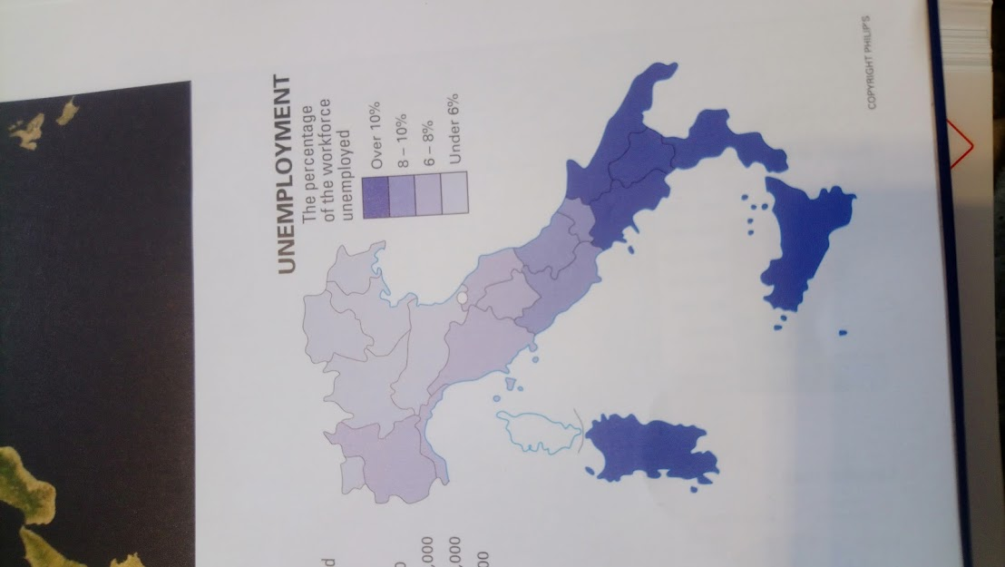

Explanation:
The evidence supports my decision that the North of Italy is more developed because its shows that this part of the country earns a lot more money. It also shows that in the South a lot more people are unemployed, which means they don’t have a job and so won’t have much, if any, money to afford basic things like shelter and food.
The unemployment maps shows that in the south of Italy is coloured dark blue. The dark blue colour means over 10% of the workforce is unemployed, whereas in the north of Italy it is the lightest blue which means under 6% of the workforce is unemployed. The wealth map shows that the north of Italy has lots of areas which are a dark green colour. The dark green colour means people earn over €30,000 per year (which is nearly as good at the UK), whereas in the south of Italy it is the lightest green colour which means people earn under €25,000.

