Project GO introduction URL:
https://www.stem.org.uk/rxg4o8
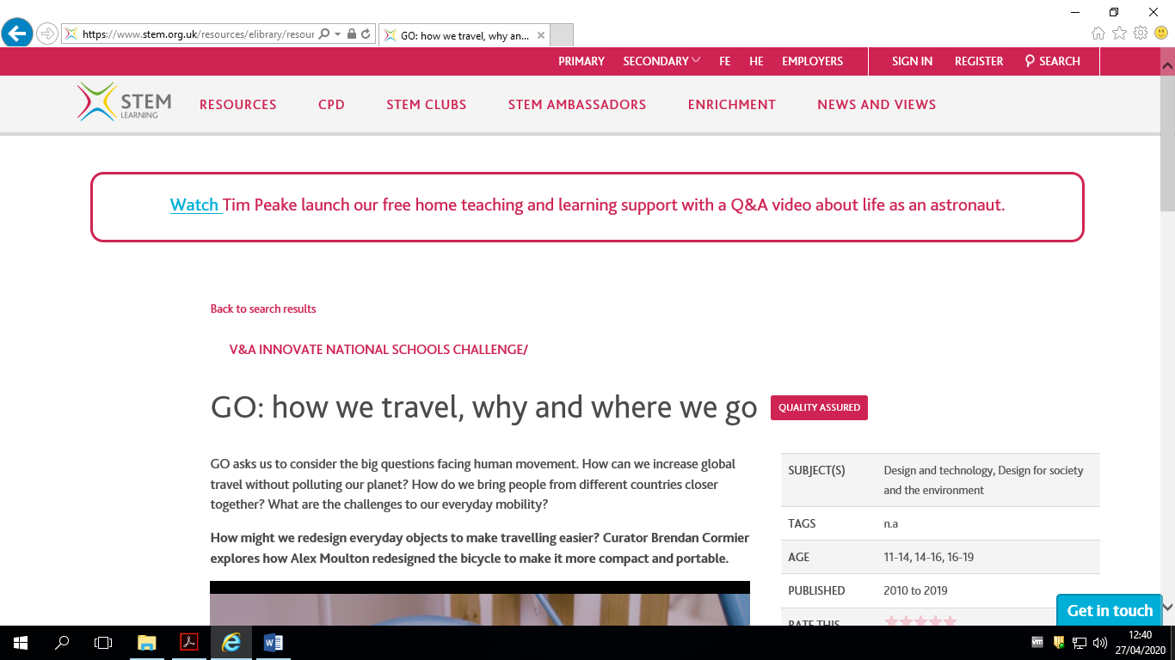

V&A Website Search URL:
https://collections.vam.ac.uk/