Angles on a straight line
Find the missing angle in each of these diagrams
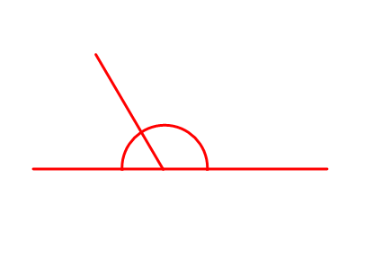
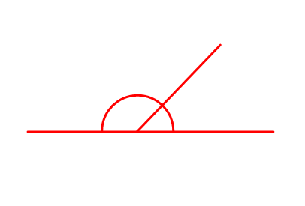
RED – Start with me

30⁰
140⁰
50⁰

10⁰
130⁰
150⁰

60⁰
110⁰
120⁰
40⁰
20⁰

Found these easy so far? Why not move onto orange?

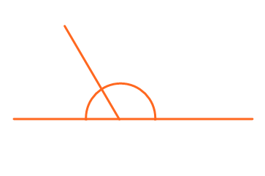
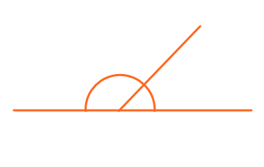
Orange – Move onto me

15⁰
35⁰
55⁰
25⁰
155⁰
125⁰

45⁰
135⁰
175⁰
105⁰
165⁰

