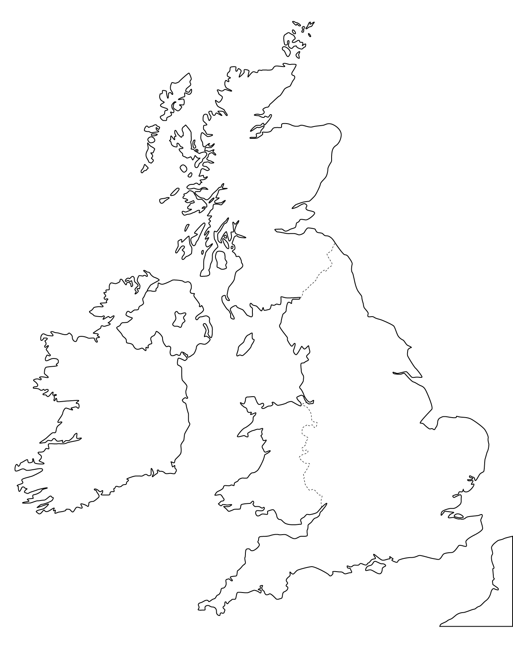
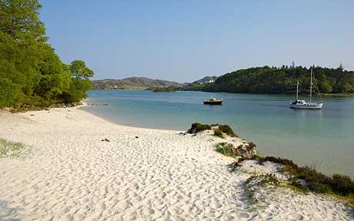
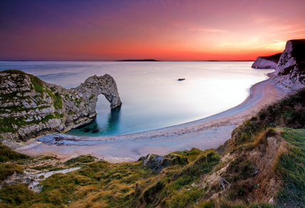
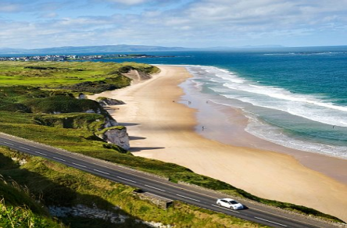
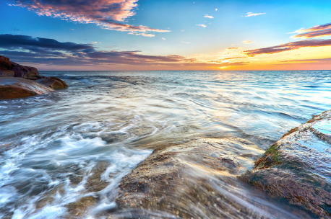
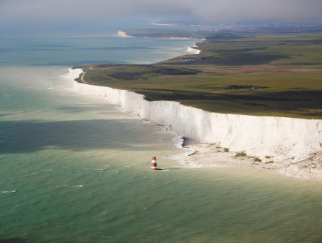
An Introduction to The Sea- Investigate the location of coastal areas.
Task: Using the internet, locate where all these coastal places are and insert an arrow to show their location…
(Use the PPT to figure out where the picture is showing!)
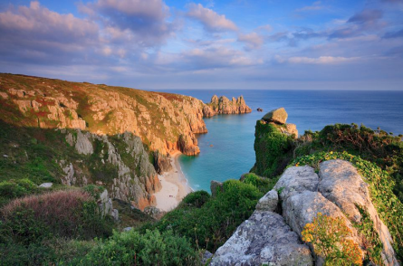
Loch Lomond
Porthcurno
Durdle Door
White Cliffs of Dover

