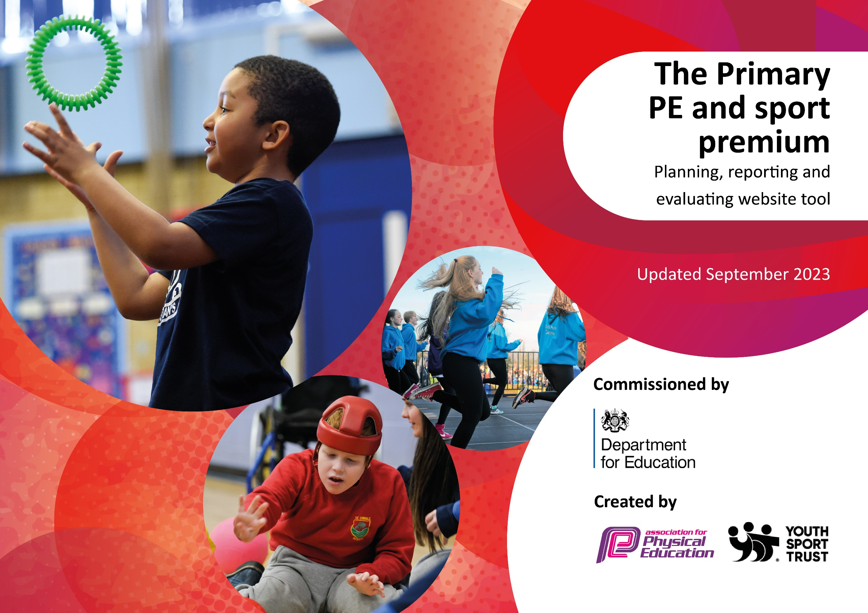

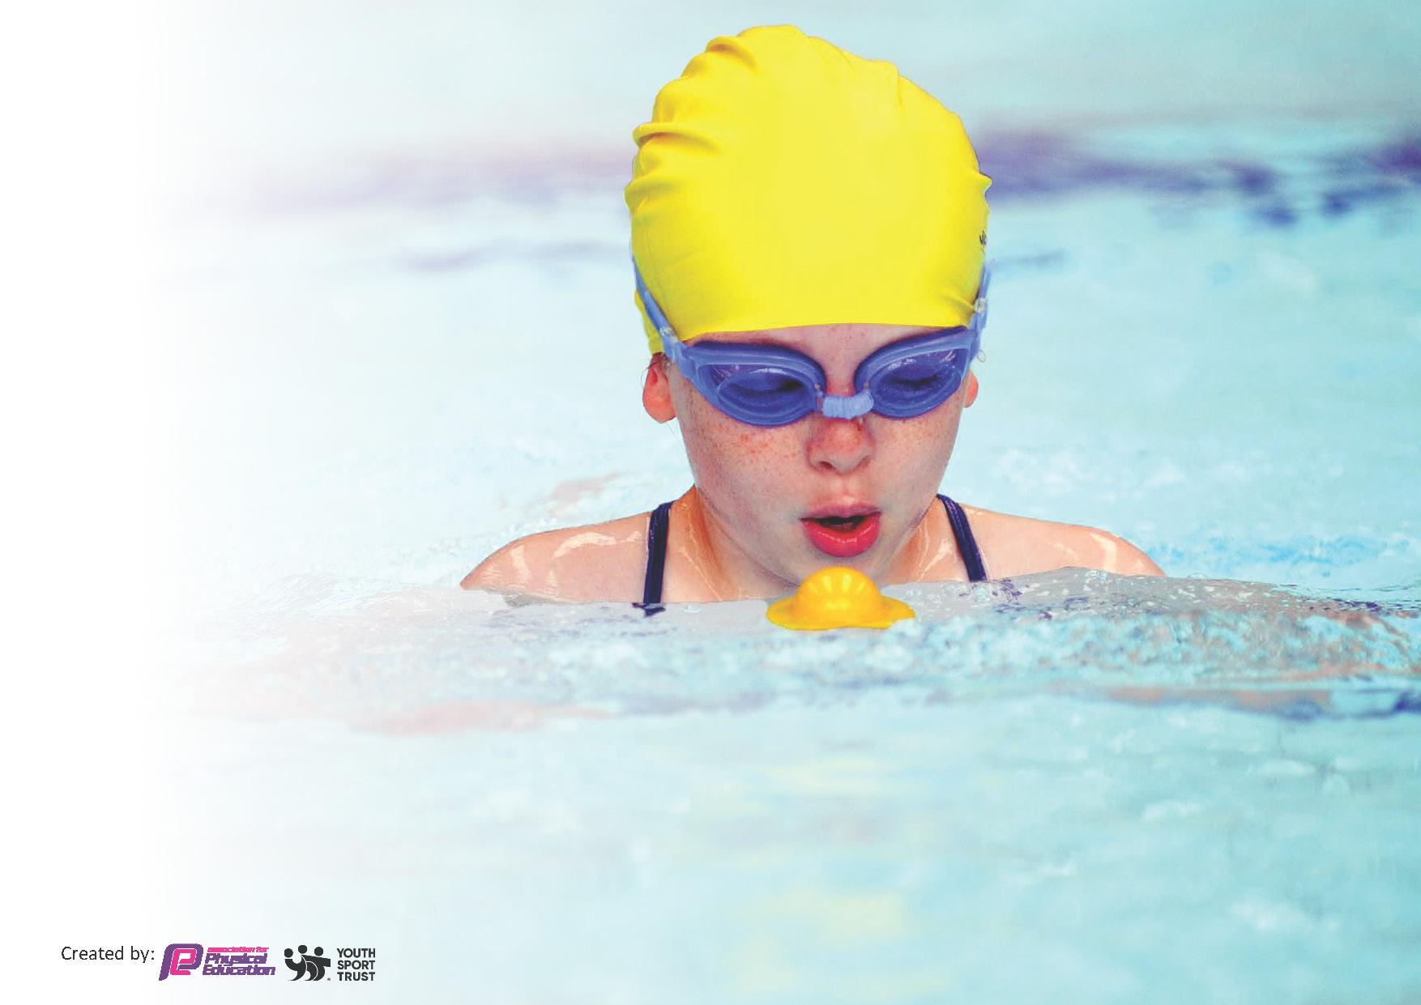
This template can be used for multiple purposes:
by:
- It enables schools to effectively plan their use of the Primary PE and sport premium
- It helps schools to meet the requirements (as set out in guidance) to publish information on their Primary PE and sport premium
- It will be an effective document to support Ofsted inspections enabling schools to evidence progress in Physical Education (PE) and evidence swimming attainment, which forms part of the PE National Curriculum. We would recommend schools consider
the Intent, Implementation and Impact of any spend, as examined within the Education Inspection Framework.

It is important that your grant is used effectively and based on school need.

Schools must use the funding to make additional and sustainable
improvements to the quality of the PE, School Sport and Physical Activity (PESSPA)
they offer. This means that you should use the Primary PE and sport premium to:

- Build capacity and capability within the school to ensure that improvements made now will benefit pupils joining the school in future years
- Develop or add to the PESSPA activities that your school already offers.

The Primary PE and sport premium should not be used to fund capital spend projects; the school’s core budget should fund these. Further detail on capital expenditure can be found in the updated Primary PE and sport premium guidance.

Key priorities and Planning
This planning template will allow schools to accurately plan their spending.

Action – what are you planning to do | Who does this action impact? | Key indicator to meet | Impacts and how sustainability will be achieved? | Cost linked to the action
Lunchtime sport sessions/activities for pupils. | Year 6 children. They are completing the Playmaker Award.  KS1 and KS2 Pupils – as they will take part in activities run by the Play Leaders. | Key indicator 1 -The engagement of all pupils in regular physical activity.  Key indicator 2 – Raise the profile of PE and sport across school. | More pupils meeting their daily physical activity goal, more pupils encouraged to take part in PE and Sport activities. This will also raise the profile of PE and sport as being an important element of the curriculum. | £175 cost for the Play Maker training. £550 on equipment for the children to use to run the activities.
Subscribe to a skill based planning scheme.  Specialist PE coaches delivering Physical Education weekly to all classes. Edstart deliver 2 days of PE per week to cover the whole school.  Specialist PE coach providing after school sport for one hour per week, to different year groups each half term  Membership Fee for Heywood Schools Sport Collaborative.  Purchasing equipment for PE and Sport.  Facility and instructor hire in Keswick for water activities.  Staffing for extra curricular competitive sport competitions at the Heywood Partnership, 1.5 hrs per week, and including releasing staff for organisers’ meetings termly  Outdoor and adventurous curriculum for Year 6 | All staff who deliver PE.  All children in the school.  All children who wish to participate  Key Stage 1 children  Key Stage 2 children  Children from Years 1 – 6 will have opportunities to participate in competitive sport with other schools both in and out of curriculum time.  Year 6  Years 2-6  Year 6 | Key Indicator 3: Increased confidence, knowledge, and skills of staff in teaching PE and sport.  Key Indicator 1: Engagement of all children in regular physical activity.  Key indicator 3: Increase the knowledge and skills of staff. The staff have opportunities to observe specialist PE coaches to better inform their own practice.  Key Indicator 5. Increased participation in competitive sport. Key Indicator 2: Engagement of all pupils in regular physical activity.  Key Indicator 5. Increased participation in competitive sport.  Key Indicator 5. Increased participation in competitive sport. Key Indicator 2: Engagement of all pupils in regular physical activity.  Key indicator 4: Broader experience of a range of sports and activities offered to pupils.  Key Indicator 5. Increased participation in competitive sport. Key Indicator 2: Engagement of all pupils in regular physical activity. Key indicator 4: Broader experience of a range of sports and activities offered to all pupils.  Key Indicator 5. Increased participation. Key Indicator 2: Engagement of all pupils in regular physical activity. Key indicator 4: Broader experience of a range of sports and activities offered to all pupils. | The staff will have an increased confidence in delivering high quality PE.  More pupils meeting their daily physical activity goal, more pupils encouraged to take part in PE and Sport Activities.  Any children choose to take part in extra curricular competitive sport.  The children will have safe and enough equipment to use in PE and extra-curricular activities and PE lessons.  Children have the opportunity to take part in water based sporting activities, and outdoor adventurous activities  led by qualified instructors.  Key Stage 1 and 2 children will take part in extra curricular competitive sport.  Brathay deposit for May 2027 to meet needs of a pupil with mobility difficulties to enable them to achieve in line with peers- Keswick not suitable. | £199  £10,540  £1,900  £250  £1,510  £3900  £2,625  £3221.25
TOTAL |  |  |  | £24,870.25

Swimming Data
Meeting National Curriculum requirements for swimming and water safety.
Priority should always be given to ensuring that pupils can perform safe self-rescue even if they do not fully meet the first two requirements of the National Curriculum programme of study

Question | Stats:
What percentage of your current Year 6 cohort can swim competently, confidently and proficiently over a distance of at least 25 metres? | 85%
What percentage of your current Year 6 cohort can use a range of strokes effectively [for example, front crawl, backstroke, and breaststroke]? | 85%

What percentage of your current Year 6 cohort are able to perform safe self-rescue in different water-based situations? | 85%
If your schools swimming data is below national expectation, you can choose to use the Primary PE and sport premium to provide additional top-up sessions for those pupils that did not meet National Curriculum  requirements after the completion of core lessons. Have you done this? | Yes, with top up lessons for 6 weeks per year since end of Year 3
Have you provided CPD to improve the knowledge and confidence of staff to be able to teach swimming and water safety? | No, we use specialist coaching through Rochdale LA

Signed off by:
Head Teacher: | Melanie Barratt
Subject Leader or the individual responsible for the Primary PE and sport premium: | Carys Wright
Governor: | John Knott  PE Link Governor
Date: | 29.9.2025

