Pupil premium strategy statement 2024-25 – St Michael’s CE Bamford Primary School
This statement details our school’s use of pupil premium (and recovery premium) funding to help improve the attainment of our disadvantaged pupils.
It outlines our pupil premium strategy, how we intend to spend the funding in this academic year and outcomes for disadvantaged pupils last academic year.

School overview
Detail | Data
Number of pupils in school | 208 + 22FTE place Nursery
Proportion (%) of pupil premium eligible pupils | 4.5% PP for FSM and 4.5% PP+ former LAC
Academic year/years that our current pupil premium strategy plan covers (3 year plans are recommended) | 2023-2025
Date this statement was published | 13 November 2024
Date on which it will be reviewed | November 2025
Statement authorised by | Melanie Barratt, Headteacher
Pupil premium lead | Melanie Barratt, Headteacher
Governor / Trustee lead | Lindsey Wilson-Willis, lead for disadvantaged pupils

Funding overview
Detail | Amount
Pupil premium funding allocation for 2024-25 | £27,990
Recovery premium funding allocation this academic year | 0
Pupil premium (and recovery premium) funding carried forward from previous years | 0
Total budget for this academic year | £27,990

Part A: Pupil premium strategy plan

Statement of intent
“We are God’s workmanship created in Christ Jesus to do good works.” Ephesians 2:10
As such, we know that every child has immense potential. Our intention therefore, is that all pupils, irrespective of their background or the challenges they face, make good progress and achieve highly across all subject areas. The focus of our pupil premium strategy is to support disadvantaged pupils to achieve that goal, including progress for those who are already high attainers.
We consider the challenges faced by vulnerable pupils, such as those who have a social worker and young carers. The activity we have outlined in this statement is also intended to support their needs, regardless of whether they are disadvantaged or not.
High-quality teaching is at the heart of our approach, with a focus on areas in which disadvantaged pupils require the most support. This is proven to have the greatest impact on closing the disadvantage attainment gap and at the same time benefits the non-disadvantaged pupils in our school. Implicit in the intended outcomes detailed below, is the intention that non-disadvantaged pupils’ attainment will be sustained and improved alongside progress for their disadvantaged peers.
Our approach is responsive to common challenges and individual needs, rooted in robust diagnostic assessment, not assumptions about the impact of disadvantage. The approaches we have adopted complement each other to help pupils excel. To ensure they are effective we:
- ensure disadvantaged pupils are challenged in the work that they’re set
- act early to intervene at the point need is identified
- adopt a whole school approach in which all staff take responsibility for all pupils’ outcomes, including those that are disadvantaged, outcomes and raise expectations of what they can achieve.

Challenges
This details the key challenges to achievement that we have identified among our disadvantaged pupils.
Challenge number | Detail of challenge
1 | Assessments, observations, and discussions with pupils indicate underdeveloped oral language skills and vocabulary gaps among some disadvantaged pupils. These are evident from Reception through to KS2 and in general, are more prevalent among our disadvantaged pupils than their peers.
2 | Assessments, observations, and discussions with pupils suggest disadvantaged pupils generally have greater difficulties with phonics than their peers. This negatively impacts their development as readers.
3 | Observations and discussions with pupils and families have identified social and emotional issues for some pupils. These challenges do not particularly affect disadvantaged pupils, but are across the school population. Sensory needs are growing across school and managing these needs impacts positively on pupils’ ability to access learning.
4 | Attendance data over the last 3 years indicates that attendance among disadvantaged pupils has been between 10-20% lower than for non-disadvantaged pupils.  More disadvantaged pupils have been ‘persistently absent’ compared to their peers during that period. Our assessments and observations indicate that absenteeism is negatively impacting disadvantaged pupils’ progress.
5 | Rising numbers of pupils have sensory needs which impact their wellbeing and attendance as well as their ability to access learning.

Intended outcomes
This explains the outcomes we are aiming for by the end of our current strategy plan, and how we will measure whether they have been achieved.
Intended outcome | Success criteria
Improved oral language skills and vocabulary among disadvantaged pupils. | Wellcomm assessments indicate significantly improved oral language among targeted pupils including those that are disadvantaged. This is evident when triangulated with other sources of evidence, including engagement in lessons, book scrutiny and ongoing formative assessment.
Improved reading attainment among disadvantaged pupils. | KS2 reading outcomes in 2025/6 show that disadvantaged pupils meet the expected standard in the same proportions as their peers.
To achieve and sustain improved wellbeing for all pupils in our school, particularly our disadvantaged pupils. | Sustained high levels of wellbeing by 2025/6 demonstrated by:  - qualitative data from student voice, student and parent surveys and teacher observations
To achieve and sustain improved attendance for all pupils, particularly our disadvantaged pupils. | Sustained high attendance by 2025/26 demonstrated by:  - the overall unauthorised absence rate for all pupils being no more than 0.5%, and authorised attendance being no more than 4.5%. The attendance gap between persistent absentees, including disadvantaged pupils, and peers being reduced.  - the percentage of all pupils who are persistently absent being below 10% and the figure among disadvantaged pupils being no more than 2% more than their peers.
To meet sensory needs effectively across school. | All pupils in KS2 have a sensory break mid-afternoon.  Targeted provision of sensory sessions for pupils enables a specific sensory diet for vulnerable pupils, including those deemed disadvantaged.

Activity in this academic year
This details how we intend to spend our pupil premium (and recovery premium) funding this academic year to address the challenges listed above.

Teaching (for example, CPD, recruitment and retention)
Budgeted cost: £14,465
Activity | Evidence that supports this approach | Challenge number(s) addressed
Use of Wellcomm diagnostic assessments across school to identify and address language gaps.  Training for staff to ensure assessments are interpreted and administered correctly.  SENCo non-contact time: £5,500 | Wellcomm provides reliable insight into the specific strengths and weaknesses of each pupil’s language development and interventions activities to then close gaps by ensuring they receive the correct additional support through interventions and teacher instruction:  Standardised tests | Assessing and Monitoring Pupil Progress | Education Endowment Foundation | EEF | 1, 2, 3, 4
Purchase of Twinkl, a DfE validated Systematic Synthetic Phonics programme to secure stronger phonics teaching for all pupils.  £700  Phonics interventions weekly: 4TAs at 2.5hrs per wk: £5,510 | Phonics approaches have a strong evidence base that indicates a positive impact on the accuracy of word reading (though not necessarily comprehension), particularly for disadvantaged pupils:  Phonics | Toolkit Strand | Education Endowment Foundation | EEF | 2
Sensory sessions targeted to pupils needing this provision, in addition to the universal offer of sensory interventions.  TA time for 2x30 mins per day setting up and running the sessions= £2,755 | Managing pupils’ sensory needs has a demonstrably positive impact on pupil attendance and enables effective access to learning, which raises standards of achievement. | 1, 2, 3, 4, 5

Targeted academic support (for example, tutoring, one-to-one support structured interventions)
Budgeted cost: £18,458.50
Activity | Evidence that supports this approach | Challenge number(s) addressed
Continue to provide high quality of social and emotional (SEL) learning through group Drawing and Talking; a therapeutic approach and Lego Therapy.  Drawing and Talking: 2hrs teacher per week: £1,900  Lego: 1hr TAs per week £551 | There is extensive evidence associating childhood social and emotional skills with improved outcomes at school and in later life (e.g., improved academic performance, attitudes, behaviour and relationships with peers):  EEF_Social_and_Emotional_Learning.pdf(educationendowmentfoundation.org.uk) | 3, 5
Phonics interventions weekly: 4TAs at 2.5hrs per wk: £5,510 | Phonics approaches have a strong evidence base that indicates a positive impact on the accuracy of word reading (though not necessarily comprehension), particularly for disadvantaged pupils:  Phonics | Toolkit Strand | Education Endowment Foundation | EEF | 2
Targeted TA intervention and in class small group support.  2.5 hr per week per TA: £12,397.50 | EEF indicates moderate impact for small group tuition (+4 months) | 1

Wider strategies (for example, related to attendance, behaviour, wellbeing)
Budgeted cost: £1,000
Activity | Evidence that supports this approach | Challenge number(s) addressed
Embedding principles of good practice set out in the DfE’s Improving School Attendance advice.  This will involve training and release time for staff to develop and implement new procedures and appointing attendance/support officers to improve attendance. | The DfE guidance has been informed by engagement with schools that have significantly reduced levels of absence and persistent absence. | 4
Contingency fund for supporting parents with educational visit costs and other costs. | Based on our experiences and those of similar schools to ours, we have identified a need to set a small amount of funding aside to respond to needs: such as parental contributions to Year 6 residential causing financial hardship or a child entitled to PP+ funding needing private speech therapy due to over 1yr waiting lists and parental request to meet cost. | All

Total budgeted cost: £33,923.50

Part B: Review of the previous academic year

Outcomes for disadvantaged pupils
Our numbers of pupils deemed disadvantaged is very low across school at 4.5% FSMs and 9 attractive PP+, therefore data from classes might make individuals identifiable.
As a result, data below includes all pupils, highlighting that attainment and standards are exceptionally high across the whole school, including many of our vulnerable pupils. Attendance data is provided for all pupils and vulnerable groups across school as there are enough pupils across school to ensure that this remains anonymous.
School Results 2024
EYFS
Average points score 31.32 | School  % at Expected Standard | 2023 National  % at Expected Standard | 2024 Local  % at Expected Standard
Good Level of Development | 80.6 | 67.2 | 59.6
Communication and language | 90.3
Physical Development | 80.6 | 85.2
Personal, social and emotional | 87.0 | 83.2
Prime learning goals | 80.6
Literacy | 80.6 | 69.7
Mathematics | 87.0 | 77.1
Understanding the world | 93.5 | 80.3
Expressive arts and design | 93.5 | 85.0
Specific learning goals | 80.6

Phonics Year 1
90% Expected Standard of 32+ out of 40

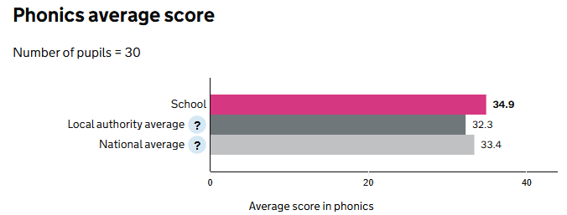

(2023: School 93% National 79%. 2019: School 93% National 85%)

Phonics Year 2: 2 children retested this year
2/2 children passed this year meaning that 100% of cohort have now passed the phonics screening.
KS1 Teacher Assessment
 | % At Expected |  | % Greater Depth
 | School | National  2023 | School
Reading | 83 | 68 | 24
Writing | 83 | 60 | 17
Maths | 86 | 70 | 31
Combined | 80 | 56 | 17
Science | 90 | 79
Year 4 Multiplication Tables Check: there is no ‘expected standard threshold’ for this test
Score/25 | 9 | 10 | 11 | 12 | 13 | 14 | 15 | 16 | 17 | 18 | 19 | 20 | 21 | 22 | 23 | 24 | 25
Children |  | 1 |  |  |  | 1 | 1 |  |  |  |  |  |  | 1 | 3 | 11 | 12
SCHOOL 2024: average score 23.13, 40% scored 25, 86.6% scored> 22

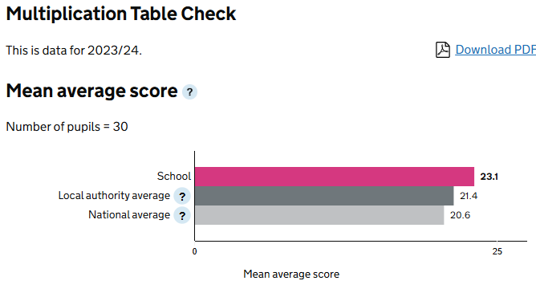

In 2023: School average score 22.44, 57% scored 25, 75.8% scored >22 2023: national average 20.2, 29% scored 25

KS2 Teacher Assessment
 | % At or above Expected |  |  | Greater Depth
 | School | National 2023 | National  2024 | School | Local | National  2024
Writing | 87 | 71 | 72 | 20 |  | 13
Science | 87 | 80 | 81
KS2 SATs Results
 | % At or above Expected |  |  | % GD/ higher standard |  |  | Ave Scaled Score
SUBJECT | School | National 2023 | National  2024 | School | National 2023 | National  2024 | School |  | National  2024
Reading | 97 | 73 | 74 | 40 | 29 | 28 | 108.4 |  | 105
Maths | 87 | 71 | 73 | 30 | 24 | 24 | 106.3 |  | 104
Combined: reading, writing & maths | 73 | 60 | 61 | 10 | 8 | 8
Grammar, punctuation and spelling | 93 | 72 | 72 | 57 | 30 | 32 | 109 |  | 105

