
St Michael’s C of E Primary School - Our Music Vision
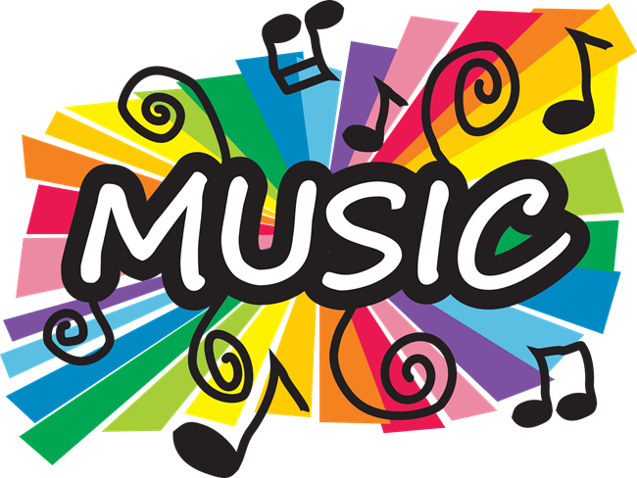

Music Intent

At St Michael’s C of E Primary School, we want to create a passion for music in our children that will stay with them in their future lives. We want to ensure that music is an inspiring and engaging experience that enables every child to develop their musical potential and develops an appreciation of the value of music that is deeply personal to them. We want children to have a curiosity for the subject and a respect for the role that music may play in any person’s life.

We endeavour to provide a variety of musical experiences through a curriculum which develops learning, improves knowledge and promotes pupil well-being through building up the confidence of all children. Music can impact the way that children feel, think and act; we want music to encourage the body and mind to work together, develop motor skills and allow self-expression.

As a result of our Music Curriculum we want our children to:
- Develop a love and appreciation of music.
- Experiment to identify what the voice can do, and learn to sing in tune
- Develop an ability to recognise the beat, rhythm, structure and organisation.
- Recognise, develop and use the elements of music: pitch, tempo, dynamics, duration and timbre.
- Make judgements and express personal preferences about the quality and style of music.
- Experience and move to music across a range of genres, styles and historical periods.
- Create and compose music, individually and collaboratively.
- Play a wide variety of instruments, both tuned and un-tuned percussion.
- Read and write musical notation.
- Know and use a range of musical vocabulary to discuss music and develop descriptive language skills.
- Take part in performances with an awareness of audience.
- Explore the musical heritage, tradition and culture of different countries.

As a Christian school our values are at the heart of everything we do. Music plays an important part in helping children feel part of a community. We want to ensure children understand the value and importance of music in the wider community and encourage them to use their musical skills, knowledge and experience to involve themselves and others in music.

Implementation
We use Jolly Music, Music Express, BBC Ten Pieces, Classroom 200 and other high quality resources. Each resource is designed to ensure full coverage of the National Curriculum. It provides wide exposure to musical styles and genres from different times and places and promotes the exploration of the language of music through active listening, performing and composing activities.

Each unit follows a sequence of learning: listen and appraise, singing, playing instruments, improvisation, composition, performing and sharing. This approach ensures the children get a rich learning experience covering all aspects of music.
There is a clear progression of skills and knowledge so that children make clear progress week by week, year on year.

In addition to the scheme, children are given the opportunity to learn to play musical instruments including cornets in Year 4, 5 and 6. Our Music curriculum reflects the intent of our whole school curriculum in that all pupils have the opportunity to use their musical knowledge and skills as a medium to express themselves.

Impact
The music curriculum enables all children at St Michael’s CE Primary School to develop a love of music and increased understanding of the impact that music can have on their own and others’ lives. They develop excellent knowledge and skills which they continuously build on and embed. Children understand the culture and history of music and experience music from around the world.

We monitor the impact of our curriculum through pupil voice, work scrutiny and teaching and learning observations.
Music is assessed and recorded using a simple triangle system, with a star to highlight those with a particular talent who can be further extended. We believe that every child can succeed, and learn to sing with joy. We target children who need additional support to learn to sing in tune so that everyone achieves.

