
St Michael’s C of E Primary School - Our Geography Vision
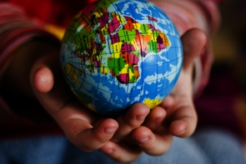
Intent
The intension of the Geography Curriculum at St Michael’s Primary School is to inspire children’s curiosity and interest to explore the world that we live in and its people, which aims to ignite a love of learning. We intend to equip children with geographical skills to develop their knowledge through studying places, people and natural and human environments. Through our teaching, we intend to provoke thought, questions and to encourage children to discover answers to their own questions through exploration and research to enable them to gain a greater understanding and knowledge of the world and their place in it.
Our Aims for pupils are:
- To inspire pupils’ curiosity to discover more about the world
- To enable children to know about the location of the world’s continents, countries, cities, seas and oceans.
- To develop in children the skills of interpreting a range of sources of geographical information, including maps, diagrams, globes, aerial photographs and Geographical Information Systems.
- To help children understand how the human and physical features of a place shapes it location and can change over time.

Implementation
Design
- Geography is taught using Oddizzi – an online scheme of work.
- Fieldwork is used to highlight and strengthen key steps of learning.
- The teaching activities in the Oddizzi Schemes helps assure lively, effective and appropriate learning based on the structured Pathways.
- We use Blooms Taxonomy to create challenge, deepen learning experiences to develop the Geographical enquiry skills.
- This design allows children to not only remember and understand information, but to apply, analyse, evaluate and create their own learning.

Teaching and Learning
- Year Group Topics follow Oddizzi.

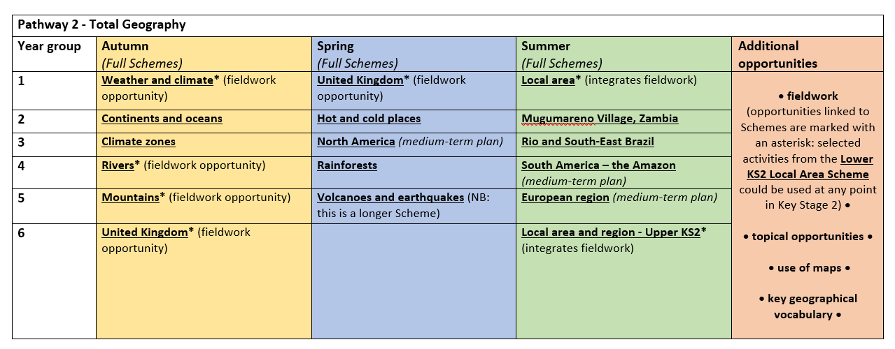

- Pre-assessments or ‘What do you know boards’ are used to start a topic to see the diversity of knowledge in the class. This is organised individually or as a class.
- Geography is planned using Oddizzi which carefully maps out skills, knowledge and vocabulary.
- Children with SEND are supported, and learning is adapted when necessary and appropriate.
- Teachers use rich, engaging resources where pupils value their learning experiences.

Impact

- Pupils enjoy learning about the world and will have developed the geographical knowledge and skills to help them explore, navigate and understand the world around them and their place in it.
- Outcomes in geography books and observed work in EYFS will show a broad and balanced geography curriculum, where children learn key skills and knowledge in a progressive manner linked to the schools long term planning documents.
- Children will review their successes in achieving geography objectives and being able to answer key geographical questions about the geographical theme they are learning. Geographical skills will be embedded alongside knowledge.
- Learning will be broad, deep and meet the National Curriculum statements for each Key Stage. (locational knowledge, place knowledge, human and physical geography, geographical skills and fieldwork.
- We provide all children with same learning experiences. Where children are identified as not being on track for geography, they will be supported as needed so they progress well in all areas.

