
St Michaels CofE Primary School Long Term Overview: Reception 2023-2024

 | Autumn 1 | Autumn 2 | Spring 1 | Spring 2 | Summer 1 | Summer 2
Themes and Topics | SUPER ME  Settling in/Autumn  1 | TERRIFIC TALES  Winter/Christmas  2 | DINOSAURS  Winter  3 | TRANSPORT  Spring/Easter  4 | COME OUTSIDE  Spring  5 | AMAZING ANIMALS  Summer  6
Key Texts | 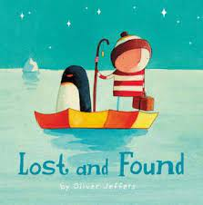  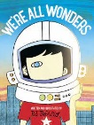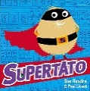 | 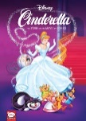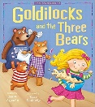 | 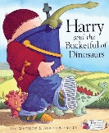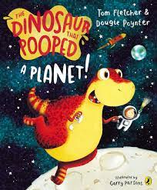  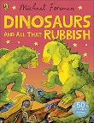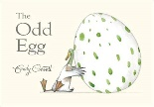 | 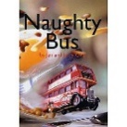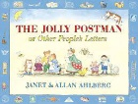  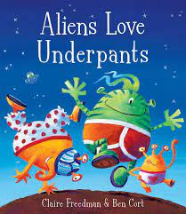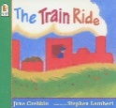 | 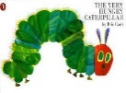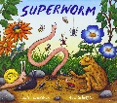  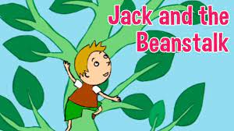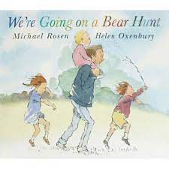 | 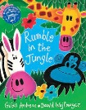  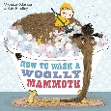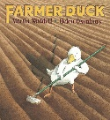
Communication and Language | Speaking and listening activities  Show and tell  Wellcomm  ELKLAN  Blank level questioning  Story time and rhyme time  Children discuss their tapestry observations  Key vocabulary in provision | Speaking and listening activities  Show and tell  Wellcomm  ELKLAN  Blank level questioning  Story time and rhyme time  Children discuss their tapestry observations  Key vocabulary in provision | Speaking and listening activities  Show and tell  Wellcomm  ELKLAN  Blank level questioning  Story time and rhyme time  Children discuss their tapestry observations  Key vocabulary in provision | Speaking and listening activities  Show and tell  Wellcomm  ELKLAN  Blank level questioning  Story time and rhyme time  Children discuss their tapestry observations  Key vocabulary in provision | Speaking and listening activities  Show and tell  Wellcomm  ELKLAN  Blank level questioning  Story time and rhyme time  Children discuss their tapestry observations  Key vocabulary in provision | Speaking and listening activities  Show and tell  Wellcomm  ELKLAN  Blank level questioning  Story time and rhyme time  Children discuss their tapestry observations  Key vocabulary in provision
Literacy | Daily phonics Level 1 and 2  Dough disco and write dance  Holding a pencil correctly  Name recognition and writing  Letter formation  Beginning to write CVC words  Writing labels for body parts  Act out a story  Re-tell a story  Sequence a story  Non-fiction books about the human body and people who help us  Owl Babies  We’re all wonders  Lost and found  Supertato | Daily phonics Level 2  Dough disco and write dance  Holding a pencil correctly  Name recognition and writing  Letter formation  Beginning to write CVC words and simple sentences  Retell of a fairy tale  Act out a story  Re-tell a story  Sequence a story  Non-fiction books about Christmas  Goldilocks  Cinderella  The gruffalo  The Nativity Story | Daily phonics Level 2  Name writing  Letter formation  Writing simple sentences  Fact file of a dinosaur  Act out a story  Re-tell a story  Sequence a story  Non-fiction books about dinosaurs  Harry and a bucket full of dinosaurs  The dinosaur that pooped a planet  Dinosaurs and all that rubbish  The odd egg | Daily phonics Level 2/3  Name writing  Letter formation  Writing 3 sentences independently  Letter writing  Information text for transport  Act out a story  Re-tell a story  Sequence a story  Non-fiction books about transport  Naughty Bus  The jolly postman  The train ride  Aliens love underpants | Daily phonics Level 3  Letter formation  Writing 3 sentences independently  Instruction writing for a broad bean  Writing a list of food for the caterpillar  Act out a story  Re-tell a story  Sequence a story  Non-fiction books about life cycles and growing  The Hungry Caterpillar  Jack and the Beanstalk  Superworm  We’re going on a bear hunt | Daily phonics Level 4  Letter formation  Writing 3 sentences independently  Rhyming and poetry  Shopping list of fruit  Instruction writing  Act out a story  Re-tell a story  Sequence a story  Non-fiction books about transport  Rumble in the jungle  Handa’s surprise  How to wash a woolly mammoth  Farmer Duck
Mathematics | A number a week 1-5  Counting in 1s: 0-20/20-0  Comparing, sorting, matching  Discussing my day  Exploring 2D shapes (circle, semi-circle, triangle, square, rectangle and pentagon)  Numbers on the clock (O’clock)  Recognising, ordering, writing numbers  Daily subitising  Saying one more/one less than each number  Exploring composition of numbers to 5  2 and 3 step repeating patterns  Comparing taller and shorter  Odd and even numbers | A Number a week 5-9.  Counting in 1s: 0-20/20-0  Number bonds to 5  Introduce shapes with 5-9 sides  2D Shape week – composing and decomposing shapes  Numbers on the clock (O’clock)  Recognising, ordering, writing numbers  Daily subitising  Saying one more/one less than each number  Days of the week  Practising a range of different addition methods – numberlines, part whole model, tens frames, using objects  Odd and even numbers | Comparing numbers to 10  Counting in 1s: 0-30/30-0 Starting from any given number  Comparing weight  Number bonds to 10  Practical subtraction within 10  First, then, now  Daily subitising  Saying one more/one less than each number  Exploring different methods of addition  Exploring numbers and place value beyond 10 (11-13)  Odd and even numbers | Counting in 1s and 10s forwards and backwards to 100  Recapping addition and subtraction within 10  Positional language  3D Shape – composing and decomposing shapes  Selecting, rotating and manipulating shapes  Daily subitising  Exploring numbers and place value of 14-16  Odd and even numbers | Counting in 1s, 10s and 2s  Doubling  Halving  Estimating  Sharing and grouping  Odd and even  Capacity  Composition of numbers to 10  Addition and subtraction recap | Consolidation to meet early learning goals
Understanding the World | Senses – senses bottles/ bags  Parts of the body  Discuss families/homes  Different jobs  People who help us  Family tree  Vegetables – our likes and dislikes  Autumn  Harvest  Being special: where do we belong? | Castles  Bears – where do they live?  Forests  Testing materials to keep our bear dry  Winter  Bonfire night  Remembrance day  Diwali  Christmas  Why is Christmas special for Christians? | Dinosaurs  Extinct  Fossils  Recycling  Winter  Hibernation  Nocturnal Animals  Melting and Freezing  Chinese New Year  Valentines Day  Which stories are special and why? | Transport  Vehicles  Make our own vehicle to test  What is the best way to travel?  Day and night  Earth/Sun/Stars/Moon  Rockets  Forces/ magnets/ push and pull e.g. using cars  Does the moon shine  Neil Armstrong  Spring  New life  Pancake Day  Mother’s Day  Why is Easter special for Christians? | Caterpillars to butterflies  Growing & planting – broad beans and sunflowers  Mini beasts  Taste testing – healthy foods e.g. fruit  Different senses – grass, mud, water  Bear hunt maps  Spring  Eid  Which places are special and why? | Pollution and the effect on animals  Different animals and habitats  Animals from around the world  David Attenborough  Summer  Father’s Day  Why is the word ‘God’ so important to Christians?
Physical Development | Dough disco, Write dance and squiggle whilst you wiggle  Building and construction.  Climbing/bikes/scooters  PE sessions  Yoga  Holding a pencil/ mark making/ writing  Using scissors  Snack time – healthy eating  Tooth brushing  Toileting  Getting dressed independently | Dough disco, Write dance and squiggle whilst you wiggle  Building and construction.  Climbing/bikes/scooters  PE sessions  Yoga  Holding a pencil/ mark making/ writing  Using scissors  Snack time – healthy eating  Tooth brushing  Toileting  Getting dressed independently | Dough disco, Write dance and squiggle whilst you wiggle  Building and construction.  Climbing/bikes/scooters  PE sessions  Yoga  Holding a pencil/ mark making/ writing  Using scissors  Snack time – healthy eating  Tooth brushing  Toileting  Getting dressed independently | Dough disco, Write dance and squiggle whilst you wiggle  Building and construction.  Climbing/bikes/scooters  PE sessions  Yoga  Holding a pencil/ mark making/ writing  Using scissors  Snack time – healthy eating  Tooth brushing  Toileting  Getting dressed independently | Dough disco, Write dance and squiggle whilst you wiggle  Building and construction.  Climbing/bikes/scooters  PE sessions  Yoga  Holding a pencil/ mark making/ writing  Using scissors  Snack time – healthy eating  Tooth brushing  Toileting  Getting dressed independently | Dough disco, Write dance and squiggle whilst you wiggle  Building and construction.  Climbing/bikes/scooters  PE sessions  Yoga  Holding a pencil/ mark making/ writing  Using scissors  Snack time – healthy eating  Tooth brushing  Toileting  Getting dressed independently
Expressive Art and Design | Painting Self-Portraits  Mixing colours – paint mixing  Listen to music and discuss how they feel  Cosmic kids yoga  Drawing and painting pictures of houses  Make super veggies  Children design themselves as a superhero  Design Police badges  Act out situations eg. someone is lost/someone is injured  People who help us craft  Leaf printing  Andy Goldsworthy outdoor art  30 minute weekly music lesson with Mrs Willis  Explore dynamics: whispering, speaking, singing, sing echo songs, perform actions to songs/rhymes. Listen and respond to identify pitch | Junk model castles  Poppies  Christmas crafts  Christmas biscuits  Winter artwork  Nativity  Making music during CP  Small world and construction  Junk modelling  30 minute weekly music lesson with Mrs Willis  Explore dynamics: whispering, speaking, singing, sing echo songs, perform actions to songs/rhymes. Listen and respond to identify pitch | Chinese New Year Crafts  Valentine’s Day cards and crafts  Dinosaur crafts  Moving like a dinosaur  Making music during CP  Small world and construction  Junk modelling  30 minute weekly music lesson with Mrs Willis  Explore patterns, sequences, rhythms inc verse/chorus. Perform cululative songs/chants inc instruments | Transport  Make our own vehicle  Mother’s Day Cards  Pancake Day Crafts  Easter Cards  Spring art work  Painting daffodils and other flowers  Art work with nature  Making music during CP  Small world and construction  Junk modelling  30 minute weekly music lesson with Mrs Willis  Explore patterns, sequences, rhythms inc verse/chorus. Perform cululative songs/chants inc instruments | Collaging butterflies  Repeating pattern caterpillars  Symmetrical Butterflies  Van Gough sunflower artwork  Making music during CP  Small world and construction  Junk modelling  30 minute weekly music lesson with Mrs Willis  Dynamics: loud, quiet. Sing actions songs and match hand/body movements to lyrics, explore instruments and dynamics | Animal crafts  Summer crafts  Father’s day cards and craft  Making music during CP  Small world and construction  Junk modelling  30 minute weekly music lesson with Mrs Willis  Dynamics: loud, quiet. Sing actions songs and match hand/body movements to lyrics, explore instruments and dynamics
Personal, Social and Emotional | Introduce classroom/school rules and routines  Stickers/Team points/Positive praise  Reward systems  Turn Taking/Sharing  Making relationships  Becoming independent toileting/getting dressed  PSHE – Heartsmart/scarf  Me and my relationships:  All about me  What makes me special  Me and my special people  Who can help me?  My feelings | Following classroom/school rules and routines  Stickers/Team points/Positive praise  Reward systems  Turn Taking/Sharing  Making relationships  Becoming independent toileting/getting dressed  PSHE –Heartsmart/scarf  Growing and changing:  Seasons  Life stages  Where do babies come from  Getting bigger  Me and my body | Following classroom/school rules and routines  Stickers/Team points/Positive praise  Reward systems  Turn Taking/Sharing  Making relationships  Independent toileting/getting dressed  PSHE –Heartsmart/scarf  Valuing differences:  I’m special/you’re special  Same and different  Same and different families and homes  I am caring  I am a friend | Following classroom/school rules and routines  Stickers/Team points/Positive praise  Reward systems  Turn Taking/Sharing  Making relationships  Independent toileting/getting dressed  PSHE –Heartsmart/scarf  Keeping myself safe:  What’s safe to go onto my body  Keeping myself safe  Safe indoors and outdoors  Listening to my feelings  Keeping safe online  People who help to keep me safe | Following classroom/school rules and routines  Stickers/Team points/Positive praise  Reward systems  Turn Taking/Sharing  Making relationships  Independent toileting/getting dressed  PSHE –Heartsmart/scarf  Rights and responsibilities:  Looking after my special people  Looking after my friends  Being helpful  Caring for our world  Looking after money | Following classroom/school rules and routines  Stickers/Team points/Positive praise  Reward systems  Turn Taking/Sharing  Making relationships  Independent toileting/getting dressed  Prepare for the transition to Year 1.  PSHE –Heartsmart/scarf  Being my best:  Bouncing back when things go wrong  Yes, I can!  Healthy eating  My healthy mind  Move your body  A good night’s sleep
Visits and Visitors | Autumn trail | Pantomime | Winter walk | Drama session | Spring Walk | Sea life or farm trip

