

Power Maths calculation policy, Reception
The following pages show the Power Maths progression in calculation (addition, subtraction, multiplication and division). The consistent use of the CPA (concrete, pictorial, abstract) approach across Power Maths helps children develop mastery across all the operations in an efficient and reliable way. In Reception, children focus on concrete and pictorial representations. At this stage, children focus on representing objects in different ways e.g. understanding that 5 cars can also be represented as 5 counters, 5 cubes, 5 pictures of cars, etc.

In Reception, children are encouraged to record their findings in their own way. This may include writing number sentences e.g. 3 + 4 = 7, however this is not a requirement until Year 1.

Power Maths calculation policy Reception
Children develop the core ideas that underpin all calculation. They begin by connecting calculation with counting on and counting back, but they should learn that understanding wholes and parts will enable them to calculate efficiently and accurately, and with greater flexibility. Children record their calculations in their own ways, there is no expectation of number sentences at this stage, however children may choose this way to record their thinking.
Key language: count, forwards, backwards, whole, part, recombine, break apart, ones, ten, tens, number bond, add, adding together, addition, plus, total, altogether, first, then, now, subtract, subtraction, find the difference, take away, minus, left, less, more, fewer, group, share, equal, equals, is equal to, groups, equal groups, divide, share, shared equally
Addition:  Children start to explore addition by sorting groups. They then use sorting to develop their understanding of parts and wholes.  Children combine groups to find the whole, using a part-whole model to support their thinking. They also use the part-whole model to find number bonds within and to 10.  Using a five frame and ten frame, children add by counting on. They start by finding one more before adding larger numbers using counters or cubes on the frames.  Children use a number track to add by counting on. Linking this learning to playing board games is an effective way to support children’s addition. | Subtraction:  Children start to explore subtraction by sorting groups. They use sorting to develop their understanding of parts and wholes.  When comparing groups, children use the language more than and fewer than. This will lead to finding the difference when they move into KS1.  Children then connect subtraction with the idea of counting back and finding one less using a five frame to support their thinking.  They explore subtraction by breaking apart a whole to find a missing part. This links to their developing recall of number bonds.  Children count back within 20 using number tracks and ten frames to see the effect of taking away. | Multiplication and Division:  Children first start to look at the idea of equal groups through their exploration of doubles. They use five frames and objects to check that groups are equal.  Children then explore halving numbers by making two equal groups. They highlight patterns between doubling and halving seeing that double 2 is 4 and half of 4 is 2.  As well as halving, children also explore sharing into more than two equal groups. They share objects one by one, ensuring that each group has an equal share.

Reception
 | Real-life representation | Other representations
Addition | Counting and adding more (within 5)  Children add one more person or object to a group to find one more.  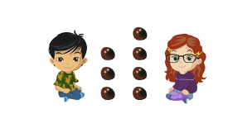  One more than 3 is 4. | Counting and adding more (within 5)  Children represent first, then, now stories on a five frame. They make the first number and then add one more.  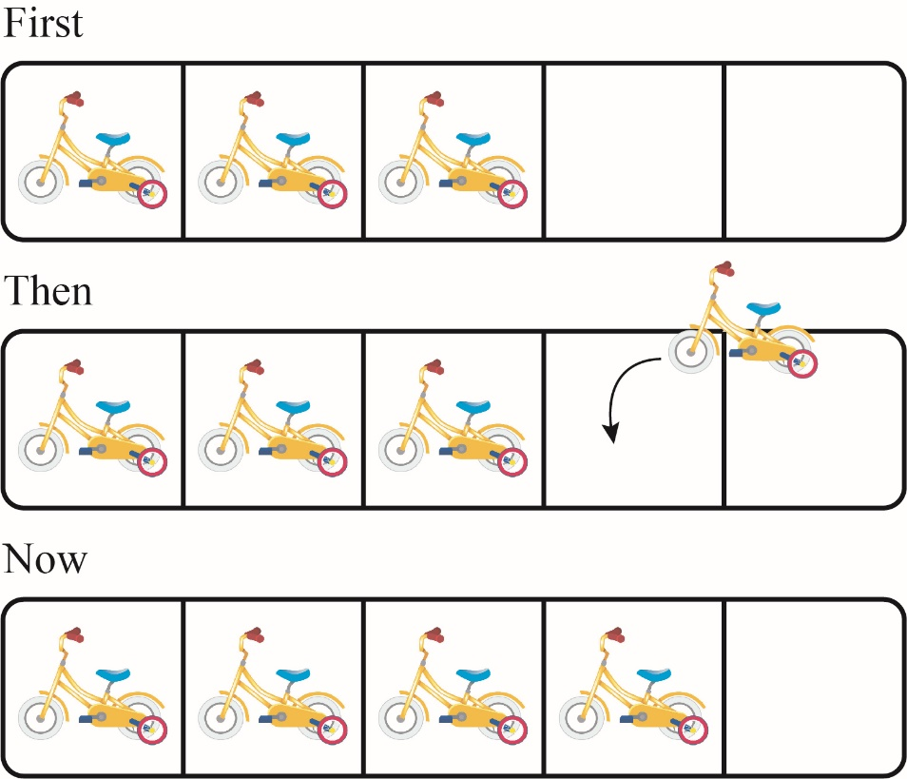  First, there are 3 bikes.  Then, 1 more bike came.  Now, there are 4 bikes.

 | Combining groups to find the whole  Children sort people and objects into parts and combine them to find the whole.  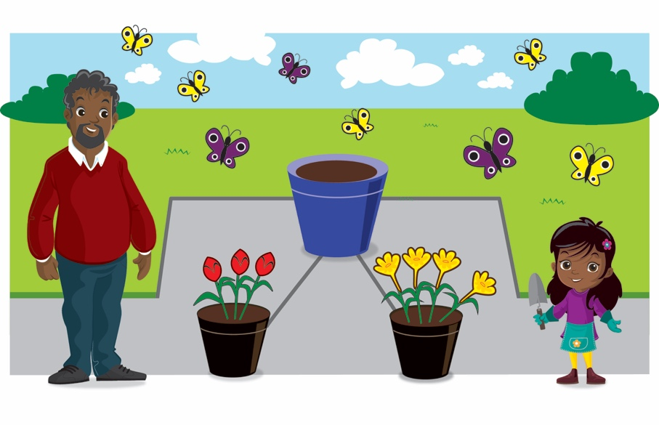  The parts are 3 and 4. The whole is 7. | Combining groups to find the whole  Children use counters or cubes in a part-whole model to find the whole.  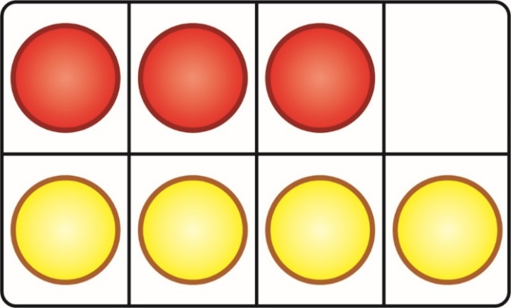  The parts are 3 and 4. The whole is 7.

 | Finding number bonds to 10  Children combine two groups to find a number bond to 10.  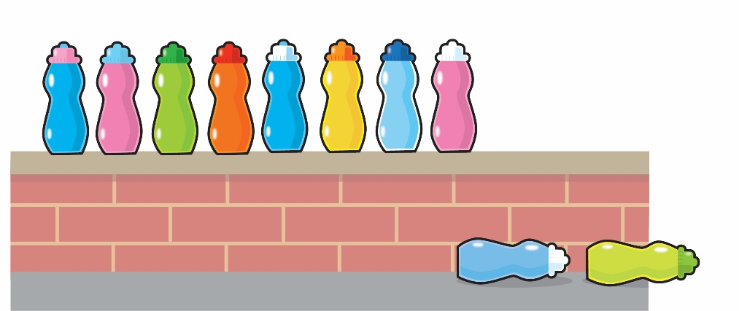  There are 8 bottles on the wall.  There are 2 bottles on the floor.  There are 10 bottles altogether. | Finding number bonds to 10  Use ten frames and part-whole models to represent key number bonds.  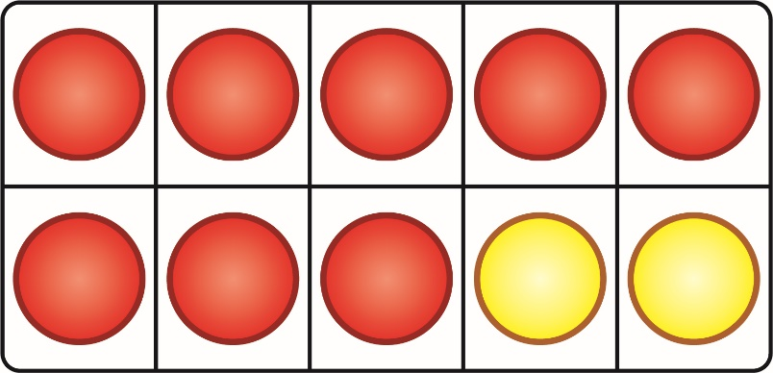  8 and 2 is 10.  There are 10 altogether.  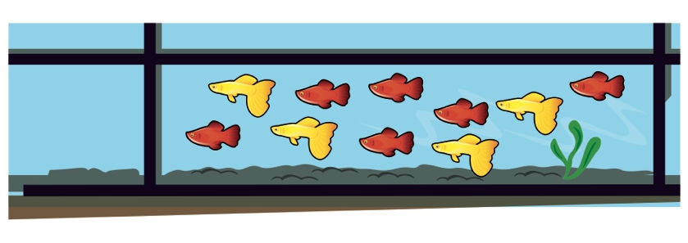  6 and 4 is 10.  There are 10 altogether.

 | Adding by counting on (number track)  Children jump along a physical number track. They start at the larger number and count on the smaller number to find the total.  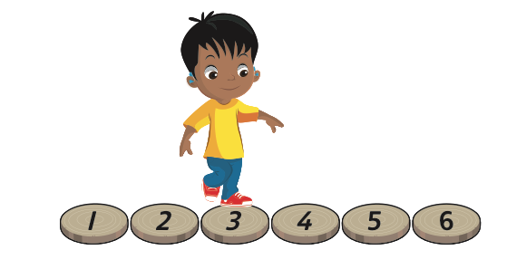 | Adding by counting on (number track)  Children use a number track and a counter. They start at the larger number and count on the smaller number to find the total.  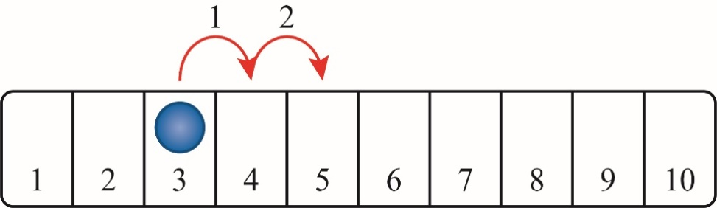
 | Adding by counting on (ten frames)  Children find the total number by counting on from the larger number. | Adding by counting on (ten frames)  Children make the larger number on the ten frames and then make the smaller number, counting on to find the total. They can use counters, cubes or other objects on the ten frames.  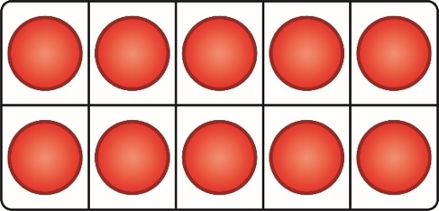  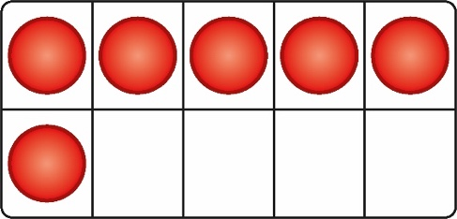
Sorting groups (optional)

Children sort everyday objects into groups.

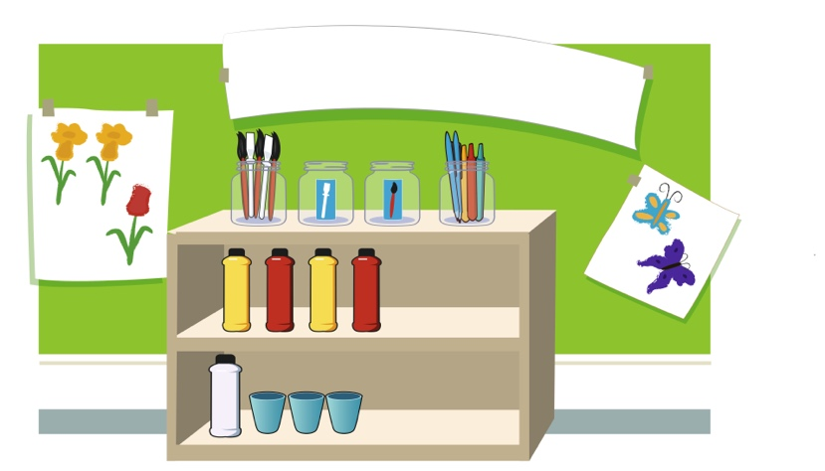

Subtraction | Comparing groups  Children line up objects to compare the amount. They line the objects up either horizontally or vertically.  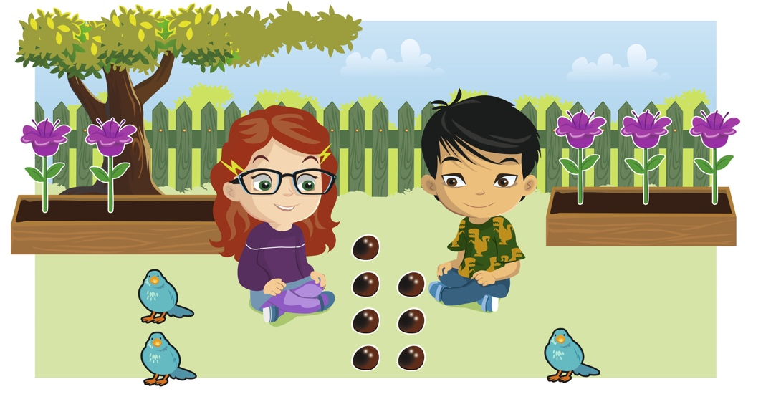  Ella has more conkers.  Tom has fewer conkers. | Comparing groups  Children line up cubes or counters to compare the amount in each group. Lines can either be horizontal or vertical. A starting line helps to line the objects accurately.  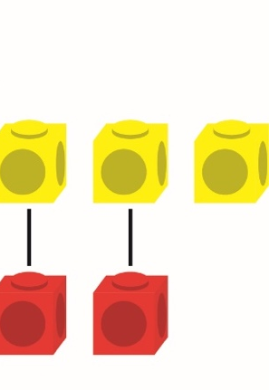  There are more yellow cubes.  There are fewer red cubes.

 | Counting back and taking away (within 5)  Children remove one more person or object from a group to find one less.  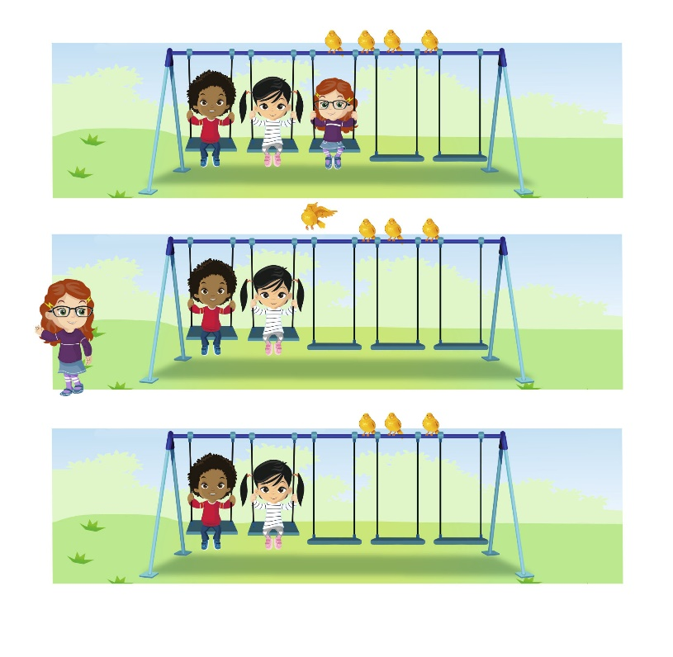  First, there were 3 children.  Then, 1 child left.  Now, there are 2 children. | Counting back and taking away (within 5)  Children use five frames and objects to make a number. They then remove or cross out one object to find one less.  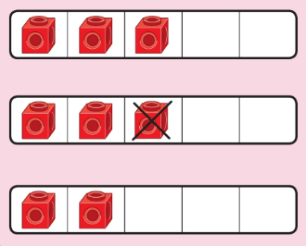  One less than 3 is 2.

 | Introducing the part-whole model  Children sort everyday objects into parts.  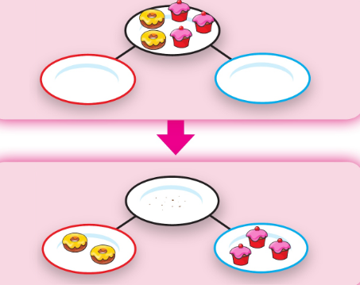    One part is the    The other part is the | Introducing the part-whole model  Children use counters or cubes to represent objects in a part-whole model.  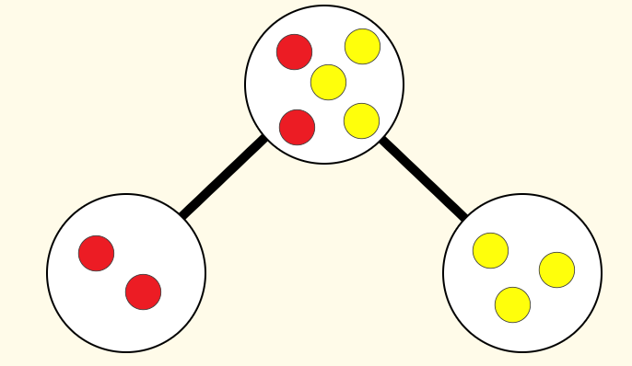  The whole is 5.  2 is a part.  3 is a part.
 | Finding number bonds to 10  Children partition 10 into different groups to find the number bonds to 10.  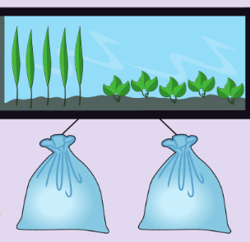  Children begin to work with subtraction number bonds. They break apart 10 to identify different number bonds to 10.  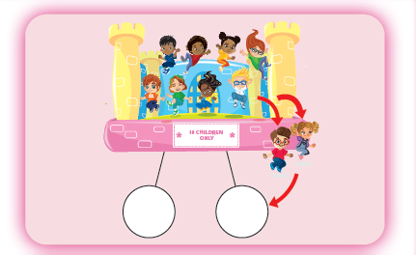  10 are bouncing.  2 get off.  8 are left.  10 – 2 = 8 | Finding number bonds to 10  Children use part-whole models, ten frames and counters to find the number bonds to 10.  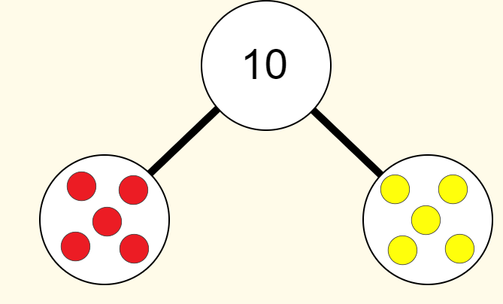  10 is the whole.  5 is a part and 5 is a part.  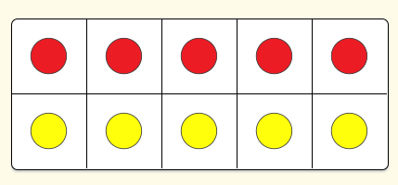  10 is the whole.  5 is a part and 5 is a part.  Children use part-whole models, and counters to find missing parts and the subtraction number bonds to 10.  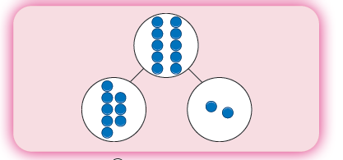  The parts are 8 and 2.  10 is the whole.
 | Counting back and taking away (number track)  Children use game boards and human number tracks to subtract by counting back.  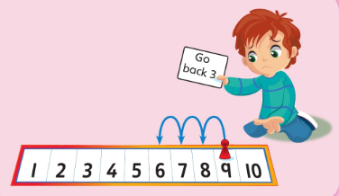  9 take away 3 equals 6  9…8…7…6 | Counting back and taking away (number track)  Children use a number track and a counter. They start at the larger number and count back the smaller number to find the answer.  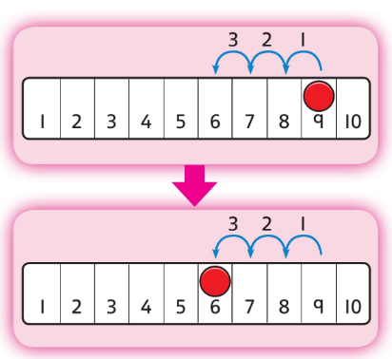  9 take away 3 equals 6  9…8…7…6
 | Counting back and taking away (ten frames)  Children count backwards to find one less with numbers up to 20.  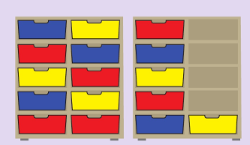  One less than 16 is 15. | Counting back and taking away (ten frames)  Children remove counters from ten frames to support in counting back with numbers up to 20.  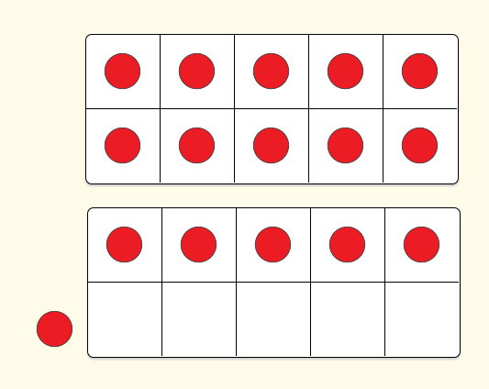  One less than 16 is 15.
Sorting groups (optional)

Children sort everyday objects into groups.
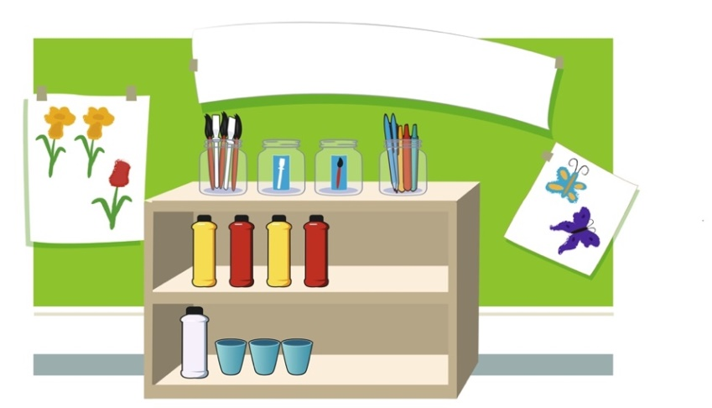
Multiplication | Making doubles  Children explore doubles in their environment including in games such as on dominoes or dice. They focus on the understanding of doubles being 2 equal groups.  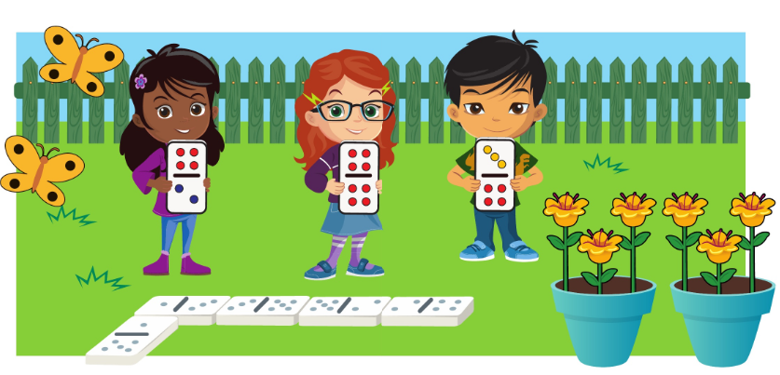  Double 4 is 8.  Double 2 is 4.  Double 3 is 6. | Making doubles  Children use five frames to find doubles by lining up counters or cubes.  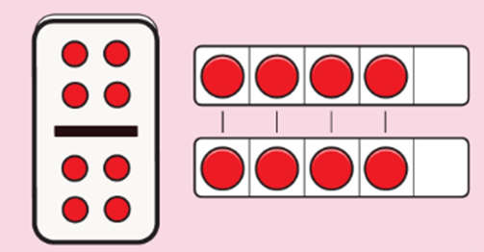  Double 4 is 8.
Division | Halving and sharing  Children explore halving and sharing through practical sharing using real life scenarios including sharing fruit or classroom equipment.  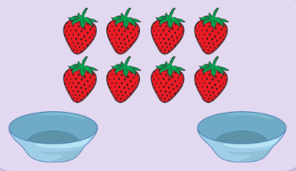  Half of 8 is 4. | Halving and sharing  Children use five frames to share amounts fairly and to check that the groups are equal. They share the counters/cubes one by one.  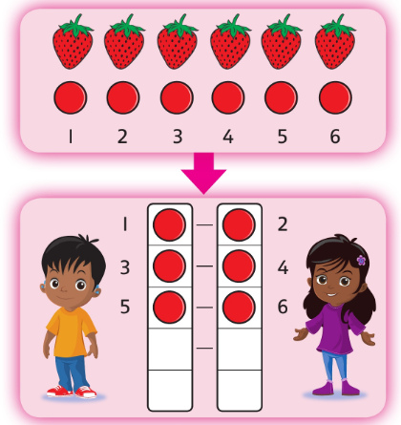  Half of 6 is 3.

