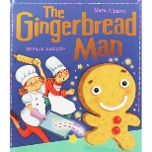
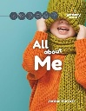

Our focuses will include matching facial expressions to the emotions of happy, sad, angry, scared. We will also continue working on allowing others to play alongside us or to join in with our play. We will begin to share our likes and dislikes.

The stories we will be focusing on:
- The Gingerbread Man
- All about me
- The Family Book

In maths we will be working on numbers to 5, counting, subitising and grouping. We will look at measuring when we look at ourselves. We will look at 2D shapes and patterns.
Maths
M
PE

Communication and Language

Our focus during this half term will be centred around using chat boards to support the children in communicating what they want and how they feel, during some of their favourite activities. We will continue to use Makaton signs we already know and learn new ones linked to our topic.

We will be using Makaton signs and story props to help us retell the main parts of our stories. We will be beginning to have a go at writing some simple words to label our pictures.

Acorns – Autumn 1
All About Me
Personal, Social and Emotional

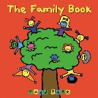

We will be taking part in continuous provision activities to support our interactions with others and develop our social skills.
Interactions

Art

In Art, we will be using our cutting and sticking skills to make pictures.



SALT

We will be working on our targets for SALT through one to one and group sessions.
Understanding the world

We will be learning and sharing about ourselves, who we are, who are family is, our homes. We will make portraits of ourselves. We explore our senses and feelings.

Literacy

In PE, we will continue developing our ball skills

