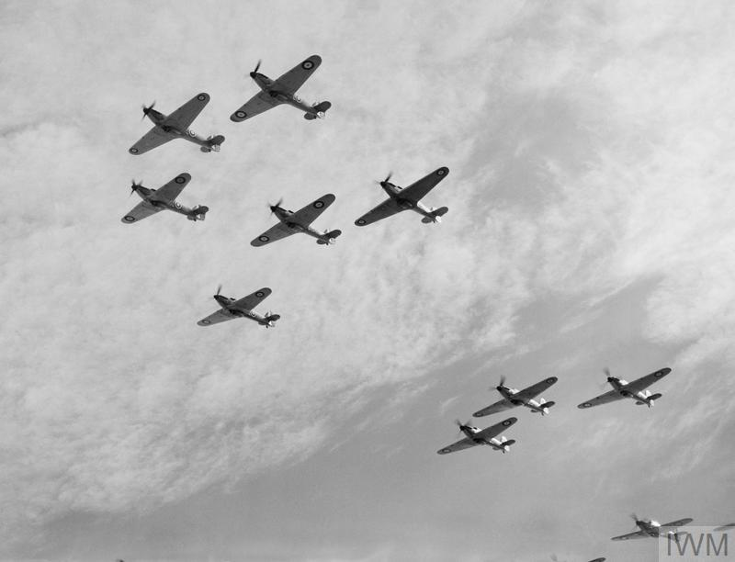
Geography
In Geography, we will use maps, atlases, globes and computer mapping to locate the world’s countries. We will focus on Europe and which countries were involved in World War Two.
English
In English, we will be using the books ‘Star of Fear, Star of Hope’ and ‘Erika’s Story’ as inspiration for writing a range of narratives including letters, diaries and flashbacks.
Vocabulary
conflict declare
occupation/occupy ally
prejudice blitz
compassion ration
invade blackout
neutral evacuation
holocaust identity
angst Jew
friction Nazi
sacrifice chancellor
Prime Minister axis
chancellor

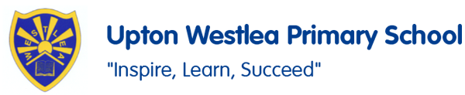
DT – Cooking and nutrition
In DT, we shall be exploring food and nutrition during the war.

RE
In RE, we will be considering what it means to live in a religiously diverse world.
French
In French, we will be learning about feelings and about how to speak about someone in the third person. They will also be looking at French school timetables.
P.E
In P.E, we will be developing our skills in gymnastics and hockey.

Music
Music, we will look at swing music, syncopation, swing rhythm, Big Band, scat singing.

History
In History, we will study World War Two with a focus on the Battle of Britain as a significant turning point in British history.

Year 6 - Autumn 1

PSHE
In PSHE, we are using the book ‘The Thing’ as part of No Outsiders. We will also look at assertiveness, cooperation, safe/unsafe touches and positive relationships.
Computing
In computing, we will use Microsoft Excel and Google Sheets to create formula on spreadheets.
Maths
In Maths, we will be focussing on place value including ordering and comparing. We will also work through all four operations: addition, subtraction, multiplication and division. We will also develop greater fluency with arithmetic style questions.

Science
In science, we will be learning about how light travels ; how we see; and how shadows are formed.

