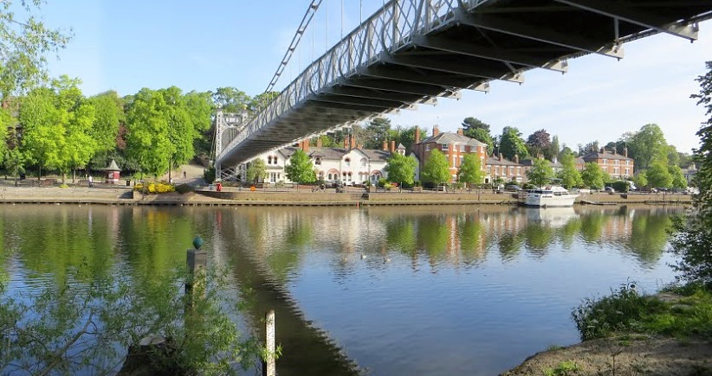
z

In History, we will look at how the Anglo-Saxons changed Britain. We will learn about where they came from, where the Anglo-Saxons invaded, their culture and their Kings.

History

In Music, we will be using our sing up scheme where we will be looking at composition of music and writing some music using a rhythm grid. As a class, we will also learn how to sing with a pitch on a strong beat. The children will practice singing in unison while playing a beat on an instrument.

English

In English, we will base our learning using the narrative book ‘Queen of the Falls’ to inspire our writing. The true story of Annie Edson Taylor, a retired charm school instructor, who decided to seek fame and fortune by going over Niagara Falls in a wooden barrel! We will be working towards writing a recount of her experience in the form of a series of diary entries.

Music

In computing, we will be looking at different computing systems and networks.
Computing

PSHE/RE

This term we will be following the ‘SCARF’ programme and we will be looking at ‘Me and My Relationships’. In RE, we will be focusing on the Five Pillars of Islam.

In Science, we will be learning about gravity, air resistance, water resistance and friction. We will also develop an understanding of mechanisms, including lever, pulleys and gears.
Year 5 Autumn 1
Rapid Rivers

Science

In Art, we are using our painting and drawing skills to imitate Claude Monet representation of the River Thames. We will be starting our DT in Autumn 2.

Art/DT

In PE, we will be working on our tennis and netball skills throughout this half term.

PE

Maths

In Maths, we will be continuing the learning of place value and developing our skills in addition and subtraction. We will further enhance our multiplication and division skills within this term whilst recapping key skills.

achieve bruise curiosity desperate disastrous embarrass especially immediately marvellous muscle opportunity profession queue recommend sacrifice temperature restless currents downriver shoreline rapids waterfall remarkable discombobulation spectators cascading locomotive plunge widow

End Point

Key Vocabulary

We will develop a solid understanding of how rivers are important to us and our wildlife.




