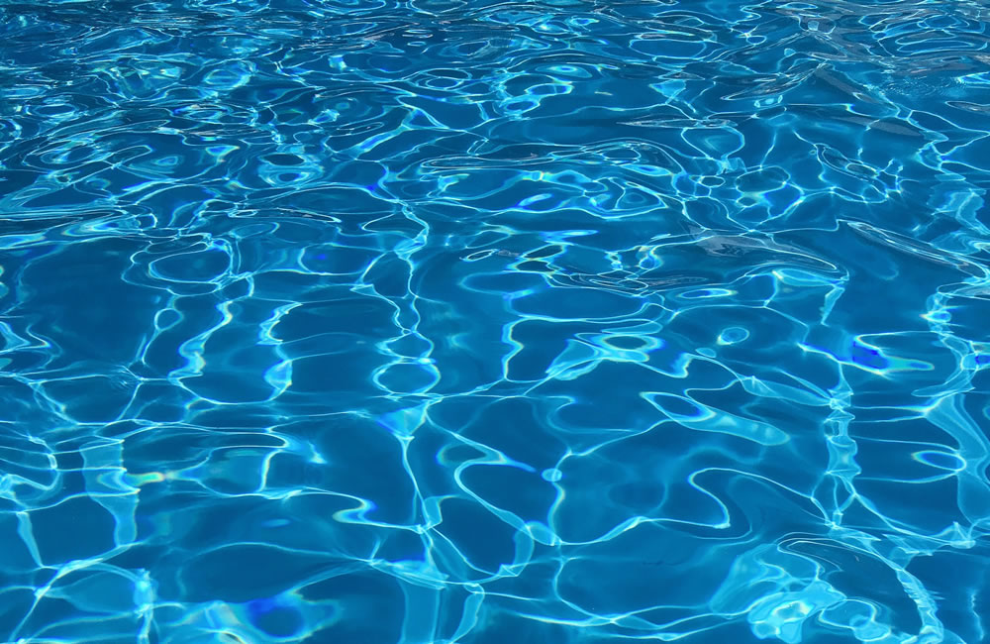
English
In English, we are using the non-chronological book ‘Seal Surfer’ (Michael Foreman) to inspire our writing. Our final piece will be a letter (recount).
Geography
In Geography, we are exploring UK, looking at coasts and counties as well as how people might travel around the UK.
PSHE/ RE
In PSHE, we are looking at the SCARF theme ‘Me and My Relationships’ where we consider how others may see us and how I can be a good friend.

In RE, we will be answering the Big Question, ‘What does a Hindu believe about God and how is Diwali celebrated?’

Make a collage of what is British.

Rich, poor, beautiful, ugly

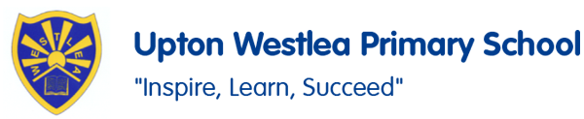
PE
In PE, we are working on our net and wall game sense.
We also have Forest School this half term.
Art/DT
In DT, we are using our cooking skills to create a healthy stew in Forest School.

French
In French, year 3 will be looking at greetings, numbers and colours. Year 4 will be looking at our ‘welcome to school’ unit.

Key Vocabulary
Smudge, nuzzle, burst, fade, brim, haul, wrench, gather, heave, buffet, churn, dissolve, gale, boulder, harbour, horizon, quay, moult, somersault, corkscrew.
Maths
In Maths, we are working on place value, addition and subtraction skills, as well as multiplication and division.
Science
In Science, we are looking at humans and other animals – their skeletal systems and nutrition.
Computing
In Computing, we are looking at how to compose emails.
Year 3/4
Autumn 1

Music
In Music, we are focusing on the song ‘I’ve been to Harlem’ to explore pitch shape, ostinato, round, pentatonic and call-and-response.

