I can create a narrative based on the structure of ‘The Hunter’ by changing characters, animals and setting.
Key Vocabulary

convenience determined desperate harass hindrance necessary occur prejudice tracked mournful poachers horizon acacia herd stalked whimper blazing tuskers

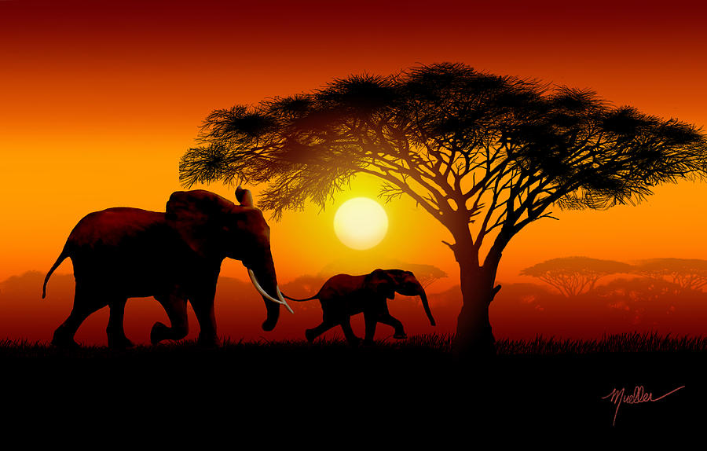
History

In History, our topic will be focusing on the Ancient Egyptians. We will understand who the Ancient Egyptians are and develop our understanding of why the pyramids were built and who were the Ancient Egyptian pharaohs. We will also learn about who discovered Tutankhamun’s tomb.

RE

In RE, we will look at how people show their beliefs in action.

English

In English, we will progress our learning linking to the book ‘The Hunter’ by Paul Geraghty. The story of Jemina and a baby elephant will give us the opportunity to write an adventure story. The children will be developing their cohesive skills, using adverbs to indicate degrees of possibility and relative clauses to add extra information.
.

Computing

In Computing, we will be developing our programming skills to create a computer animation.

PSHE

In PSHE, we will be looking at growing up into young adults and how this might affect us.

In Science, we will be learning living things and their habitats. We will have the opportunity to describe different life cycles and describe the process of reproductions in some plants and animals.
Science

Year 5 Summer 2
Into Africa!

In Music, we will continue to improve on playing our instruments and will compose a song for a performance.

Music

Art

In Art, we will be progressing our skills in drawing. We will be looking at perspective drawing and creating a final piece using our new skill.

In PE, we will develop our learning of rounders and football. Children will have the opportunity to gain confidence and improve their skills in swimming.

PE

In Maths, we will be progressing towards geometry and measurement. Properties of shape including angles and position and direction including coordinates will be introduced this half term. Children will then convert a variety of units and learn about volume.
Maths

End Point




