Throughout this half term, we will be learning about shapes, area and position and direction.

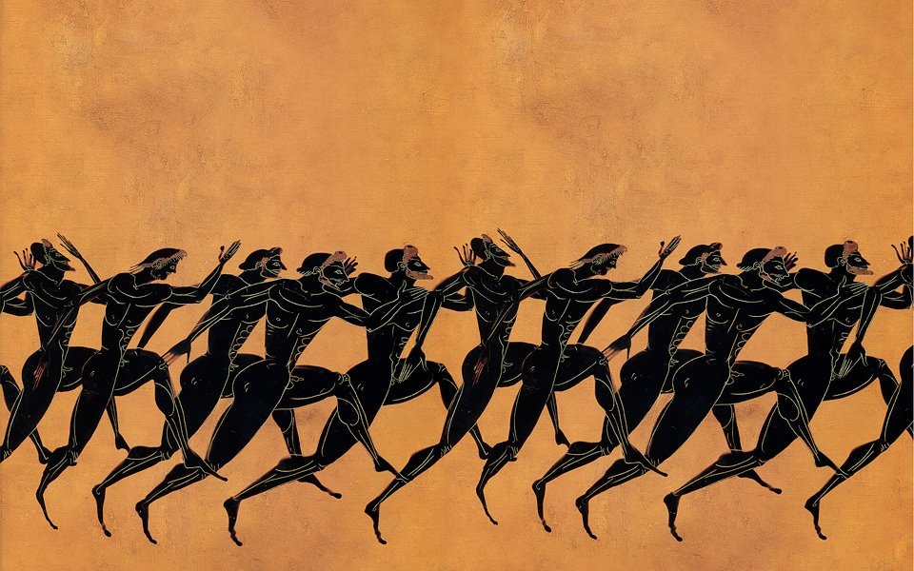

In History, we will be learning all about life in Ancient Greece. Children will gain an understanding of why Greek soldiers were so powerful. They will also investigate the origins of the Olympic games.
English

In English, we will be using the book Blue John by Berlie Doherty as the stimulus for our learning. We will use a range of sentence structures and developing an awareness of organising to write a letter with an explanation about cave formations.

History

In Music, we will be looking at Favourite song, a fast, folk-rock style with a driving rhythm, reminiscent of the style of Mumford and Sons.
Music

In Computing, we will be looking at creating media by photo editing.
Computing

PSHE

During SCARF lessons, we will be looking at Growing and Changing.

Year 3/4 Summer 2
Honour and Pride

In Science, our focus will continue to be on living things and their habitats. We will be improving our investigation skills to group living things in a variety of ways and recognising that environments can change, posing potential dangers.

Science

In PE, we will be developing our track and field skills in athletics. We will also be playing cricket and going swimming.

PE

Art and DT

In Art, we will be looking at printing repeated patterns and colours.
In DT, we will be at shell structures.

Surge glacier gush cavern billow stalactites chamber stalagmites snatch formation mould pools clasp amethyst enchantment amber sprawl grotto ebony ledge pressure knowledge experiment peculiar interest length guard

Key Vocabulary

Maths

RE

During RE sessions, we will be learning all about Hinduism and how people worship at home.

