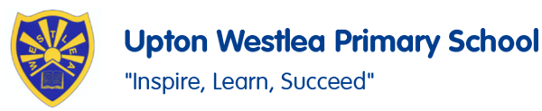
PSHE
In PSHE, we are going to be focusing on themes including ‘Growing and changing’ with a focus on keeping ourselves healthy, who can help us and about keeping ourselves safe. We will also be focusing on transitions and the NSPCC Pants activities.

Make a collage of what is British.

Rich, poor, beautiful, ugly

History
In History, we are going to be learning about the Great Fire of London. We will be learning about the key events of the historic event and be able to explain what happened and why it spread.
PE
In PE, we will be practising for our Sport’s Day and Understanding games focusing on attacking and defending within game situations.
Social Skills
We will work together to build our social skills including turn taking, learning about situations and emotions and feelings.
English
In English, we are going to be reading lots of poems. We will be learning and performing some of our favourite poems before we create our own poems and perform them for our friends.

SALT
We will be working on our targets for SALT through one to one and group sessions.

Oaks
Summer 2

Science
In Science, we are exploring the topic of Healthy me! We will be learning about personal care and why is it important. We learn about making healthy choices including exercise, healthy food and conduct some experiments.
DT
In DT this half term we are going to focus on food. We will be planning and making different meals such as pizzas and smoothies. We will try new foods.

Music
In Music, we are going to listening to music from Poland includingTańczymy labada and Płynie statek. We will be focusing on following a change in beat and tempo and accompany music with instruments.
Maths
In Maths, we will be continuing with our Recap Maths to recap and develop our multiplication and division recall. In our lessons, we will be focusing on fractions, division, time and shape.
French
In French, we are focusing on learning and identifying different minibeasts and looking at the theme of birthdays.

