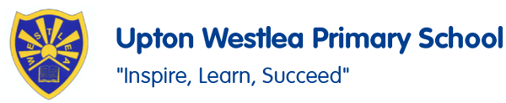
PSHE
In PSHE, we are going to be focusing on themes including ‘Being my best’ and continuing our learning of the Zones of Regulation and how we can use our new learning to help us understanding our feelings and emotions.

Make a collage of what is British.

Rich, poor, beautiful, ugly

Geography
In Geography, we are going to be learning about the different hot places in the world. We will be locating them using our map and atlas skills and learn about their geographical features.
PE
In PE, we will be practising for our Sport’s Day and learning skills linked to rackets, bats and balls.
Social Skills
We will work together to build our social skills including turn taking, learning about situations and emotions and feelings.
English
In English, we are using the books ‘The Little Lost Dragon’ and ‘The adventures of egg box dragon!’ With these books we will be focusing on character descriptions and instructional writing.

SALT
We will be working on our targets for SALT through one to one and group sessions.

Oaks
Summer 1

Science
In Science, we are exploring Living things and where they live. Following our trip to Chester Zoo we will be focusing on different habitats and classification of different animals. We will also look at Microhabitats and how we can protect them.
Art
In Art this half term, the children are going to be using the themes of our English Dragon characters to complete dragon inspired art work.

Music
In Music, we are going to looking at music from Charlie Chaplin and music by Swing-a-long with Shostakovich. We will be listening to the music and discussing it and composing our music to link with the genre.
Maths
In Maths, we will be continuing with our Recap Maths to recap and develop our multiplication and division recall. In our lessons, we will be focusing on fractions, time and money.
French
In French, we are focusing on learning and identifying different family members in French and continue to learn more colours and learn and identify parts of our faces.

