Maths

In Maths, we will be learning more about money and begin our new topic of mass, volume and length.

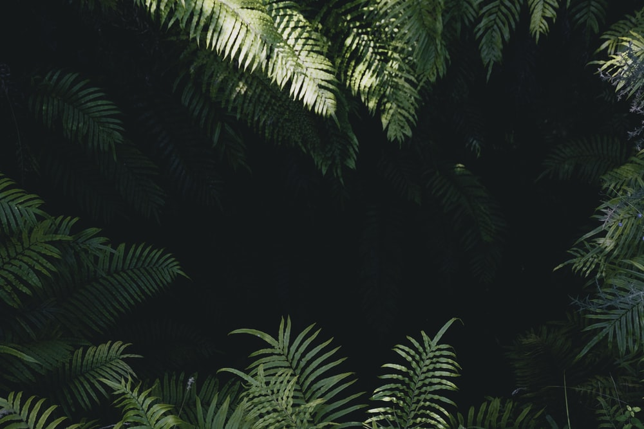
Music

In music, we will be looking at the pentatonic scale – a five-note musical scale, which takes its name from the Latin ‘penta’ meaning five, and ‘tonus’, which means sound or tone.
We will also be looking at one of the first ever motion pictures of a horse running.

In Geography, they will be learning about the key aspects of a tropical climate and the layers of the Rainforest. They will learn about the animals and plants living in the Rainforest. They will also learn about the effects that humans are having on the trees and forests through deforestation.
English

In English, our focus will be on non-fiction writing. Using two fantastic books (Rainforests in 30 Seconds and Where the Forest Meets the Sea) as the foundations for our learning, our aim is to write a non-chronological report to be used as a zoo information display. We will develop varied and rich vocabulary throughout.

Geography

Computing

In computing, we will be looking at branching databases.

PSHE

In PSHE, we will be looking at how to be our best selves.

Year 4 Summer 1
Deep in the Jungle

In Science, our focus will be on living things and their habitats. We will be grouping living things in a variety of ways using classification keys and recognising that environments can change, posing potential dangers to living things.
Science

PE

In PE, we will be developing our throwing and jumping in Athletics. We will also developing our game sense through invasion games.

In Art, we will be learning about the American painter Edward Hopper.
In DT, we will be learning about James Dyson.
Art and DT

In RE and Worldviews, we will be looking at Humanism.

RE and Worldviews




