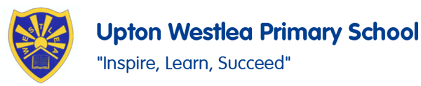
PSHE

In PSHE, we are going to be focusing on themes including being respectful, how to be healthy, who can help us and how can we take care of something.

Make a collage of what is British.

Rich, poor, beautiful, ugly

Music
In Music, we are going to looking at the piece of music Grandma Rap. We will be learning some new songs and composing some of our own.
PE
In PE, we are developing our gymnastic skills focusing on linking and ball skills focusing on using our feet and our control.
Social Skills
We will work together to build our social skills including turn taking, learning about situations and emotions and feelings.
English
In English, we are using the book ‘All things Tigers’. We are going to learn all about Tigers and use our knowledge to create non-fiction texts about Tigers and other animals.

SALT
We will be working on our targets for SALT through one to one and group sessions.

French
In French, we are focusing on learning and joining in French rhymes, playground games and learning more French vocabulary.
Geography
In Geography this half term we are going to be learning about the North and South Pole. We will focus on where they are, what wildlife lives there and what is it like to live in these spectacular places.
Oaks
Spring 1

Art
In Art this half term, we are going to link it to our Geography topic and develop our painting skills to create different pieces of work linked to the North and South Pole.

Science
In Science, we are exploring Growing Plants. We will be focusing on how plants grow and the different types. We will investigate what makes a plant grow well. We will also plant our own seeds and observe them germinate and grow.

Maths
In Maths, we will be continuing with our Morning Maths to recap and develop our addition and subtraction skills. In our lessons, we will be focusing on further addition and subtraction and shape.

