In Art, we will be looking at drawing. We will be using different grades of pencil and techniques.
Maths

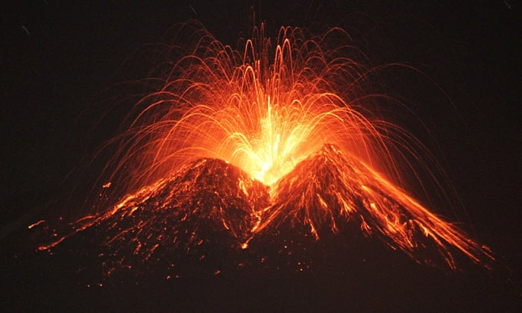
Music

In Music, we will be listening to and learning about Fanfare for The Common Man.
We will also be creating music inspired by Spain.

In Geography, we will be learning about natural disasters through physical and locational knowledge. Children will learn all about volcanoes focusing on where they are, how they are formed and the structure inside. Children will complete a case study on Iceland and its volcanic eruption.

In English, we will base our learning on the story of ‘When the Giant Stirred’. The story of one island, formed and ultimately destroyed by the action of a volcano. We will be working towards writing a story from the point of view of one of the characters in the text using a variety of descriptive sentences.

English

Geography

In computing, we will be looking at repetition in games, using Scratch.
Computing

Year 3/4 Spring 2
The Power of Mother Nature

In PSHE, our SCARF theme is ‘Rights and Responsibilities’.

PSHE

In Science, our focus will be on states of matter and the water cycle. We will be grouping and comparing materials, observing the changes of state and identifying the parts played in evaporation and condensation.
Science

In PE, we will be focussing on Dance and we will have Forest School.

PE

Art

Throughout the half term, we will be focusing further on fractions and time. We will also continue to focus on our times tables.

In RE, we will be continuing our focus on Christianity. We will be looking at why Easter was part of a plan and why Jesus died.
RE

