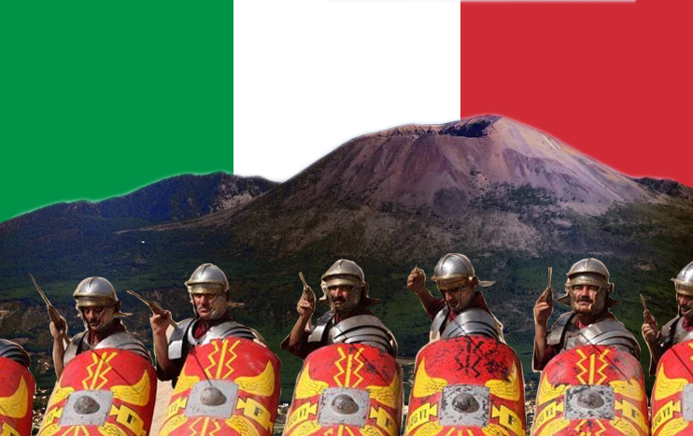

In English, we will base our learning on the story of ‘Escape from Pompeii’. The story of life in Pompeii and how it all suddenly changed due to one of the most terrifying moments recorded in history- the eruption of Mount Vesuvius. We will be working towards writing a story from the point of view of one of the children there.

In Music, we will be looking at The Doot Doot Song and classroom percussion.

History- Storyhouse

In History, we will investigate the Roman Empire and the true force of its army. Children will learn all about Julius Caesar and his attempt at invading Britain. We will also explore the influence of the Roman Empire on Britain.
Music

English

In computing, we will be looking at programming – events and actions
Computing

In PSHE, we will be looking at how we can keep ourselves safe.
PSHE

Year 3/4 Spring 1
Italy’s Force

Science

In Science, our focus will be on animals and humans! We will be learning about the digestive system and teeth to understand their functions. We will also be looking at food chains.
PE

In PE, we will continue to develop our gymnastic skills with ‘Bridges’ and we will be engaging in a new GULP initiative by Chester FC which combines exercise and healthy eating..

In Art, we are going to look at the work of the architect John Douglas.
Art & DT

In Maths, we will continue to explore multiplication and division and then move on to measurement, fractions and decimals throughout this half term.
RE

In RE, we will be looking at world views and exploring the idea that “We have far more in common than that which divides us.”
Maths

French
Year 3 – Animals
Year 4 – Alien faces, family
