|  |
| --- |
| **Literacy** |

* Goldilocks and three bears
* The Three Little Pigs
* Little Red Riding Hood

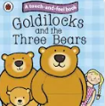 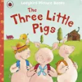 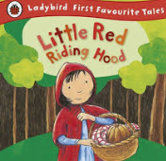

**Personal, Social and Emotional**

**Communication and Language**

**The stories we will be focusing on:**

Our focuses will include our personal care and how to keep healthy. Making friends with our new class friends and taking turns in activities together.

Our focus during this half term will be centred around getting to know the children and practising and developing our listening skills through activities such as What’s in the bag and story time. We will be learning lots of Nursery rhymes and action songs to support our language development.

**Interactions**

We will be taking part in continuous provision activities to support our interactions with others and develop our social skills.

**Acorns – Autumn 1**

**Traditional tales**

Within Maths, we will be using counting songs and adult activities to help us with our counting and understanding of numbers. We will practise our number formation.

**Maths**

M

We will be learning about our environment through exploration and using our five senses. This will include our Forest School area and begin to learn the rules of our weekly sessions.

**Forest School**

**In Art, we will create art work inspired by our favourite traditional tales.**

**Art**

**PE**

In PE, we will develop our gross motor skills focusing on big movements including movement to music and climbing.

**SALT**

**Understanding the world**

We will be using the traditional stories to support our learning by encouraging us to ask questions about the story and characters. We will share books with our friends and adults in our class.

We will be working on our targets for SALT through one to one and group sessions.

We will be looking at our families and who is important to us and sharing who is in our family. We will also be learning about the days of the week and months through daily songs and daily check ins.

