|  |
| --- |
| In Maths, both year 3 and year 4 will explore place value, the four operations (addition, subtraction, multiplication and division). Year 4 will also cover length and perimeter throughout this half term.  **Maths** |

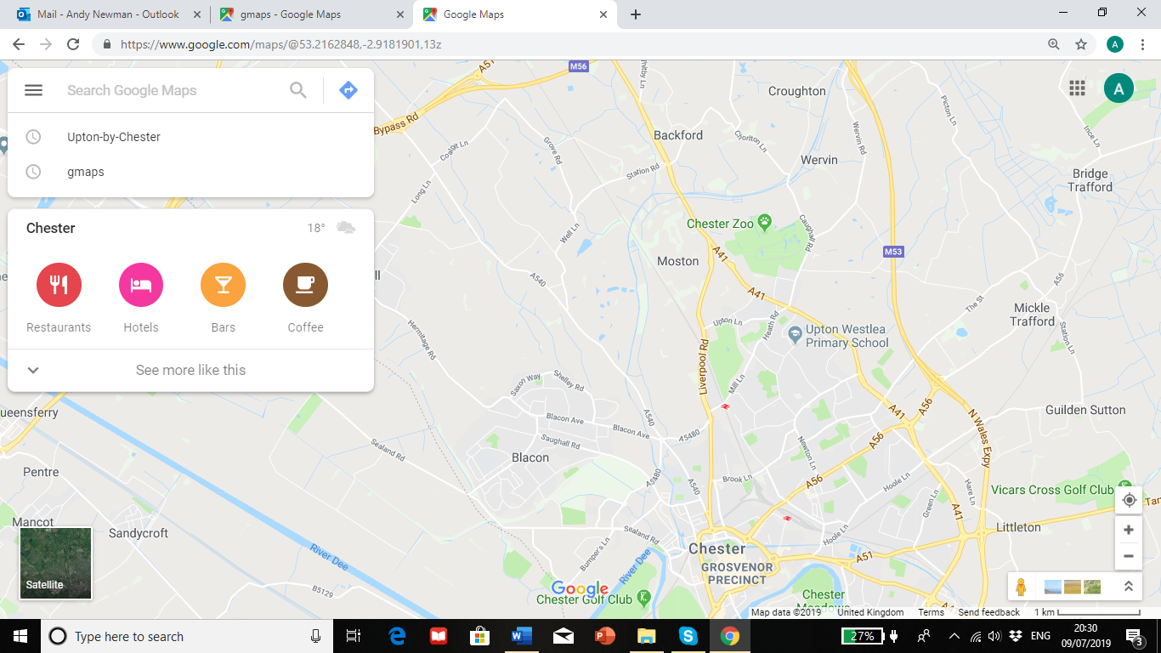

In RE, we will be looking at the Jewish religion to answer the question, ‘How do Jews demonstrate their faith through their communities?’

**PE**

In PE, we will be working on our general game sense for invasion games as well as a unit of rounders.

**RE**

In PSHE, we will be using our SCARF scheme. Our topic this half term is ‘Me and My Relationships’.

**PSHE**

**Music**

In Music, we will be looking at the song ‘This Little Light of Mine’. We will be singing in a Gospel style with expression and dynamics.

In Computing, we will gain an understanding of data and information skills through data logging.

**English**

In English, we will base our learning on the story of ‘Gorilla’. The story of a lonely girl, a friendly gorilla and their amazing journey will allow us to create a descriptive piece of writing.

**History**

In History, we will take a journey and explore the local area. Children will delve into the City of Chester and make informed judgements about the rich history that surrounds us.

In Science, we will learn that sounds are produced by vibrations and that these vibrations go on a journey from the source through a variety of materials.

**In Art and DT, we will focus on textiles to create a tile that represents ourselves using cross stitch skills.**

**French**

In French, year 3 will be looking at greetings, numbers and colours. Year 4 will be looking at our ‘welcome to school’ unit.

**Art and DT**

**Science**

**Computing**

Year 3-4 Autumn 1

**Journey of Discovery**