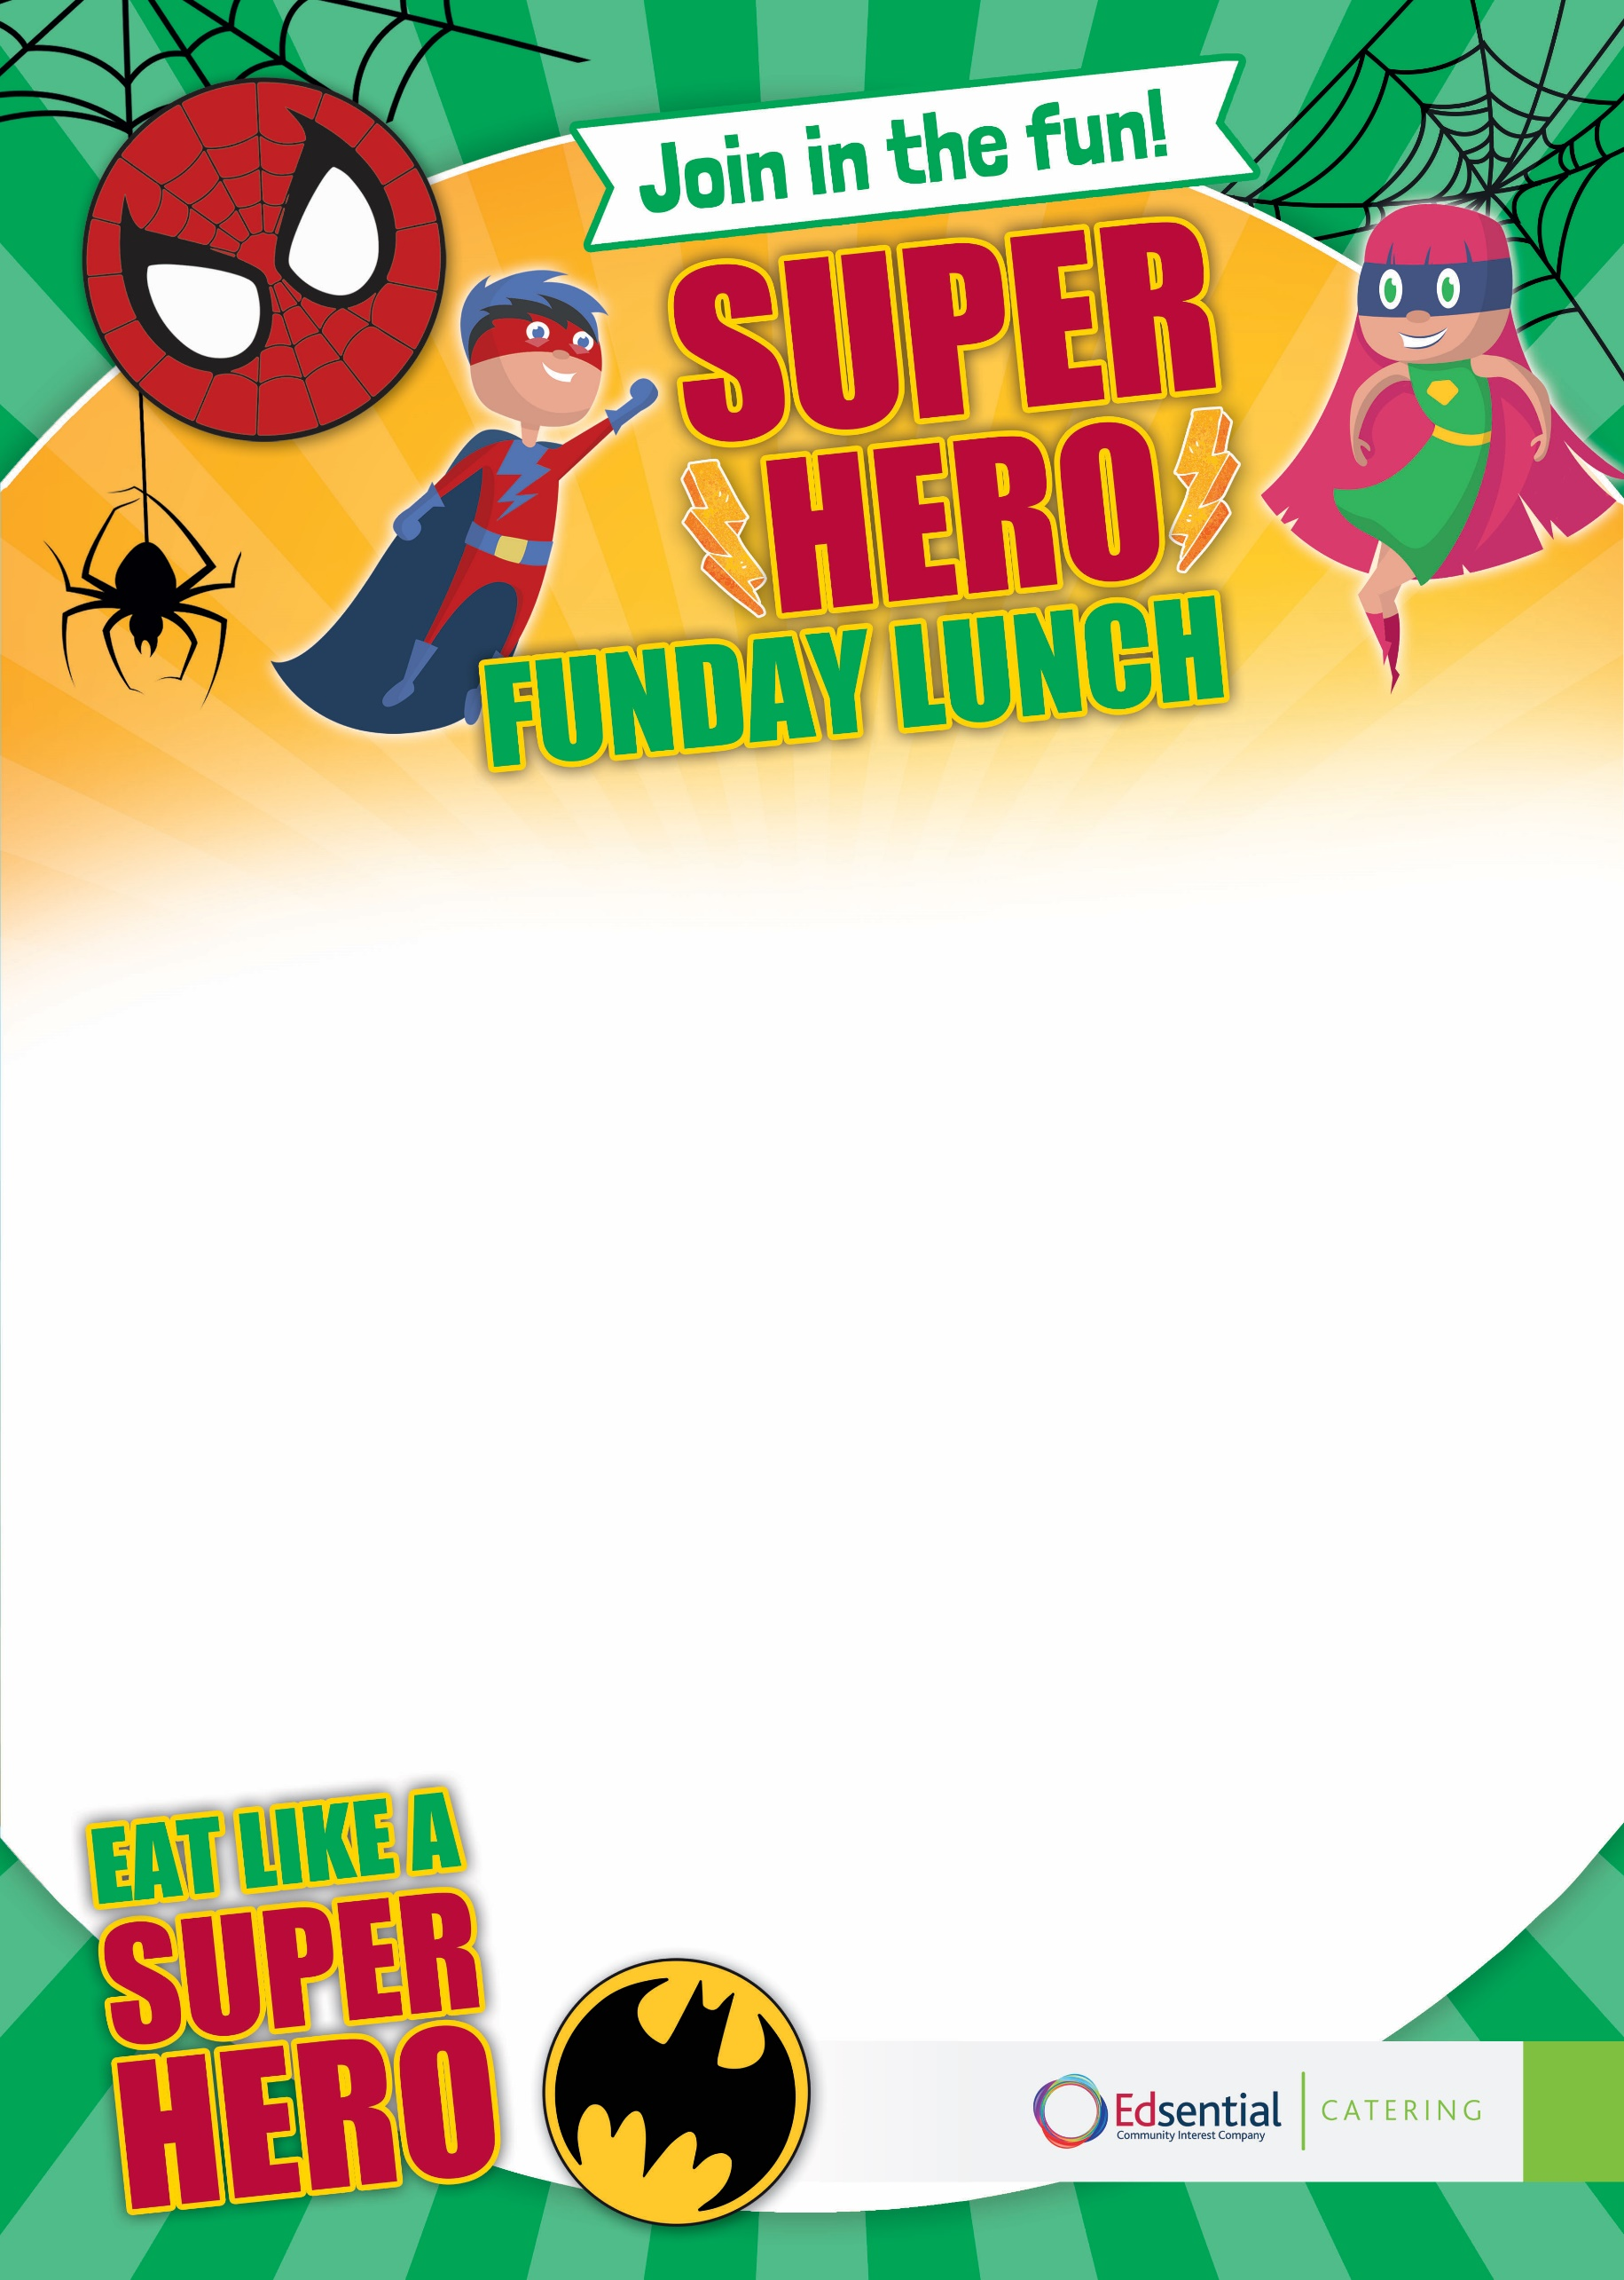
Infinity Stones Jelly
Fresh Fruit Platter
Vegetarian options available
Doctor Strange’s Deli & Joker’s Jacket Potato Served with Various Fillings and a Mixed Salad
Iron Man’s All in One Brunch Served with Crispy Doctor Octopus’ Diced Potatoes and Batgirl’s Baked Beans
Marvel’s Meatball Pitta Pocket (Build Your Own) Served with Superman’s Ziggy Fries and Magneto Mixed Salad
Thursday 21st May 2026

