  IN-tuition Mission Statement
  An innovative and nurturing approach to Education where life inspiring skills are unlocked and you are guided intrinsically to meet your fullest potential.
  Inspiring young people to maximise their life chances through bespoke methods of Teaching and Learning.
  Cultivating strong and independent people who can positively connect to their community.
  Principles Melanie Hawe / Emma Shutt
  20 Rosslyn Road
  Longton
  Stoke On Trent
  Staffordshire
  ST3 4JD
  IN-tuition
  Innovative nurture tuition
  A platform for reaching your intended potential
  

 |  |  | Our Curriculum Offer  We offer a comprehensive catalogue of curriculum subjects that will support and motivate you as you progress with your personalised and bespoke package of learning. Students are taught by a selection of qualified teachers, SEN tutors and wellbeing coaches. In-tuition will offer learners opportunities to maximize skills and knowledge in English, Math, Art, Business Enterprise and Well-being/ PSHE. Open Credit Network will provide you with desirable qualifications and certification that will strengthen your journey with lifelong learning. All of our students follow a 6 week assessment cycle to ensure that we can show their progression in smaller steps and parents are welcome to come into the school to view their progress.  Contact Us 0178231578  Principles  Melanie Hawe & Emma Shutt  Telephone 01782315758  Email Address: support@diamond-families.org.uk  Website www.diamond-families.org.uk/intuition
  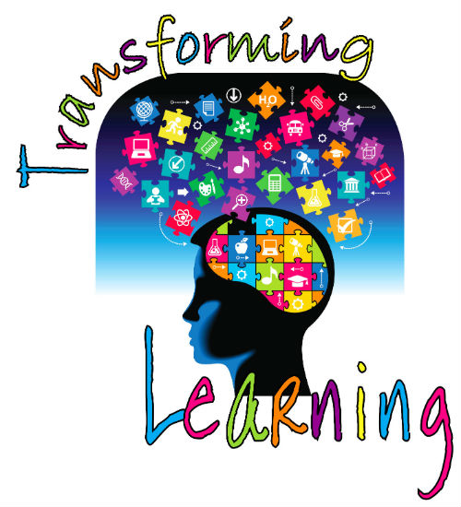’
  Potential
  It is our every aim and intention to create an innovative platform whereby young people who may have found conventional learning problematic previously. By combining various approaches that we foster organically through well-established assessment processes we can create a unique back drop for young people to add to and fulfill their very own potential.
  Experience
  Emma and Melanie have a combined 30 years experience in the field of Teaching and Learning, as well as therapeutic approach to young people that require nurturing and delicate emotional care and support. This wealth of experience is now harnessed via IN-tuition and its staff, who also possess the integral ethos that we demonstrate.
  IN-tuition will inspire you to be the person and the lifelong learner that you were intended to be!
  ‘ENGAGE, LEARN, RELEASE POTENTIAL!
  Referral Process
  Our referral processcan be accessed through S-O-T local Authority Alternative pathway service. All referrals and correspondence will be dealt with confidentially and with complete regard to an individual’s personal circumstance.
  Complaints/suggestions:Each student is assigned a keyworker, please discuss any issues with them in the first issues. If you do not feel that the issue is resolved or you wish to speak with some one different in the teamor the chair with complete confidentiality. Our Principles, Chair of governors, LA AP could also assist if more appropriate. (please ask the office for a list of contacts)

Holistic Plan
At IN-tuition we will create a sessional learning plan that suits all of your needs and bonds closely with your personality. We aim to develop innovative and creative styles of learning that will support you educationally and with all other aspects of your life so that we can truly and authentically guide you to meet your potential. You can also expect
- Termly/half termly review
- A sessional time table negotiated with the local authority
- Regular one to one mentoring sessions to build and review action plans
- Full support and guidance via your Teacher virtually or in person
- Assessment opportunity and qualifications acquired
- Access to multi disciplinary support
- A personalised support package to help you to re enter mainstream school fulltime
- Access to evidence based emotional health programmes

