January New Starters
For those children who are staying with us next year, you can help your child at home by encouraging independence when toileting, putting on their own coats and shoes and encouraging them to ask for help if they are stuck.
Spring Term
The year is going fast! Our thoughts are on preparing the children for going into Reception.
There are key skills that you can help practise at home. These include:
Continuing to practise writing their name. It is very important that the letters start in the correct place because it has a big impact on future writing. Mistakes with letter formation take a very long time to unlearn.
Using scissors safely to cut out simple shapes.
Getting dressed. This will be very helpful next year when the children will need to change into a PE kit.
To talk about past events in order using words such as then, and, because.
To talk about familiar stories they have read.
To share toys and take turns.
To use a knife and fork.

Down on the Farm
We have a wonderful surprise happening soon in Nursery. We hope you enjoy our regular “Breaking News” updates. (Keep an eye on Seesaw for more information).
Our new topic is ‘Down on the Farm’ and we will be talking about farms and farm animals by reading texts such as “Come on Daisy”, “Squash and a Squeeze”, “Cock a Moo Moo” and “Hungry Hen”.
We live in a wonderful area with lots of opportunities to see farm animals around us. It will be lambing season soon and I’m sure it won’t be long before we see lambs in the fields. Keep a look out.

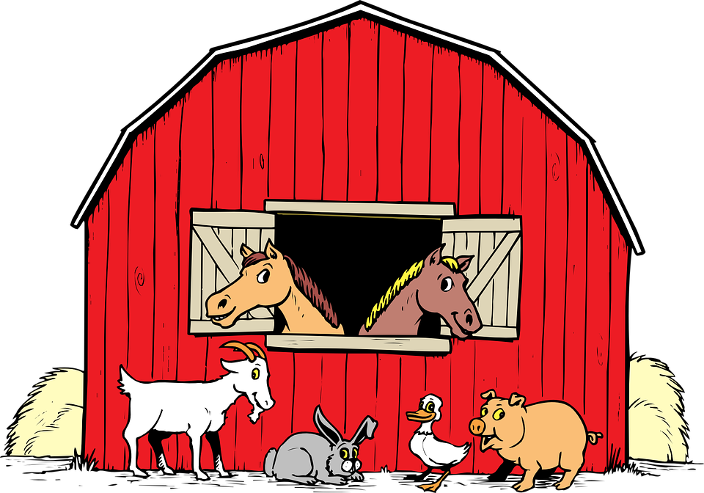

Things to Remember
Snack money is £5 for the half term. Please pay by school spider.
Stay and Play – Thank you to everyone who has attended our Stay and Play sessions. The next one will be on Thursday 19th March and we’ll send more information soon.
Parents’ Evening – Parents’ Evening is on the 17th and 18th March. Please keep a look out for the slots going live on School Spider

Phonics
This term, we will be concentrating on alliteration. This is where we listen to the initial sounds in words and identify words with the same initial sounds for example cat, cow, cone, carrot.
It is important that we pronounce the phonemes correctly. For some useful parent advice please visit
The Alphablocks guide to phonics - CBeebies - BBC

