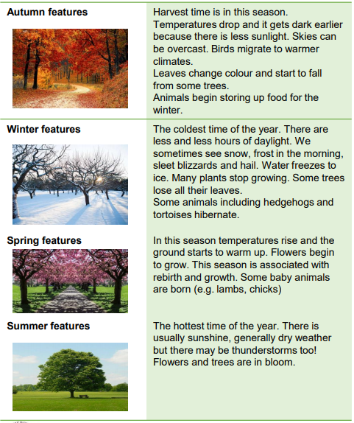
Days are longer in the summer and shorter in winter
Weather changes through the year, getting hotter in the summer and colder in the winter.

Objectives
-observe changes across the four seasons
-observe and describe weather associated with the seasons and how day length varies
Vocabulary
Autumn | The time of year between September and November. Many leaves fall off the trees.
Spring | The time of year between March and May. This is usually signs of new growth in spring.
Summer | The hottest season in the UK. It happens between June and August.
Winter | The coldest season in the UK. Winter occurs between December and February.
Weather | Weather is what the sky and air outside are like, such as cold and cloudy.
Weather symbol | These are signs used to help us understand more about our daily weather.
Deciduous | Deciduous trees are trees that shed their leaves once a year, usually during the season of autumn.
Evergreen | Evergreen trees are trees that stays green throughout the year.

Sticky knowledge

