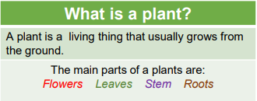
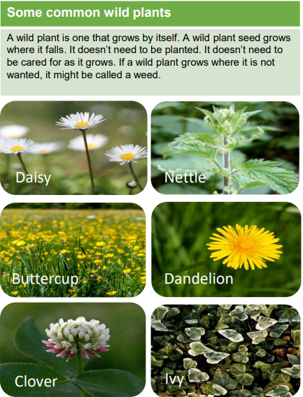
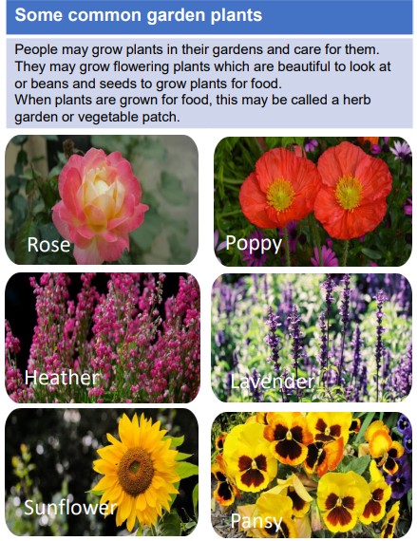
Sticky knowledge
Vocabulary
Flower | Part of a plant that attracts insects and birds.
Stem | Part of a plant which helps support it and keep it upright.
Root | Part of a plant which takes in water and nutrients from the soil.
Leaf | Part of a plant which absorbs sunlight which is used by the plant to make food.
Seed | The part of a flowering plant that can grow into a new plant.
Blossom | Blossom is the flower that comes before the fruit. For example, apple blossom comes before the apple starts to grow.
Deciduous | A tree that sheds its leaves during autumn.
Evergreen | A tree that keeps its leaves all year round.

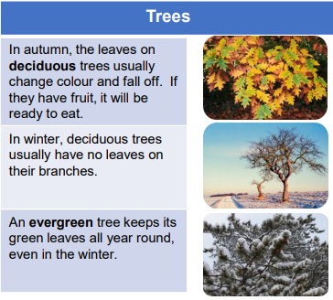
Objectives
-identify and name a variety of common wild and garden plants, including deciduous and evergreen trees
-identify and describe the basic structure of a variety of common flowering plants, including trees

