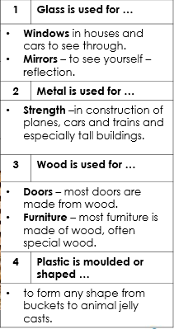
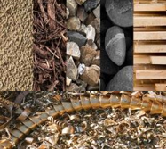
Vocabulary
Materials | What something is made of e.g. wood, plastic, metal.
Wood | The material that comes from a tree.
Plastic | A man-made material that can be shapes or moulded to any shape.
Metal | A tough and strong material which can be heated and shaped into anything.
Liquid | Liquids can flow and take on the shape of their container.
See through | Able to see through it easily.
Bend | A bendy material is one that can be twisted and is flexible.
Waterproof | A material that does not allow water or liquid through.
Smooth | An even surface without lumps or bumps.
Rough | Has an uneven surface.

Which material would you use to make a jumper?
Wood or wool
Objectives
-distinguish between an object and the material from which it is made
-identify and name a variety of everyday materials, including wood, plastic, glass, metal, water, and rock
-describe the simple physical properties of a variety of everyday materials
-compare and group together a variety of everyday materials on the basis of their simple physical properties
Sticky knowledge

